**Notes**

**Review:**

1. Sketch the graphs of the following power functions. Assume that the power is positive.

|  |  |  |  |
| --- | --- | --- | --- |
|  |  |  |  |
|  |  |  |  |

1. The function, , is called a __________________ function.
2. Graph the polynomial function from #2 on your graphing calculator using the following window: Xmin=−10, Xmax=10, Xscl=1, Ymin=−100, Ymax=100, Yscl=20.
   1. Write down the end behavior for this graph.
   2. Which power function in #1 has the same end behavior as the polynomial function graphed? Why do you think that this might be?
   3. List at least two differences in the graph of the polynomial function and the power function you listed in **part b**.

**Vocabulary:**

* General Form of a Polynomial Function:
* Degree:
* Leading Term:
* Leading Coefficient:

**Characteristics:**

* Global Behavior:
* Vertical Intercept:
* Horizontal Intercepts (Zeros):
* Turning Points:

1. For each of the following polynomials, identify the degree, the leading term, the global behavior, and the vertical intercept.

|  |
| --- |
|  |
|  |
|  |

1. Given the polynomial function: ,
   1. What is the degree of the function?
   2. What is the leading term and leading coefficient?
   3. Sketch a graph of how the power function looks for very large positive or negative values of x (global behavior)?
   4. What is the maximum number of turning points for this function?
   5. What is the maximum number of horizontal intercepts?
   6. Determine the vertical intercept.
   7. Determine the horizontal intercepts.
   8. Sketch a graph of the function.



1. Find the leading term and the vertical intercept of the polynomial function without multiplying out.

|  |  |
| --- | --- |
|  |  |

1. Identify the leading term and the horizontal intercepts of each of the polynomial functions. Using technology, graph each function to verify your work.
   1. 
   2. 

# In-Class Activity/Homework -- Graphing Polynomial Functions

For each of the following polynomials:

1. Give the leading term
2. Identify the vertical intercept
3. Identify the horizontal intercepts (zeros)
4. Match each polynomial function with its graph

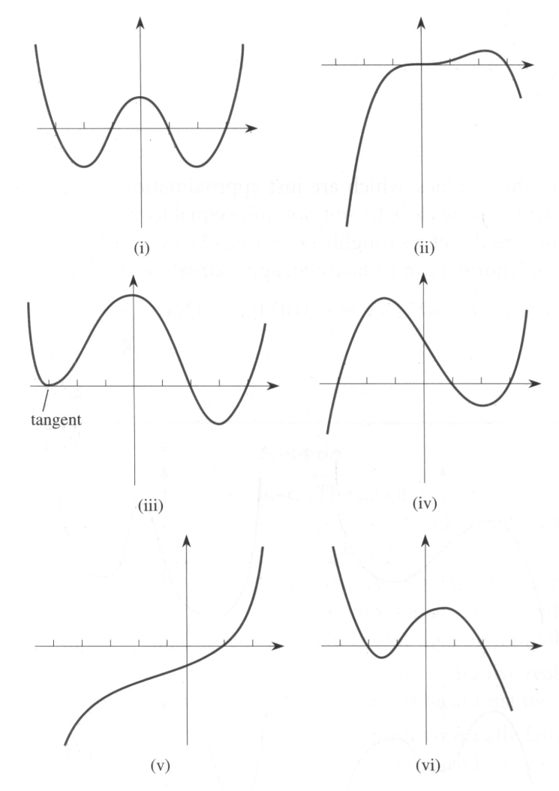1. 

a)

b)

c)

d)

2. 

a)

b)

c)

d)

3. 

a)

b)

c)

d)

4. 

a)

b)

c)

d)

5. 

a)

b)

c)

d)