**Review**

1. Given the function: 
   1. Determine the vertical intercept.
   2. What is the degree of the function?
   3. What is the leading term?
   4. What is the global behavior of this function?
   5. What is the maximum number of turning points for this function?
   6. What is the maximum number of horizontal intercepts?
   7. What is the name of this polynomial?
2. Match the factored form of the quadratic function with its graph.

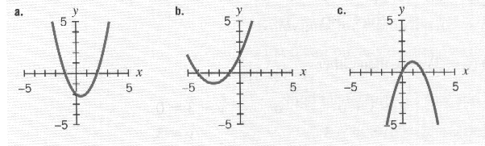

* 1. 
  2. 
  3. 

**Quadratic Functions and their characteristics:**

* General form of a Quadratic Function:
* Shape :
* Vertex:

* Axis of Symmetry:

1. The following function represents the relationship between time t (in seconds) and height h (in feet) for objects thrown upward on the planet Pluto:



* 1. Identify the values of *a*, *b*, and *c* in the equation and determine if the function is concave up or concave down.
  2. Determine the vertical intercept AND interpret it in the context of the problem.
  3. Find the horizontal intercept(s) **using the quadratic formula: **.
  4. Interpret the horizontal intercepts in the context of the problem.
  5. Find the vertex AND interpret it in the context of the problem.
  6. Write the equation for the axis of symmetry.
  7. Label the axes. Label the vertical intercept, the horizontal intercepts, the vertex and the axis of symmetry. Sketch the graph.



* 1. What is a reasonable domain for this

situation?

* 1. Solve *h(t)=25*.

1. It is summer and everyone has her or his favorite thing to do. Sherri loves to get on top of a building and throw water balloons at people walking below. Leslie, on the other hand, loves to launch air-powered rockets from the ground. At the same time, Sherri throws a water balloon and Leslie launches an air rocket. The following quadratic formulas model the objects’ height (in feet) as a function of time (in seconds). **Round all answers to three decimal places.**



1. Which formula models which object? Explain your reasoning.
2. Which object reaches a higher height? What is the height and when is it reached?
3. Which object hits the ground first? When does the object hit the ground?
4. What is a reasonable domain and range for Sherri’s situation?
5. What is a reasonable domain and range for Leslie’s situation?
6. At what time do the objects reach the same height? What is the height?