**In-Class Activity/Homework**

1. An object fired straight upward at an initial speed of 800 ft/s will reach a height of *h* feet after *t* seconds, where *h* and *t* are related by the formula: .
2. When does the object hit the ground?
3. When does it reach a height of 6400 ft?
4. What is the maximum height reached and at what time?
5. The shape of the main cable between towers of a suspension bridge can be modeled by the following quadratic equation: , where *h* is feet above the water and the origin is denoted in the figure below.

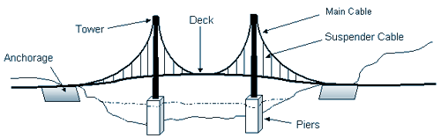

Origin (0,0)

1. How tall is the tower above the pier?
2. How far is the deck above the water?
3. What is the distance between the two towers?
4. Parabolic flight paths are used to create zero gravity situations for both scientific experiments and thrill seekers. Below is a graph of a parabolic flight. The flight path can be modeled by the following quadratic equation: , where *h(t)* is height above cruising altitude and *t* is time in seconds. The zero gravity phase is the time during the parabolic flight path where passengers on the flight experience zero gravity.

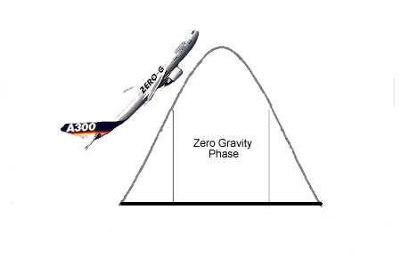

Height above cruising altitude (feet)

time (seconds)

1. How high above cruising altitude does this parabolic flight get and at what time does this occur?
2. If the zero gravity phase begins 60 seconds into the flight path, at what height above cruising altitude does this phase begin and how long does the zero gravity phase last?
3. At what time does the parabolic flight path return to cruising altitude?
4. You have just become the assistant manager for the local hockey rink. Your manager estimates that the total profit, *P*, in hundreds of dollars, per game can be approximated by the formula: , where *c* is the cost of a ticket.
   1. What is the vertex? What does this mean in the context of the problem?

* 1. What is/are the horizontal intercepts? What does this mean in the context of the problem?
  2. At what ticket price(s) will you earn $48 hundred in profit?

1. It is more than a month past Halloween and the Headless Horseman is still running around trying to scare people. Mr. Horseman walks into a room with a 12 foot ceiling that is full of festive people. Deciding to be the center of attention, the Headless Horseman tosses his head up in the air. The height of his head as a function of time in seconds is modeled by the following quadratic:



1. Does the Headless Horseman bump his head on the 12 foot ceiling?
2. If so, when does this occur? If not, how close to the ceiling does his head get and when does this occur? Give your answer to TWO decimal places.

c. What is the interpretation of the vertical intercept within the context of this problem?

1. Assuming the Headless Horseman is too carefree to catch his head, when does the head hit the floor? Give your answer to TWO decimal places.

**Mr. Potato Head Data**

A terrible crime has been committed. A well respected potato has been murdered. When found, the temperature of the body was given in degrees Celsius. The temperature of a healthy potato is 65 degrees Celsius. Today, you will be collecting data that models the decrease in temperature of a dead potato over time. This data will be used for Monday’s in-class activity.

|  |  |
| --- | --- |
| **Time in minutes** | **Temperature in Celsius** |
|  |  |
|  |  |
|  |  |
|  |  |
|  |  |
|  |  |
|  |  |
|  |  |
|  |  |
|  |  |
|  |  |
|  |  |
|  |  |