Understanding Factoring and Canceling
Sometimes people get confused between factoring and canceling because they are both based on using common factors. Canceling refers to using the principle of division to reduce or simplify a fraction. Canceling uses the following two ideas:
- If a≠0, then a÷a = 1 or $\frac{a}{a}=1$.
- 1 is the multiplicative identity, meaning if a is a real number, a ∙ 1 = a.
Here is an example of canceling. The numerator and denominator have a common factor of 2:

$\frac{6}{10}=\frac{3∙2}{5∙2}= \frac{3}{5}$ The twos are said to “cancel” meaning that 2÷2 = 1 and $\frac{3∙1}{5∙1 }= \frac{3}{5}$.

It may appear that the twos just “disappear”, but it is important to understand that they have divided out to make 1. It is also very important to note that the result is equivalent to the original expression.

When factoring a common factor from an expression, we separate out a common factor from an expression, but the factor still remains as a part of the expression. The example below illustrates how a factor of 6 is separated out from the expression.

$24a^{2}+60a-6=6(4a^{2}+10a-1)$ Notice that in the last term, a 1 remains. This is because subtracting 1 (as in this case) does change an expression. In the example above, the ones were not written in the expression $\frac{3}{5}$ because multiplying by 1 did not change the value.

It is a common mistake to drop the 6 out of the problem above thinking that it has “canceled out”. However, that would change the expression. The two expressions would no longer be equivalent. This is obvious when you use expressions that have a contextual meaning. Consider this example. Suppose we have the tile design shown below.
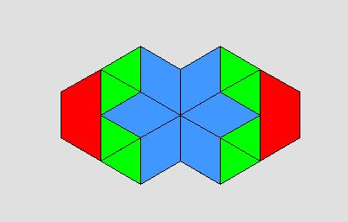
The expression for this design would be 2Z + 8T + 6R_{b}. Each term has a common factor of 2 so we could write the expression in an equivalent factored form:
2Z + 8T + 6R_{b} = 2(Z + 4T + 3R_{b})
We can see that these expressions are equivalent based on the context. The design is made up of two groups of the tiles (Z + 4T + 3R_{b}):
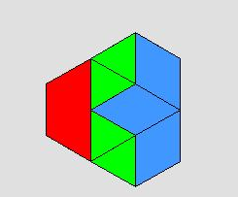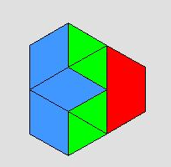

Therefore, the common factor of 2 must be written in the factored form.

Often, we use canceling and factoring together to simplify an expression. The following example shows steps to simplify the expression. For each step, explain what is being done:
Step | Explanation
$$\frac{\left(8x+12\right)}{4} → \frac{4\left(x+3\right)}{4}$$

$$\frac{4\left(x+3\right)}{4} → x+3$$

Factor and simplify the expressions if possible. If not factorable, state, “no common factors.”
- $15x-27x$ | - $\frac{20x+21}{4}$
- $$\frac{14b-8}{4}$$ | - $49x^{2}- 28x-7$

For each expression below, list 3 numbers that could be placed in the blanks to make the expression factorable.

- $18y^{3}+_____y^{2}-48$ | - 45x – 81

Estimate. Explain your estimation.
- 38% of 2450.

Complete the following problems from your textbook: p. 499; #6, 7, 13-17, 21, 23, 25, 27, 39, 41, 43, 93, 94, 96

