The tile design shown below is called Calico Flower.
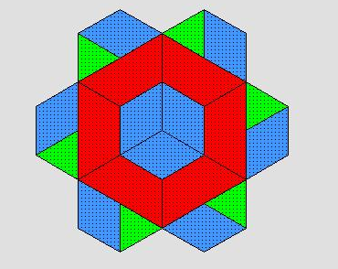

- Write the expression for Calico Flower: ____________________________

One of your customers wants to modify the design by removing the center:
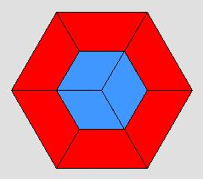

- Write the expression for the center design: ____________________________

The resulting Custom Flower design is shown below. Write a statement using subtraction of polynomials that models this situation.
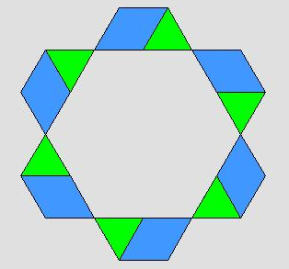

----- =

- _______________________________________________________________________

A similar situation is shown below. Write the subtraction statement for the situation.
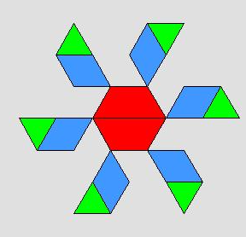
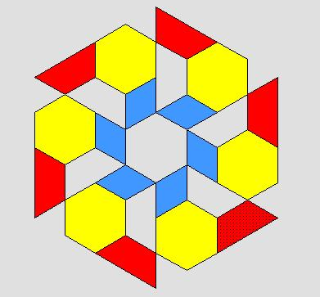
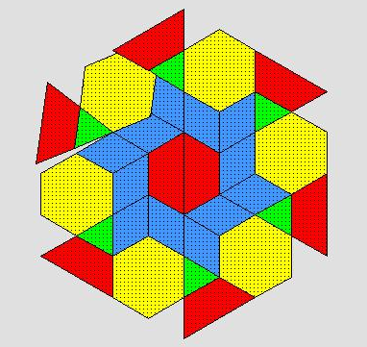

-- =

- _______________________________________________________________________

Simplify.
- $\left(5x^{2}+3x-7\right)- (8x^{2}- 10x+2)$

- $3\left(4a+6b-2\right)-3(8b-5)$

- $5-2(3x+2y+6)$

