Day 10 Misleading Graphs Packet
Write your answers using complete sentences.

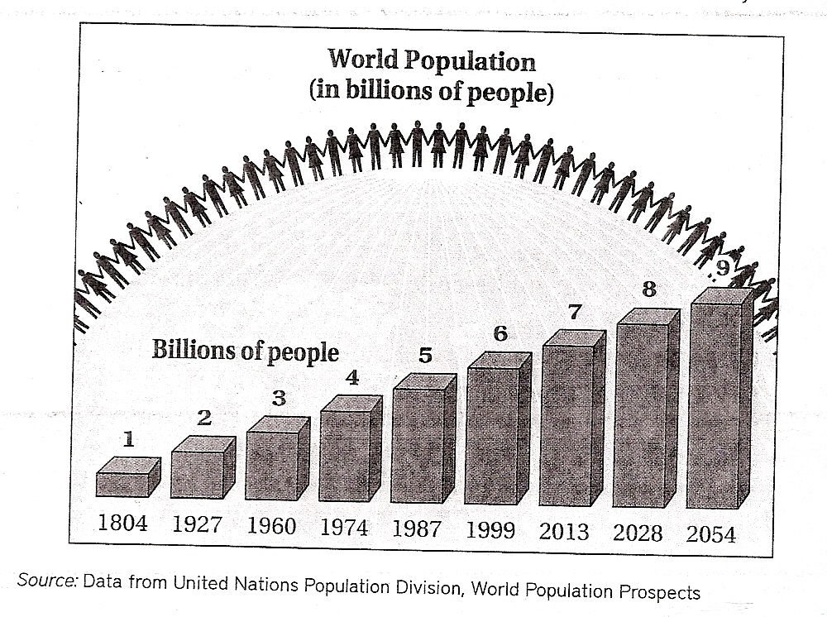

- How are the 2 graphs above related?

- Which graph is easier to read? Why?

- Which graph gives a more accurate portrayal of the population growth? Why?

The following two graphs are from Information Week, October 13, 2003:
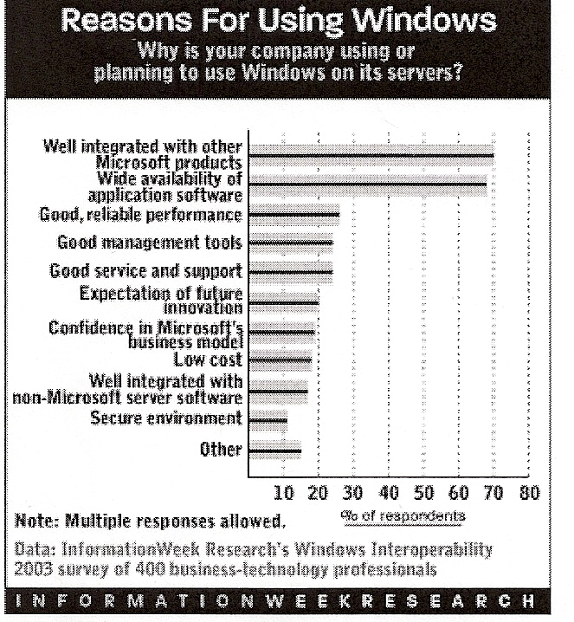

- Interpret the meaning of the top bar in the graph on the left.

- Interpret the meaning of the top bar in the graph on the right.

- Describe at least 2 ways in which the graphs are confusing or misleading.

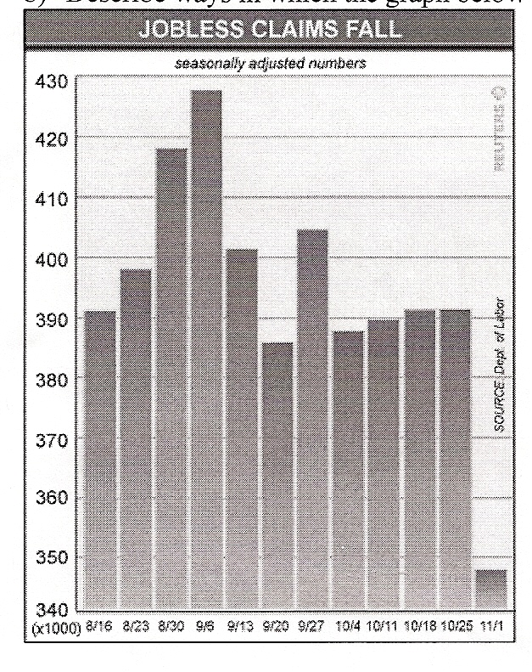

The graph to the left was published by Reuters in 2003.

- Based on the title of the graph, what point do you think the graph is meant to make? Be as specific as possible.

- Describe at least 2 ways in which the graph is confusing or misleading.

This graph is from the College Board.
- What is this graph demonstrating?
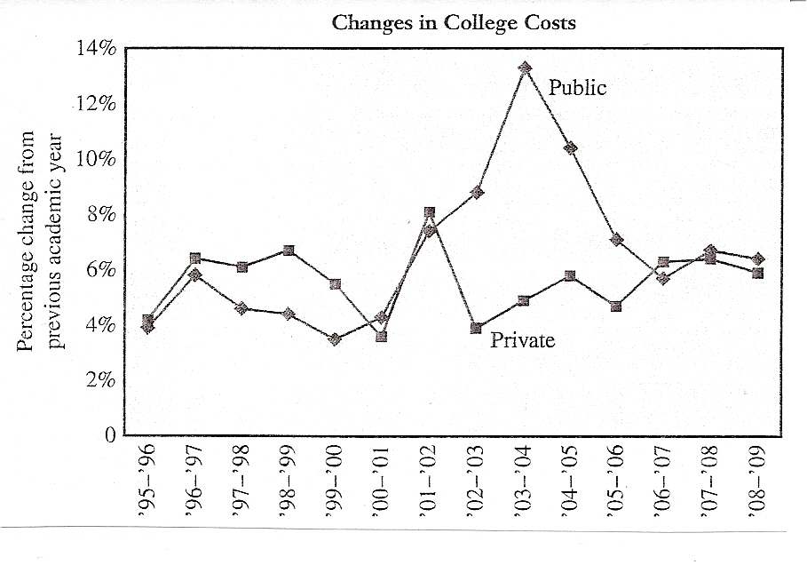

- What happened to the cost of private colleges from 01-02 to 02-03?

- What are at least 2 ways this graph is confusing or misleading?

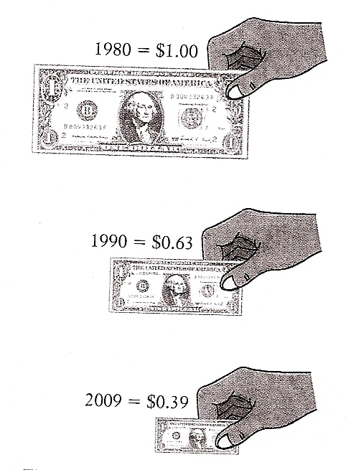

- What point do you think this graphic is trying to make?

- What are at least 2 ways this graphic is confusing or misleading?

