Day 9 Making Inferences from Graphs
Show work where needed
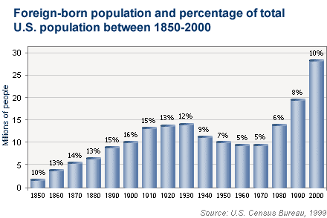

- What is the relationship between bar height and percent?

- How many foreign born people were in the United States in 1970?

- What does the 15% for 1910 mean?

- Calculate the total population of the United States in 1950.

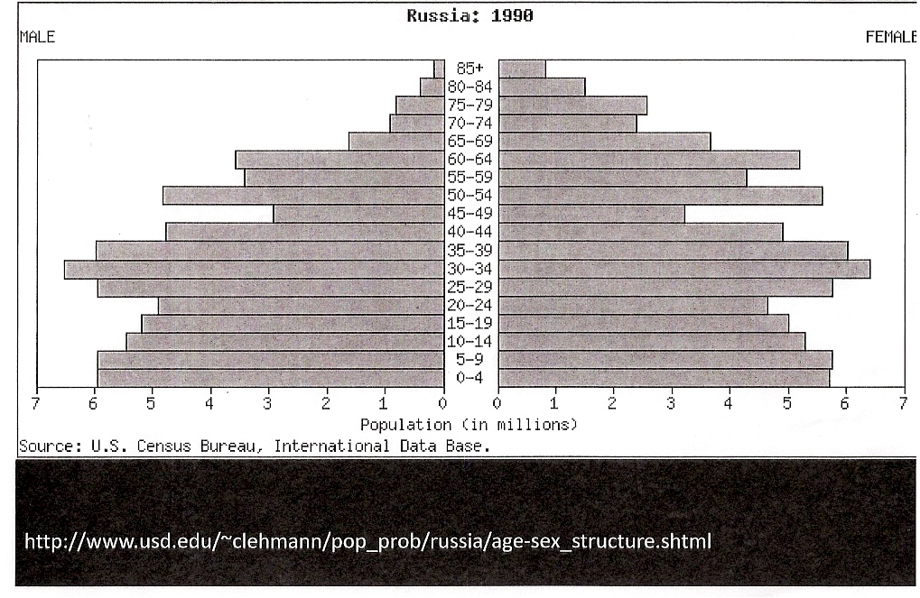

- Based on the graph above, write a couple sentences about the composition of the Russian population.

- Approximately how many Russians are aged 25 – 29?

- If the total population of Russia in 1990 was approximately 148 million, what percentage were females aged 0 – 9?

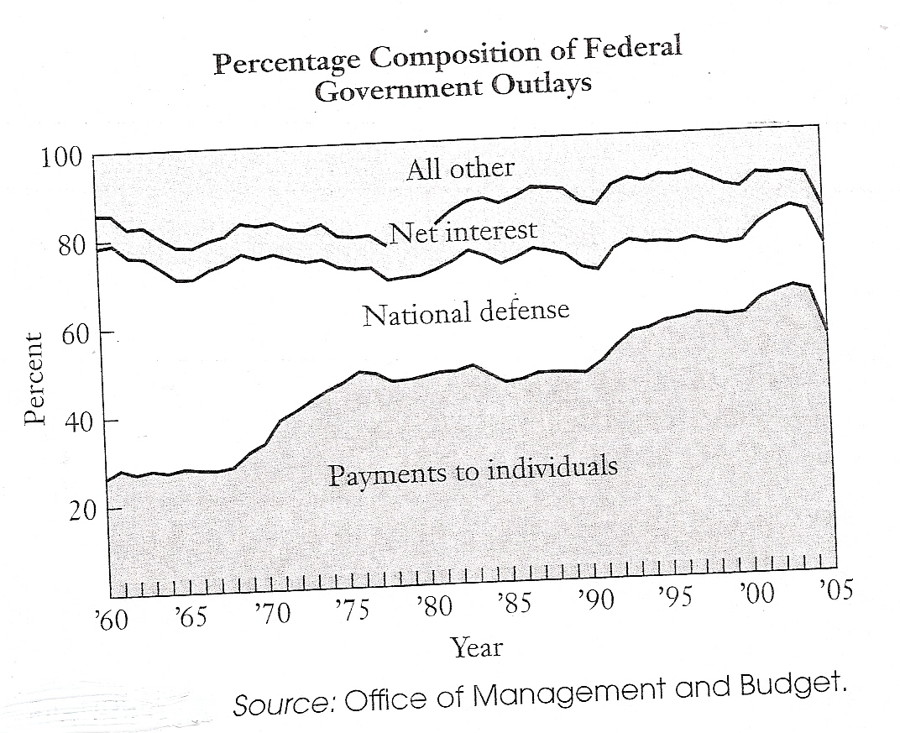

(Payments to individuals includes Social Security and Medicare; net interest represents interest payments on the national debt; all other represents non-defense discretionary spending.)

- What percent of the budget was allocated for national defense in 1977?

- If 110 million dollars ($110,000,000) was allcoated for national defense in 1977, how much was the federal budget?

Use the graphs to answer the questions below.

The total population in 1900 was approximately 76,000,000 and in 2000 it was 281,400,000.
- About how many people were between the ages of 5 and 19 in 2000?

- Compare the populations under the age of 5.
  - In which year was there a greater percentage of people under the age of 5?

  - In which year was there a greater number of people under the age of 5?

- Approximately what percent of the population was over 20 in 1900?

- Circle the letter of each statement that is correct.
- In 2000, approximately 20 out of every 100 people were between the ages of 45 and 65.
- There were approximately the same number of people between 20 and 44 in 1900 and 2000.
- The percentage of people age 65 and older tripled from 1900 to 2000.
- In 1900, there were about 3 times as many people below the age of 5 than 65 and older.
- The number of people age 65 and older tripled from 1900 to 2000.
- In 2000, about 1 in 20 people was between 5 and 19.
- In 1900, about 1 in 10 people was under 5.

- Which population is younger? Justify your answer.

