Linear Inequalities – Pre-Notes
Graphing a linear inequality is exactly like graphing a regular linear function, until you have to deal with the inequality sign and shade above or below the function. The usual linear function y=mx+b only has solutions ON the line while an inequality has a shaded area of solutions that are not necessarily on the line. The area of the graph that is shaded can be referred to as the feasible region or the solution region or more simply as the shaded region.

In this class, we will mainly deal with graphing systems of linear inequalities in order to find the intersection between the shaded regions of the system. The intersection of two or more inequalities that bound the feasible region results in a corner point to the feasible region.

To graph a system of inequalities:

Step 1: | Find the intercepts of each equation OR rewrite the equations in slope-intercept form
Step 2: | Graph each equation just as you would a regular linear equation. If < or > use a dotted line. If or use a solid line.
Step 3: | To find the shaded region of each inequality, pick a point not on the line of interest (the origin is a great point choice if it is not on the line).
Step 4: | Substitute this point into the inequality.  - If inequality is true, shade on the side of line that includes that point.  - If inequality is not true, shade on the side of line not including that point.

Example 1: Graph the linear inequalities:
$${2x+y>-3 \atop -6x+2y≤15}$$

Step 1: Start with the first equation,$2x+y>-3$. Determine the vertical intercept by setting x=0 and solving for y. Because you are trying to find the vertical intercept, you can pretend the inequality sign is an equal sign to make this easier.

$${\begin{aligned}2x+y=-3 \\ 2\left(0\right)+y=-3 \\ y=-3\end{aligned} \atop vertical intercept: (0, -3)}$$

Then find the horizontal intercept by setting y=0 and solving for x.
$${\begin{aligned}2x+y=-3 \\ \begin{aligned}2x+0=-3 \\ 2x=-3\end{aligned} \\ x=-1.5\end{aligned} \atop horizontal intercept: (-1.5,0)}$$

- So for the first equation, $2x+y>-3,$ the intercepts are: $\left(0, -3\right) and (-1.5,0)$

The same can be done for the second inequality: $-6x+2y≤15$.
$$-6x+2y=15 \\ -6\left(0\right)+2y=15 \\ 2y=15 \\ y=7.5$$
$$vertical intercept: (0, 7.5)$$

$$-6x+2y=15 \\ -6x+2(0)=15 \\ -6x=15 \\ x=-2.5$$
$$horizontal intercept: (-2.5, 0)$$

- So the intercepts for the second equation are: $\left(0, 7.5\right) and (-2.5,0)$

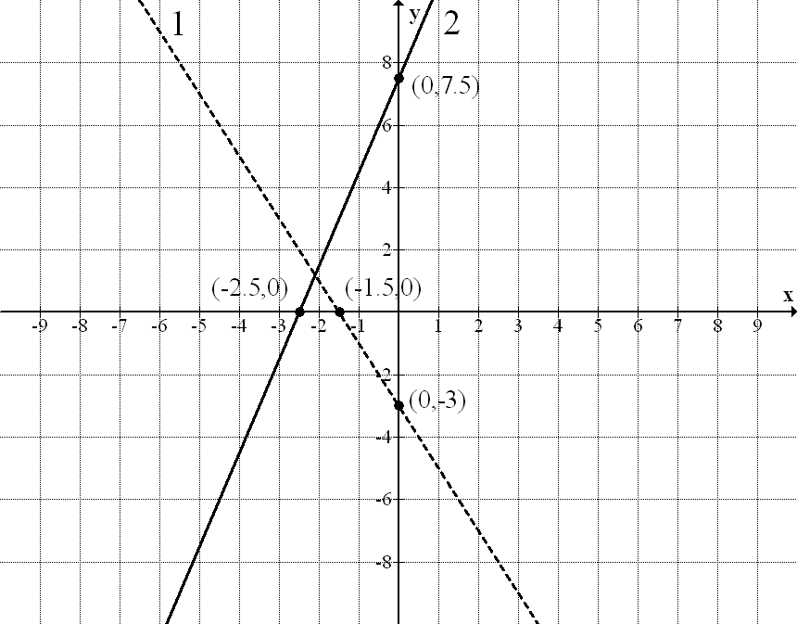
Step 2: Now with two points for each inequality you can graph both lines. The first inequality should be a dotted line while the second inequality will be a solid line due to their respective inequality signs.

Notice that the lines are labeled as 1 and 2. This will help distinguish between the lines as you shade and find corner points.

Step 3: After graphing the first equation, $2x+y>-3,$ you know the line does not go through the origin. Choose (0,0) as your test point.

Step 4: Substitute (0,0) in the inequality to determine which direction to shade.
$$2x+y>-3 \\ 2\left(0\right)+0>-3 \\ 0>-3$$

- This is a true inequality so you need to shade the first inequality up to include (0,0) in your shading.

Step 3: For the second inequality, $-6x+2y≤15$, you can also use (0,0) as your test point.

Step 4: Substitute (0,0) in the inequality.
$$-6x+2y≤15 \\ -6\left(0\right)+2\left(0\right)≤15 \\ 0≤15$$

- This is a true inequality so you need to shade the second inequality down to include (0,0) in your shading.
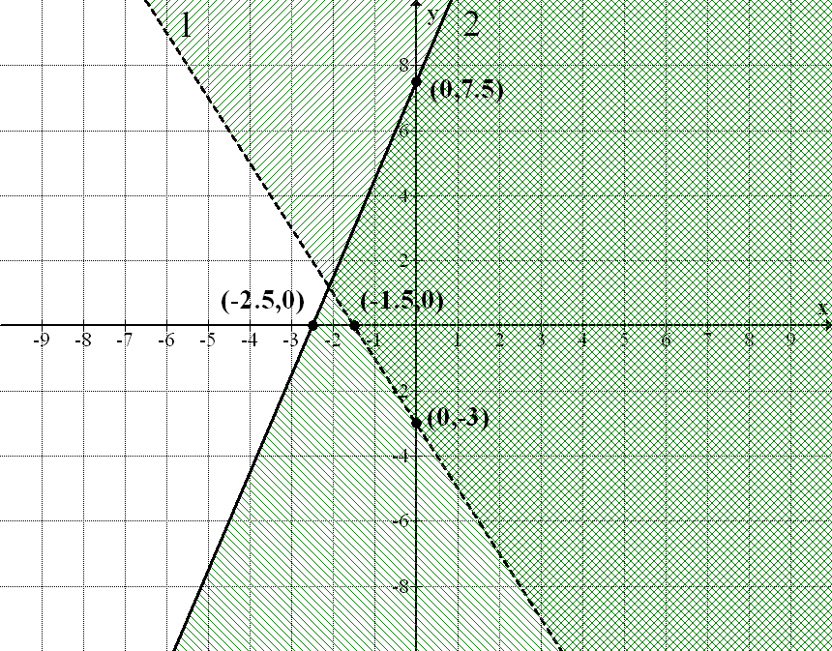

The intersection of the shaded region of the two inequalities forms the feasible region. In this case there is only one corner point, the point at which the two inequalities intersect.

There are three ways to find the intersection point that have been previously discussed in class: algebraically using substitution or elimination or using your graphing calculator’s intersection function. When using either of the algebraic methods, change the inequality signs to equal signs and proceed as usual.

The intersection point between these two inequalities is (-2.1, 1.2).

Thus the feasible region and final answer would be:

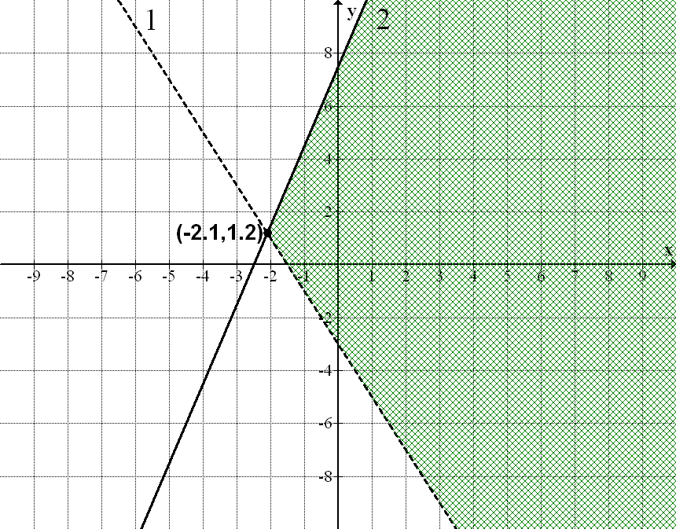

Now try one on your own.
- Graph the system of inequalities, shade the feasible region and determine the corner points
$${10x+y≤400 \atop \begin{aligned}5x+y≥250 \\ y≥0 \\ x≥0\end{aligned}}$$
.
Hint: Think about what $y≥0$ and $x≥0$ would represent on a graph. You should deal with graphing these two first. Then deal with the other two inequalities which are handled like the example.

