Earth Systems Science

Laboratory 13

Oceans and Coastal Processes

LEARNING OBJECTIVES

1. To observe how waves interact with various shorelines and coastal features in a simple wave tank.
2. To explore the formation of nearshore currents and the transport of sediments along a shoreline.
- To understand the distribution and extent of the oceans in both hemispheres.
- To understand how temperature and salinity affect the movement of ocean water.

BACKGROUND

Waves
As we travel along a coastline, we observe the most obvious movement of the ocean—its waves. Whether gentle, rhythmic lappings on a sandy shore, or violent surges of surf on a rocky coast, waves represent the periodic up-and-down movement of water, most often caused by wind blowing over the open ocean. Without wind, the surface of the ocean would be almost as smooth as glass. Even slight breezes create ripples in the ocean, which may grow into waves as increasing energy is transferred from escalating winds to the water. When the wind continues to blow in the same direction for long periods of time, more energy is transferred to the water. The greater the energy transferred, the larger the resulting waves. However, winds seldom maintain their direction for very long, and the ocean's surface is usually marked by many smaller waves moving in various directions in response to changing winds.

A wave has two basic parts—a crest and a trough. The crest represents the highest point of a wave, while the trough is the lowest point between two crests. The vertical distance between the crest and the trough is called the wave height. Scientists refer to the horizontal distance between two consecutive crests or troughs as the wavelength, and the wave period is the time it takes for one complete wavelength to pass a given point. We can calculate the speed at which a wave moves by dividing its wavelength by its wave period.

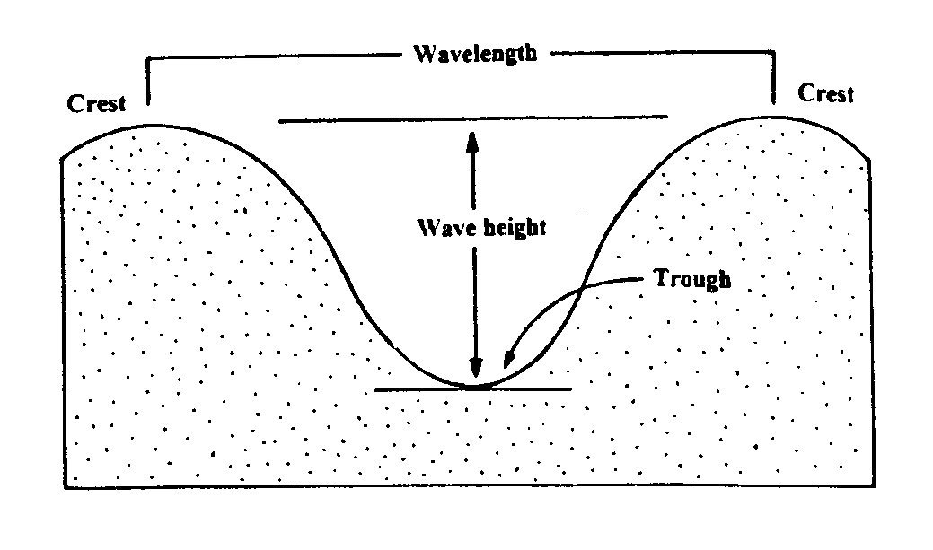

Wavelength Wave speed = ----------------
Wave period

Deep water waves form in the open ocean, while shallow water waves form as waves approach the shoreline and begin to touch bottom. This occurs as the water depth becomes less than half the wavelength, causing the bottom of the wave to slow down due to friction with the ocean floor. However, the top of the wave continues to move at its original speed. As the wave approaches the shoreline, its top moves steadily farther ahead of its bottom, growing in height, until it eventually topples over into a foamy mass of water called a breaker. Both the original wave height and the steepness of the ocean floor determine the size and force of breakers. The steeper the topography near the shore, the greater the force of the breakers.

Regardless of the type of shoreline, waves also impact the coastal topography by eroding surface landforms and transporting and depositing sediments back and forth across the shore zone. Most waves approach the shore at an angle, creating a longshore current of water that runs parallel to the shore. Longshore currents carry large quantities of loose sand and sediment, which are deposited as the energy of the wave decreases. This often occurs where waves refract along shoreline bays or inlets, forming sandbars, spits, tombolos, or barrier islands from the accumulated deposits. Shore zones of all types constantly change due to erosion and deposition from waves, tides, and longshore currents.

PART I: Wave tank and coastal process simulation
OVERVIEW

In this activity, you will be setting up a simple wave tank and shoreline simulation. You will work in small groups of 3-5 students to perform the four simulations.

Prepare the tank and practice making waves
Fill the wave tank with water to a depth of about 15-20 mm. Use the wax pencil provided to mark the side of the tank approximately 10 cm from one of the ends. Draw a second mark 10 cm further down the side of the tank. Practice creating waves by holding the white plastic panel in the water so that it just touches the bottom of the tank and is parallel to the first 10 cm mark. Move the panel in a steady motion from one mark to the next, and then remove the panel from the water. This entire process should take about one second. Be sure to keep the panel in a position perpendicular to the bottom of the tank, and maintain a fluid motion as you move the panel through the water. Practice this motion until you can produce uniform waves.

When you are ready, add sand to the tank to set up four basic simulations as shown. You should run each simulation (make waves) for at least 5 minutes, noting the wave characteristics and movement of sand particles during that time. Once you've added the sand, you can adjust the water level (if necessary) to optimize each simulation. When you are finished, siphon the water from the tank using the tubing provided, and allow the sand to dry out for re-use.

PROCEDURE - Simulation #1

A. Once you have mastered the wave generation technique, add the sand to your wave tank to create a shoreline as shown in the diagram for Simulation #1 (on the next page). Place the sand in the tank at the end opposite where you have marked your wave generation points. Make sure the sand is spread uniformly across the end of the tank so that at least half of the sand remains above water level and the total sand area occupies no more than about 1/4 of the tank's length.

B. With the sand now in place, position your wave generator panel in the center of the water, and begin generating waves by moving the panel between the two marks on the side of the tank. Continue to generate waves in this manner for at least 5 minutes. You may wish to take turns at this with your lab partners, but make sure to maintain the position and pace of the waves. During this time, observe the wave characteristics and movement of sand particles along the shoreline.

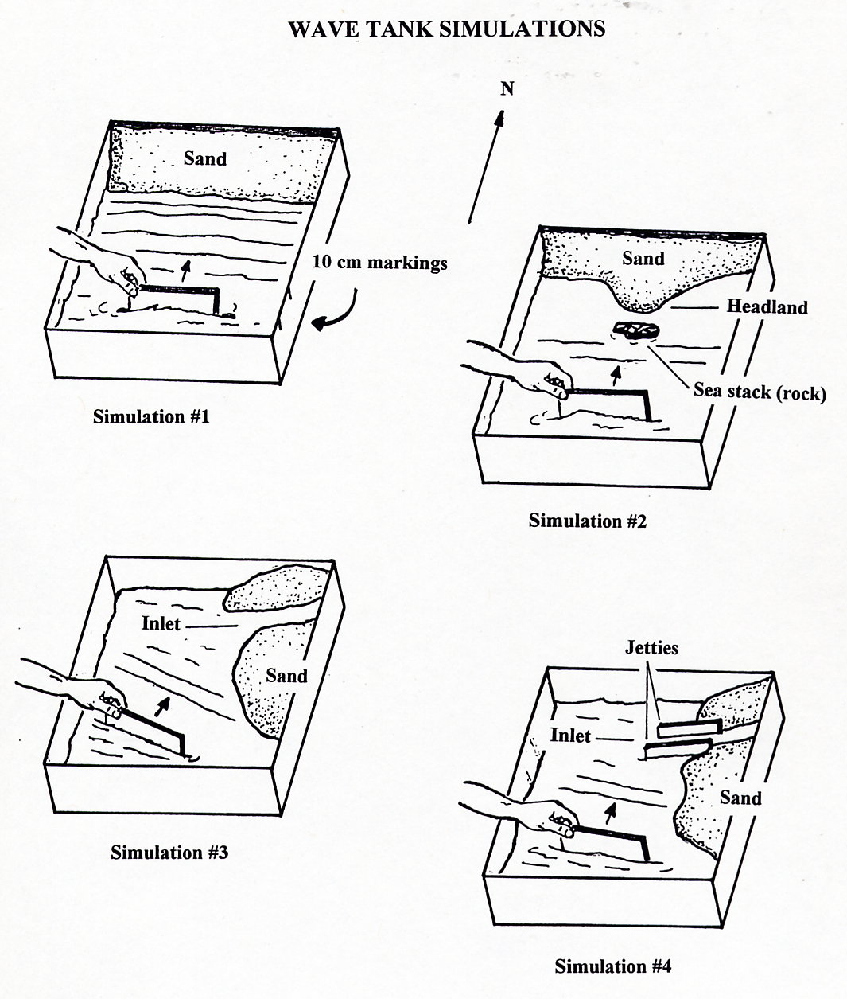

QUESTIONS (Simulation #1)
Use both your observations and the background material at the beginning of this lab to answer the following questions. Write your answers on your answer sheet.

1.1) Draw a sketch showing the movement of waves and sand in this simulation. Label places where sand is eroded and places where sand is deposited.

1.2) How is your method of generating waves in this activity different from the way waves are created in the natural environment?

1.3) Describe the movement of the sand particles as the waves reached the shoreline. Was there any difference in the movement of the larger sand particles versus the finer sand grains? If there was a difference, explain it.

1.4) Beaches often look different in the summer and the winter, because powerful storms create larger, more energetic waves. How do you think increasing the energy of the waves would change the character of the beach? Why?

PROCEDURE - Simulation #2

C. Rearrange the sand in your wave tank to create a headland as shown in the diagram for Simulation #2. Place the rock provided a short distance from shore to simulate a sea stack.

D. Repeat Steps B & C as outlined in Simulation #1. Answer the questions which follow.

QUESTIONS (Simulation #2)

2.1) Draw a sketch showing the movement of waves and sand in this simulation. Label places where sand is eroded and places where sand is deposited.

2.2) The sea stack in this simulation represents a small, isolated, rocky island which has been detached from the headland by wave erosion. Describe the movement of sand in the area immediately behind the sea stack in your simulation.

2.3) If the sand movement you described above were to continue over time, what would happen to the sand behind the sea stack?

PROCEDURE - Simulation #3

E. Next, set up your wave tank to create a small inlet as shown in the diagram for Simulation #3.

F. Repeat Steps B & C as in Simulation #1, but angle the direction of your wave fronts slightly so that the waves hit the shoreline at a slight angle as shown. Run the simulation for at least 5 minutes as before.

G. After recording your observations, place a small amount of talcum powder in the water near the shoreline closest to the wave generation area. Begin making waves once again at a slight angle to the shoreline as in Step G. Observe the movement of the talcum powder along the shoreline for a minute or two, and answer the questions which follow.

QUESTIONS (Simulation #3)

3.1) Draw a sketch showing the movement of waves and sand in this simulation. Label places where sand is eroded and places where sand is deposited.
3.2) Describe the movement of the sand particles along the beach during the simulation. In what direction did they move?

3.3) What did you observe happening to the inlet?

3.4) If the simulation were to continue for a longer period of time, what topographic feature might you expect to form at the mouth of the inlet?

3.5) Describe the movement of the talcum powder in Step G. The talcum powder is carried by a current you created by changing the onshore angle of the waves. What do we call this type of current?

PROCEDURE - Simulation #4

H. Clean out the inlet area from your setup in Simulation #3, and position two jetties about 50 to 70 mm apart at the entrance of the inlet. To set up the jetties, slide two plastic support stands along the edge of each of the two jetty panels so they will remain upright and in place along the inlet entrance. Allow the jetties to stick out about 100 mm or so beyond the edge of the shoreline, and anchor each jetty with some sand along its base.
I. When your setup is complete, begin wave generation as before, but at a slight approach angle to the shoreline as shown in the simulation diagram. Observe the movement of any beach sediments, and answer the questions which follow.

QUESTIONS (Simulation #4)

4.1) Draw a sketch showing the movement of waves and sand in this simulation. Label places where sand is eroded and places where sand is deposited.

4.2) How did the introduction of jetties to the inlet affect the movement and deposition of sediment?

4.3) Why do you think jetties are built on both sides of an inlet? How would shortening their length or altering their angle to the open water affect the movement or deposition of sediment?

PART II: Oceanography

The ocean covers nearly ¾ of the Earth’s surface. The purpose of this section is to understand some of the basic physical characteristics of the ocean. We will examine the distribution of the oceans as well as the salinity and temperature of the water.

5. Follow a line around the globe and estimate what percentage of Earth’s surface is ocean at latitude 40º North, latitude 40º South, latitude 60º North, and latitude 60º South.

6. Salinity of sea water
The next section of this lab will deal with the relationship between the salinity, temperature, and density of ocean water. Salinity and temperature control the movement of deep ocean water.

For this section you will need a graduated cylindar and pipette. Fill the graduated cylindar with 100 mL of room temperature tap water. Slowly drip each of the provided solutions into the cylindar, measuring the amount of time it takes for a drop to reach the 50 mL mark. Repeat each experiment twice. Record your observations in table 6.1 on your answer sheet.

6.2) Since the densest solution falls the most quickly, which solution has the highest density?

6.3) Using the data given in the table below, plot two curves showing the change in salinity with latitude in the Atlantic and the Pacific Oceans. Use the table on the following page as your graph paper.
Ocean salinity in ppt (0/00) at various latitudes
Latitude | Atlantic Ocean | Pacific Ocean
60º N | 33.0 | 31.0
50º N | 33.7 | 32.5
40º N | 34.8 | 33.2
30º N | 36.7 | 34.2
20º N | 36.8 | 34.2
10º N | 36.0 | 34.4
00º | 35.0 | 34.3
10º S | 35.9 | 35.2
20º S | 36.7 | 35.6
30º S | 36.2 | 36.7
40º S | 35.3 | 35.0
50º S | 34.3 | 34.4
60º S | 33.9 | 34.0

6.4) At which latitudes are the highest surface salinities located?

6.5) What processes could concentrate salt in seawater? What processes could make water less salty?

6.6) Of the two oceans, which has the higher surface salinity? Suggest a reason why.

7. Temperature and density of sea water.

Refill your cylinder with room temperature tap water. Drip hot water (heated on the hot plate) into the cylinder, and observe the depth to which the water falls before it stops moving. Record your observations in Table 7.1 on the answer sheet. Repeat the experiment.

Refill your cylinder with tap water and drip cold water (from the cooler) into the cylinder and measure the depth to which it falls before it stops moving. Record your observations in Table 7.1. Repeat the experiment.

7.2) Given equal salinities, which would have the greatest density, cold seawater or warm seawater?

7.3) The following table shows the average surface temperature and density of seawater at various latitudes. Using the data in the table, plot two curves showing how the temperature and density of water changes with latitude on graph 7.3 on the answer sheet.
Temperature

Ocean surface temperature and densities at various latitudes
Latitude | Surface Temperature (Cº) | Surface Density (g/cm³)
60º N | 5 | 1.0258
40º N | 13 | 1.0259
20º N | 24 | 1.0237
00º | 27 | 1.0238
20º S | 24 | 1.0241
40º S | 15 | 1.0261
60º S | 2 | 1.0272

7.4) Describe the variation of water temperature with latitude.

7.5) Describe the variation of water density with latitude. Where is the highest density water found?

7.6) The deep water in ocean basins forms when ocean surface water becomes denser than the deep water below it and sinks. This new deep water flows along the ocean floor to other latitudes. Most of the world's deep ocean water forms in two places, where the combination of temperature and salinity creates the densest water. Based on your two graphs of temperature and salinity, where do you think the world's deep ocean water forms?

7.7) The density of water is controlled by both temperature and salinity. Given what you know about the processes that control the salinity of water, is there any way that the current creation of the cold, salty deep ocean water could be changed?

