Earth Systems Science

Laboratory 4

Igneous Rocks

Goals and Objectives:
To learn the classification of igneous rocks.
To use minerals to identify the compositional groups of plutonic igneous rocks.
To use rock textures to identify volcanic vs. plutonic igneous rocks.
To identify and name igneous and metamorphic rocks.
To understand how fractional crystallization can lead to different compositional groups of igneous rocks.
To relate Bowen's reaction series to the compositional groups of igneous rocks.
To use combinations of rocks to identify the geologic environment in which the group of rocks could have formed.

Key Terms and Concepts:
texture mafic diorite
composition intermediate andesite
igneous felsic granite
volcanic fractional crystallization rhyolite
extrusive Bowen's reaction series obsidian
plutonic gabbro pumice
intrusive basalt tuff

Materials Needed
provided in lab:
mineral study set nail magnifying lenses
rock box penny
M & Ms dilute hydrochloric acid
bring to lab:
calculator pocket knife

Introduction
Igneous rocks form from the cooling and solidification of molten rock. Although some igneous rocks cool quickly to form a glass, most crystallize more gradually into a mixture of different minerals.

PART 1: MAKING IGNEOUS ROCKS

Sorry – you won’t actually be able to make your own igneous rocks in this lab. (We would need a really hot furnace.) But you will be able to use chocolate to simulate a process that happens in magma.

Fractional crystallization
The different minerals that make up igneous rocks crystallize at different temperatures. Because each of the minerals has a specific composition that is different from the chemical composition of the magma as a whole, the crystallization of minerals changes the composition of the remaining liquid. This process, called fractional crystallization, allows magmas to change in composition, creating different igneous rocks.

1.1) To simulate the process of fractional crystallization, use different colors of M&Ms to represent different elements. (Geologists keep track of rock compositions using percentages of oxides – ions plus oxygen – because oxygen is the main negatively charged ion that balances the positive charges on all the other ions.) Start with 100 M&M's, distributed like this:

Table 1.
Oxide | Color | Number
SiO₂ | blue | 46
Al₂O₃ | yellow | 13
FeO + MgO | orange | 25
CaO | red | 11
Na₂O + K₂O | green | 5

The mixture of M&Ms represents the composition of the magma. Start by determining the percentage of the magma’s weight that each oxide makes up. Write your answers in Table 1.1 on your answer sheet.

As minerals crystallize, they can fall to the bottom of the magma chamber, or get stuck to the sides of the magma chamber, or otherwise get removed from the magma. If the remaining liquid leaves the magma chamber, for instance, during a volcanic eruption, the liquid will have a different chemical composition from the starting magma.

You can simulate what happens during fractional crystallization with your M&Ms. We'll simplify the process so that just one mineral, olivine, is removed from the magma at each step. Olivine has a composition of (Mg,Fe)₂SiO₄, so for every olivine crystal you want to remove, take two orange (MgO + FeO) M&Ms and one blue (SiO₂) M&M from your pile.

Remove three olivines (six orange and three blue M&Ms) from your pile to simulate removing 10% of the magma. Count all the remaining M&Ms and record your results in Table 2. Then calculate the % of the magma that is made up of each oxide (for instance, %SiO₂ = (# blue M&M's)/(total # M&M's).

After you have calculated the composition of the magma after removing 3 olivines, remove 4 more olivines and calculate the composition of the magma after 20% of it has crystallized.

1.2) Answer the following questions on your answer sheet.

a) What happens to the % SiO₂ in the remaining magma as olivine is removed from the magma?
b) What happens to the % FeO+MgO in the remaining magma as olivine is removed from the magma?

c) What happens to the % NaO₂+K₂O in the remaining magma as olivine is removed from the magma?

Fractional crystallization is only one of several ways in which different compositions of igneous rocks can form. It can explain some of the differences in the compositions of igneous rocks, however.

PART 2: BOWEN'S REACTION SERIES

Minerals that crystallize from magmas form in a predictable sequence controlled by the temperatures at which the minerals crystallize. The order of crystallization can be simplified into a sequence called Bowen's reaction sequence.

From highest temperature to lowest temperature, the minerals that form in Bowen's reaction sequence are:
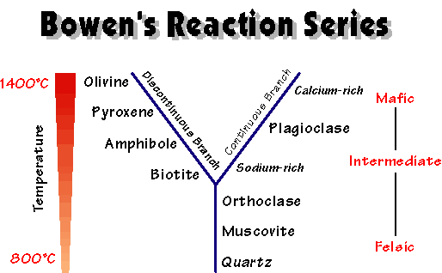

The minerals found in an igneous rock tell you its composition, and provide part of the information you need to identify and name an igneous rock. Mafic rocks contain minerals that form early in Bowen's reaction series: olivine, pyroxene, and calcium-rich plagioclase (usually the darker-colored plagioclase). Felsic rocks contain minerals that form late in Bowen's reaction series: quartz, alkali feldspar, and smaller amounts of sodium-rich plagioclase (usually the white plagioclase), biotite, and muscovite. Intermediate rocks contain minerals that form in the middle of Bowen's reaction series: pyroxene, hornblende, biotite, and a plagioclase feldspar that contains a mixture of calcium and sodium (usually grey in color).

2.1) Examine the rocks labeled A, B, and C. Identify the minerals from Bowen's reaction series in each rock, and determine which rock is mafic, which rock is intermediate, and which rock is felsic. Write the answers in Table 2.1 on your answer sheet.

PART 3: CLASSIFICATION AND NAMING OF IGNEOUS ROCKS

Igneous rocks can be named in one of two ways. Most igneous rocks are named based on a combination of their chemical composition and their grain size, but some volcanic rocks are named solely based on their texture.

Compositional names:
 | Mafic | Intermediate | Felsic
Plutonic rocks | Gabbro | Diorite | Granite
Volcanic rocks | Basalt | Andesite | Rhyolite

Textural names:
With some volcanic rocks, you can't easily determine the composition. They have very distinctive textures, however, which are used to identify them.

Obsidian: volcanic glass. Obsidian is usually black, shiny, and fractures like glass. Pure obsidian does not contain crystals.

Pumice: a volcanic rock that contains many air bubbles (technical name: vesicles).

Tuff: a volcanic rock consisting of fragments of rock blown apart in a volcanic eruption. Tuffs can contain fragments of crystals, volcanic glass, pumice, or broken rock that once surrounded the magma chamber.

3.1 Fill out the Table 3.1 on the answer sheet. For each rock sample, identify as many of the minerals as you can, describe the texture, and name the rock. Each rock name (granite, diorite, gabbro, rhyolite, andesite, basalt, obsidian, pumice, and tuff) will be used exactly once.

For the “texture” column, describe things like the grain size, grain shape, crystalline or clastic texture, presence of bubbles, glassiness, or anything else that does not include identifying minerals.

For the “minerals present” column, list all the minerals that are large enough to see. If the minerals can’t be seen (for instance, in a volcanic glass), leave the mineral space blank.

Use your textbook to find an example of a tectonic setting in which the rock type could be found. (There may be more than one correct answer for this.)

PART 4: INVESTIGATION

Complete the Investigation in section 5.14 (p. 134-135) in your textbook. Put the answers on your answer sheet.

The area below has five sites, labeled A, B, C, D, and E, where igneous activity has been observed. For each site, consider the igneous processes responsible for the activity, such as the type of plate boundary or other feature. Possible choices are listed in Table 1.
Site D: Volcanoes on top of a mountain belt near the edge of the continent. The volcanoes erupt light-colored and gray volcanic rocks. Older intrusive rocks, some with coarse crystals, are also exposed. [Samples 5, 6, and 7]

Site A: A line of volcanic islands and submarine mountains. Broad volcanoes on the islands are forming dark volcanic rocks. [Sample 1]

Site E: A chain of volcanic islands adjacent to an oceanic trench. The volcanoes erupt gray volcanic ash and lava flows. There are also some intrusive rocks. [Samples 8 and 9]

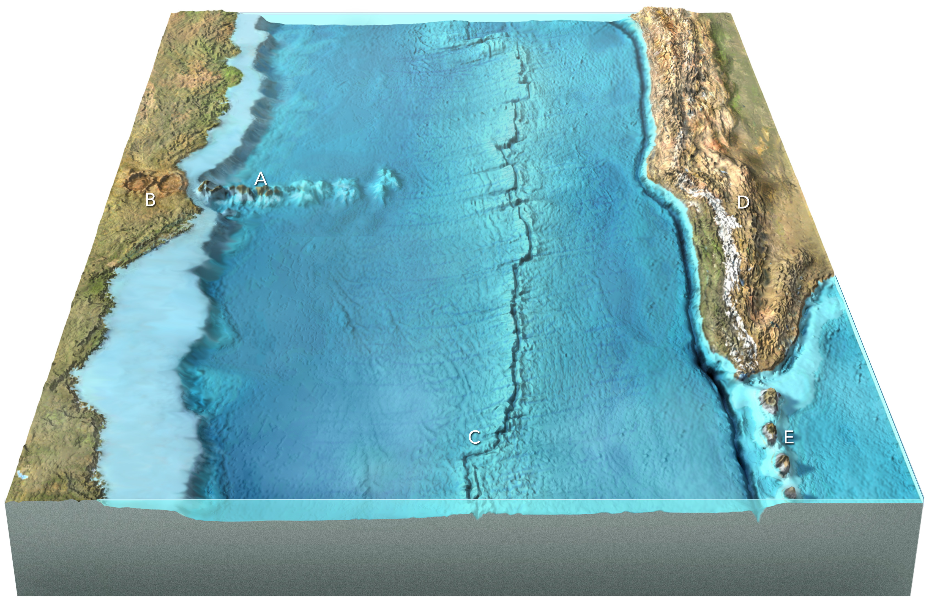
Site E: A chain of volcanic islands adjacent to an oceanic trench. The volcanoes erupt gray volcanic ash and lava flows. There are also some intrusive rocks. [Samples 8 and 9]
Site B: Circular volcanic depressions on land, which are filled with light-colored volcanic ash and light-colored volcanic rocks. [Samples 2 and 3]

Site C: A volcanic ridge that zigzags across the ocean floor. The rock sample is dark colored and is from a lumpy lava flow on the seafloor. [Sample 4]

