BA 352: Online Class Activity 9
General PMBoK Concepts

1. List the five project management process groups, in order. You should memorize these with a mnemonic device, like “I Prefer Eating Mac & Cheese Cold.”

_____________________________________________________________________________________

2. What are the three sides of the PM triangle? ______________________________________________

3. What are the three additional constraints? _______________________

_______________________ and _______________________.

4. What is it called to speed up a project at minimum cost? _____________________________________

5. A project is a _______________ endeavor undertaken to create a ___________________ product, service or result.

6. A ________________________ is a significant point or event in a project.

7. The project __________________ formally authorizes the existence of a project and provides the project manager with the authority to apply organizational resources to project activities.

8. Who would likely get paid more? A project manager, a program manager or a portfolio manager? (Circle your answer.)

9. Fill in the three blanks below. These three terms show up repeatedly for every process throughout the PMBoK.

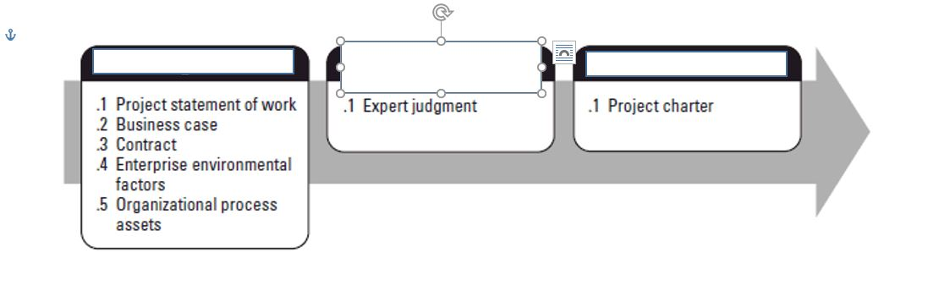

10. Which of the ten knowledge areas best fills in the blanks below (same word)? __________________

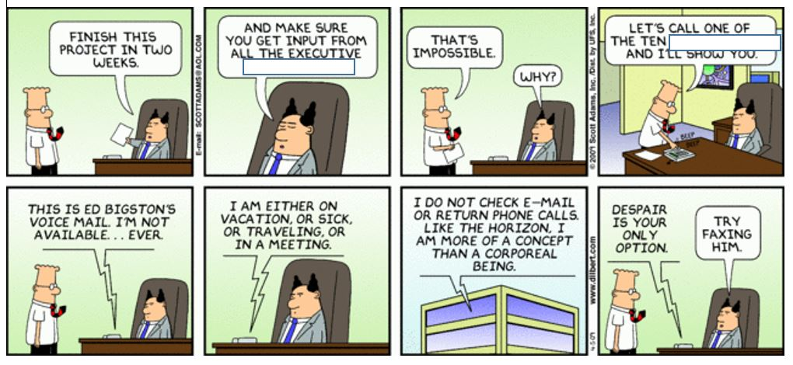

11. Project managers in the software industry tend to use a different style of project management,
______________ (same word), as referred to in the Dilbert cartoon below.

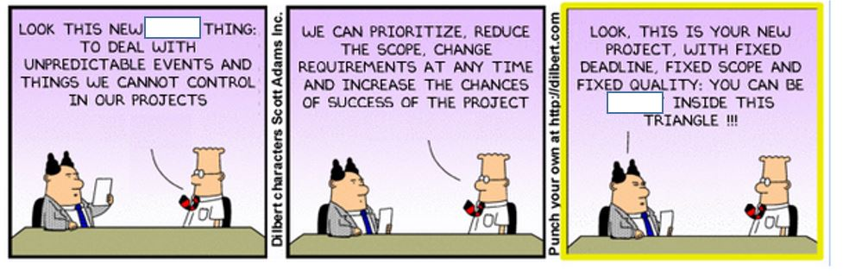

12. Which two of the three sides of the PM triangle best fill in the blanks below? ____________ and ___________.
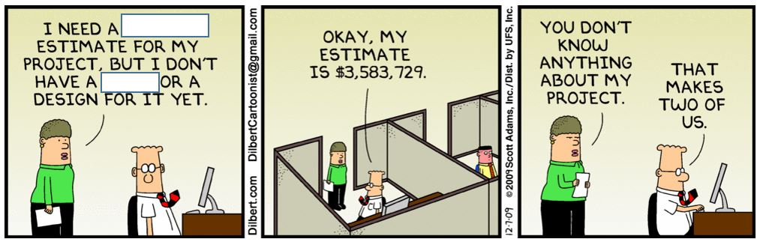
13. Our recent speaker LeRoi Smith talked about becoming a “Product Owner” using the Scrum terminology. In traditional project management terminology, this person might be known as what is represented in the picture on the right. Who is this?

_______________________

14. Develop a mnemonic device to remember the ten knowledge areas. The initials are below in order. There is one I, one Q, one P, two C’s, two R’s and three S’s, maybe that helps? I have come up with one but it stinks, I hope you can do better. The best handful of them will be shared with the class for a vote and the winner will become canon for future classes.

I – S – S – C – Q – R – C – R – P – S.

15. Develop a hilarious meme for a project management concept (or concepts) of your choice. The best ones will be shared with the class; they will be judged by how well the PM concept is integrated into the meme. Google memes or meme generator for a hint. Here’s my attempt – you can’t use this meme or the concept of Agile in yours because I already nailed it. But you can use any other (PG-13 or milder) meme like Baby Yoda, Drake, Woman Yelling at Cat, Change My Mind, Exit 12, Distracted Boyfriend, Success Kid, Bad Luck Brian, etc…

