Name(s) _______________________________________________

BA 353: Take Home Exam 1 Key

1) (10 points) Forecasting: The monthly data for about 160 StoneAge parts over a three-year period are available online. Why don’t we try to forecast just Part 90 for the next period (January of 2018/period 37)? This data is on Row 88 of the spreadsheet from Columns F to AO. a) Forecast period 37 using the Naïve method, Moving Averages with N = 12 (not N =2 as we’ve done in class), Linear Regression and Exponential Smoothing. Program MS Excel to do the calculations for you, don’t try to do this by hand, and round your final answers to one decimal place. Hint: I’ve done the forecast for Naïve for you and it might be a good idea to copy the 36 data points and paste them into a separate sheet vertically using the Transpose function.
Method | FC | MAD
Naïve | 82 | 38
MA(12) | 65 | 29
ES | 62 | 31
LR | 62 | 25
b) Draw a scatter diagram of the data and paste it here. Do you see any obvious patterns? Not really, pretty random…
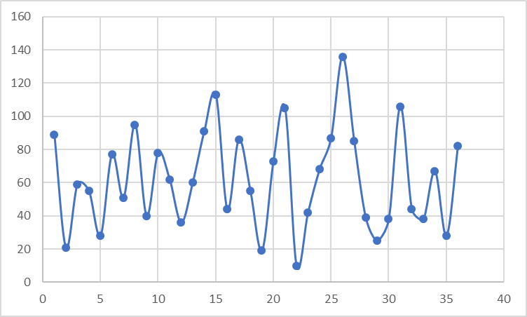

c) According to MAD, which forecast is
the best bet for period 37?

62 ± 25

d) Bayesian Information Criterion, Mean Absolute Percentage Error, Symmetric MAPE, Root Mean Square Error

2) (10 points) Seasonality: a) Sum up the totals for each year and fill in the blanks below. b) Forecast demand for each month and the total for 2013 using linear regression. c) Graph the monthly data and forecasts (preferably with a different marker/color) in chronological order to display the seasonal pattern. d) Determine the slope for each month and fill in the blanks below. According to the slopes, which two months are growing the fastest (at about the same rate)? May and October (due to the popularity of seasonal beers Mexican Logger and Euphoria.)

 | 9 | 10 | 11 | 12 | 13 | Slope
January | $183,481 | $257,782 | $309,313 | $365,117 | $428,033 | $ 59,644
February | $160,674 | $215,592 | $313,726 | $381,677 | $458,203 | $ 76,114
March | $218,095 | $346,604 | $332,353 | $416,746 | $473,875 | $ 58,170
April | $222,372 | $264,723 | $351,315 | $525,876 | $590,348 | $ 99,711
May | $278,188 | $367,369 | $602,500 | $649,204 | $811,360 | $ 134,818
June | $294,763 | $429,907 | $554,599 | $572,670 | $702,588 | $ 95,841
July | $327,825 | $420,999 | $508,422 | $653,534 | $743,833 | $ 106,455
August | $332,121 | $475,822 | $613,860 | $554,901 | $695,771 | $ 80,638
September | $310,011 | $397,577 | $402,091 | $626,399 | $672,439 | $ 95,368
October | $294,756 | $440,234 | $520,636 | $717,822 | $830,762 | $ 134,960
November | $211,514 | $305,238 | $303,034 | $529,011 | $574,771 | $ 95,029
December | $225,591 | $335,135 | $385,686 | $440,188 | $520,235 | $ 69,434
Total | $3,059,390 | $4,256,982 | $5,197,535 | $6,433,145 | $7,502,217 | $ 1,106,182

e) Interpret the slope for the two fastest growing month(s) and interpret the annual slope.

From 2009 to 2012, sales in May and October grew by about $135,000. During the same time, annual growth was over a million dollars per year (at $1.106M/year)!

Extra Credit: Forecast demand for each month in 2013 using the =forecast.ets() function in MS Excel. Good luck!
Extra Credit
513977
495023
570512
536174
713741
682999
697630
727897
681243
694427
579913
600890
