**BA 353: Take Home Exam 1 Key**

|  |  |  |
| --- | --- | --- |
| Method | FC | MAD |
| Naïve | 92 | 36 |
| MA(**12**) | 67 | 23 |
| ES | 78 | 29 |
| LR | 65 | 24 |

**1) (10 points) Forecasting:** The monthly data for about 160 StoneAge parts ([StoneAge Waterblast Tools](https://www.stoneagetools.com/)) over a three-year period are available online. Why don’t we try to forecast just **Part 12** for the next period (January of 2018/period 37)? This data is on Row 14 of the spreadsheet from Columns F to AO. a) Forecast period 37 using the Naïve method, Moving Averages with **N = 12** (*not* *N =2, this is different from other examples we have done*), Exponential Smoothing and Linear Regression. Program MS Excel to do the calculations for you, don’t try to do this by hand, and ***round your final answers to integers***. Hint: I’ve done the forecast for Naïve for you and it might be a good idea to copy the 36 data points and paste them into a separate sheet vertically using the Transpose function.

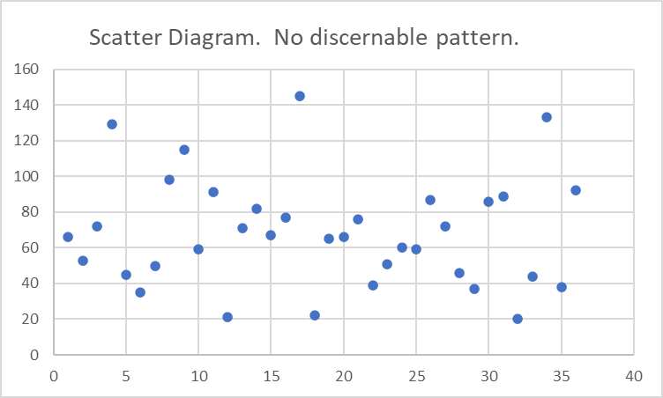b) Draw a scatter diagram of the data and paste it here. Do you see any obvious patterns?

c)Draw a “Sparkline” of the data and insert the cell here. (Sparklines are found under the Insert tab and can be very handy. If you’re on Mac you might not have this option; break down and use a PC if you must to accomplish this.)

d) According to MAD, which forecast is the best bet for period 37? The best forecast is **67** ± 23. The best forecasting *method* is MA(12).

e) At the top in columns AZ, BA, BB, BC and BD, five different measures of error are listed. You know what MAD is, google what the other four abbreviations stand for and list them here.

Bayesian Information Criterion, Mean Absolute Percentage Error, Symmetric MAPE, Root Mean Square Error

**2) (10 points)** **Seasonality:** a**)** Sum up the totals for each year and fill in the blanks below. **b)** Forecast demand for each month and the total for 2013 using linear regression. What is your best estimate for total sales in 2013? Best guess for total sales is $7.732M. **c)** Graph the monthly data *and* forecasts (preferably in a different color) in **chronological order** to display the seasonal pattern. Insert the graph here. **d)** Determine the slope for each month and fill in the blanks below. According to the slopes, which **two** months are growing the fastest (at about the same rate)? May and October (due to seasonal brews Mexican Logger and Euphoria Pale Ale it turns out.) **e)** Interpret the slope for the two fastest growing month(s) **and** interpret the annual slope. May and October are growing by $135k per year and the annual growth is about $1.1M per year!

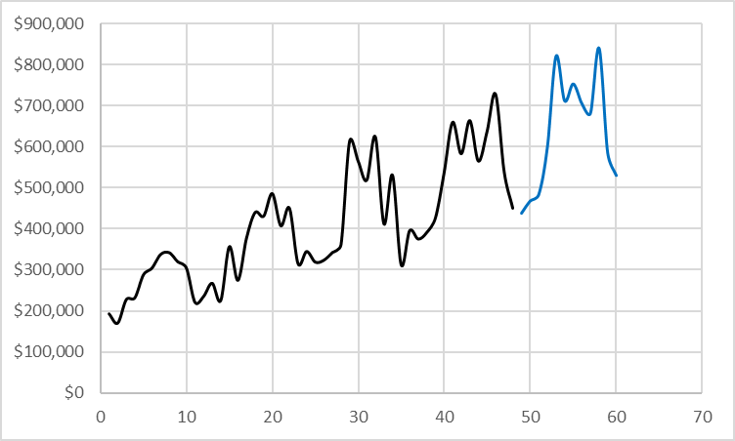

|  |  |  |  |  |  |  |
| --- | --- | --- | --- | --- | --- | --- |
|  | **9** | **10** | **11** | **12** | **13** | **Slope** |
| **January** | $203,481 | $277,782 | $329,313 | $385,117 | **$448,033** | 59644 |
| **February** | $180,674 | $235,592 | $333,726 | $401,677 | **$478,203** | 76114 |
| **March** | $238,095 | $366,604 | $352,353 | $436,746 | **$493,875** | 58170 |
| **April** | $242,372 | $284,723 | $371,315 | $545,876 | **$610,348** | 99711 |
| **May** | $298,188 | $387,369 | $622,500 | $669,204 | **$831,360** | 134818 |
| **June** | $314,763 | $449,907 | $574,599 | $592,670 | **$722,588** | 95841 |
| **July** | $347,825 | $440,999 | $528,422 | $673,534 | **$763,833** | 106455 |
| **August** | $352,121 | $495,822 | $633,860 | $574,901 | **$715,771** | 80638 |
| **September** | $330,011 | $417,577 | $422,091 | $646,399 | **$692,439** | 95368 |
| **October** | $314,756 | $460,234 | $540,636 | $737,822 | **$850,762** | 134960 |
| **November** | $231,514 | $325,238 | $323,034 | $549,011 | **$594,771** | 95029 |
| **December** | $235,591 | $345,135 | $395,686 | $450,188 | **$530,235** | 69434 |
| **Total** | $3,289,390 | $4,486,982 | $5,427,535 | $6,663,145 | **$7,732,217** | 1106182 |

**Extra Credit:** Forecast demand for each month in 2013 *using all the data simultaneously* with the =forecast.ets() function in MS Excel. Good luck!

|  |  |
| --- | --- |
| 49 | 533977 |
| 50 | 515023 |
| 51 | 590512 |
| 52 | 556174 |
| 53 | 733741 |
| 54 | 702999 |
| 55 | 717630 |
| 56 | 747897 |
| 57 | 701243 |
| 58 | 714427 |
| 59 | 599913 |
| 60 | 610890 |