BA 353: ICE 3 Answer Key

ICE 3

1) Naïve 300 ± 27, MA 290 ± 24, ES 288 ± 24, LR 286 ± 18. (LR has lowest MAD, best forecast?)

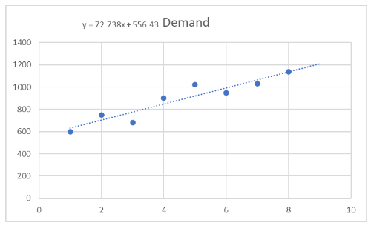
2a), 2b) r = 0.94, good fit, very linear, 2c) y = 73x + 557, 2d) historically, demand has been increasing by about 73 per month, 2e) 1211 ± 51.

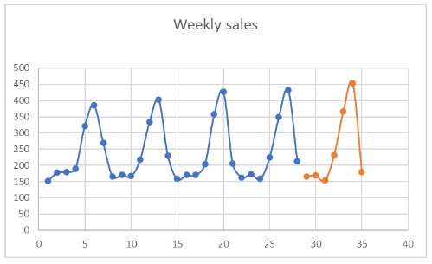
3b) Slopes are 2.5, -1.2, -6.3, 9, 10.8, 16.6, -19.8 and 11.6 for the total, 3c) 58%, 3d) Saturday, 3e) Sunday, 3f) varies.

