BA 353: ICE 5 – Medium LPs

Set up and solve the two medium-sized LPs from the online chapter below. Work in teams if possible, these can be tricky to do on your own. Good luck!

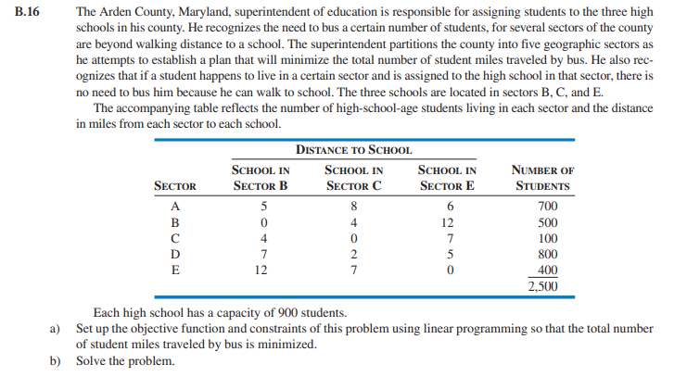

Hints: Call the three schools 1, 2 and 3. Variable A1 then means how many students from neighborhood A go to school 1 (which happens to be in neighborhood B); A2 is students from A that go to 2 etc. all the way to variable E3. Fifteen variables! Eight constraints.

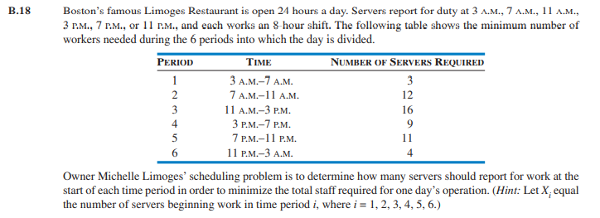

Hints: Six variables and six constraints. Don’t ignore hint above – each variable is how many servers start at a given time, not how many are working at that time.

