Case 4 Answer Key

a) No students from WV. b)
State | Count | Percentage
CO | 1712 | 48%
NM | 485 | 14%
AZ | 292 | 8%
CA | 152 | 4%
AK | 110 | 3%
OK | 106 | 3%
TX | 101 | 3%
IL | 59 | 2%
UT | 36 | 1%
IA | 34 | 1%
Ranges | Students in Range | Percentage of Total
0 | 297 | 8.4%
10 | 105 | 3.0%
25 | 240 | 6.8%
50 | 93 | 2.6%
100 | 1513 | 42.6%
250 | 311 | 8.8%
500 | 565 | 15.9%
1000 | 336 | 9.5%

c) Answers vary. d)
Distance | Count | Percent
0-50 | 642 | 18%
50-100 | 93 | 3%
100-150 | 305 | 9%
150-200 | 335 | 9%
200-250 | 873 | 25%
250-300 | 141 | 4%
300-350 | 85 | 2%
350-400 | 58 | 2%
400-450 | 14 | 0%
450-500 | 13 | 0%
500-550 | 10 | 0%
550-600 | 63 | 2%
600-650 | 92 | 3%
650-700 | 112 | 3%
700-750 | 64 | 2%
750-800 | 67 | 2%
800-850 | 29 | 1%
850-900 | 24 | 1%
900-950 | 76 | 2%
950-1000 | 28 | 1%

e)
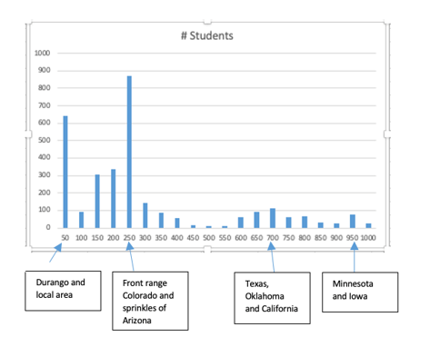

f) 