**BA 352: Earned Value Management (EVM)**

Earned Value Management (EVM) is a methodology to determine if a project is on schedule and on budget. It’s also referred to as Earned Value Analysis (EVA). In EVM, we look at how far along a project is at a certain point of the project, maybe halfway through, and see how our cost and work completed compare to what they were planned to be.

There are multiple acronyms to learn here, but they are all related and with a little practice you can get them down. Specifically, we are looking at the PMBoK, Section 7.4.2.2 from pages 261 – 267. The table on page 267, included below, lists all the terms and definitions. In some cases, there are multiple definitions, we’ll only consider the first one. You have seen some of these terms on the Mock CAPM exams that you have taken.

**BAC** = Budget at Completion = Planned total cost of the project.

**PV** = Planned Value = The value of work expected to be completed at a given time.

**EV** = Earned Value = How much actual work has been completed at a given time.

**AC** = Actual Cost = Actual cost of completing the work done so far.

**CV** = Cost Variance = EV – AC = The difference between how much value has been created and what it cost to create it. Positive CPI is good, negative CPI is bad.

**SV** = Schedule Variance = EV – PV. The difference between how much work you have completed versus how much you expected to complete.

**CPI** = Cost Performance Index = EV/AC. A measure of cost performance efficiency. If CPI > 1, the project is costing less than expected. If CPI < 1, it is costing more than expected.

**SPI** = Schedule Performance Index = EV/PV. A measure of schedule performance efficiency. If SPI > 1, you are ahead of schedule. If SPI < 1, you are behind schedule.

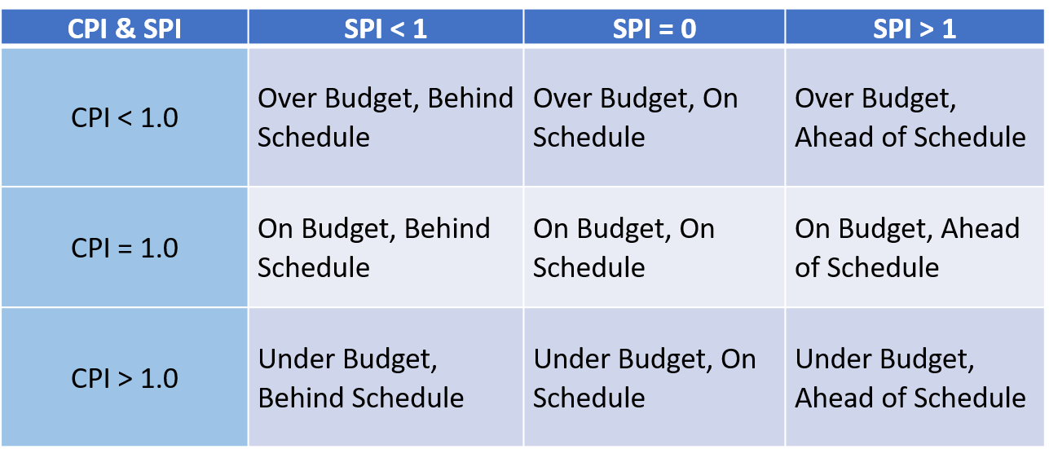

**EAC** = Estimate at Completion = BAC/CPI = An updated estimate of what the project will cost.

**ETC** = Estimate to Complete = EAC – AC = How much more it’s going to cost to get the project done.

This video gives a decent explanation of some of these terms.

<https://www.youtube.com/watch?v=sAZZ5av9kk0>

*Example:*

*A million dollar project is planned to be done in 16 months. After 8 months, the data is:*

*AC = $580,000*

*PV =*

*EV = $430,000*

*a) What are the BAC and what do the three items above mean?*

*b) Calculate and interpret the remaining EVM statistics.*

**BAC** = $1M. This is the overall budget for the project.

So, we are halfway through this project, 8 months/16 months. Where are we in terms of how much we’ve spent and how much work we’ve completed?

**PV** = $1M*(8/16) = $500,000. Assuming the project moves linearly (not great, but OK assumption), halfway through the project, if things are going according to plans, we should have completed $500,000 worth of work at a cost of $500,000.

**But this is not the case** with AC = $580,000 and EV = $430,000. In fact, at this point, the project is in trouble. It has actually cost us $580,000 to only complete $430,000 worth of work. We have spent more than expected (AC > PV > EV) and completed less work than expected (EV < PV).

**CV** = EV - AC = $430,000 - $580,000 = -$150,000 < 0 means we are over budget. We have spend $580k to do $430k worth of work, not good.

**SV** = EV – PV = $430,000 - $500,000 = -$70,000 < 0 means we are behind schedule. We should have half of the value of the project completed by now but only have 43% of it done.

CPI and SPI are similar to CV and SV.

**CPI** = EV/AC = $430k/$580k = 0.74 = 74%. CPI = 0.74 < 1 means we are over budget. The 74% means we are only 74% efficient on cost – we are only getting $0.74 worth of value for every dollar we spend.

**SPI** = EV/PV = $430k/$500k = 0.86 = 86%. SPI = 0.86 < 1 means we are behind schedule. We are supposed to have $500k worth of work done at this point, but only have $430k completed. The 86% means we are only 86% efficient with our time – every day we work we only complete 86% of what we are supposed to do.

Basically, we are not doing very well with this project, being both over budget and behind schedule at this point. So, what is our updated overall budget and how much more are we going to spend if things continue at this rate?

**EAC** = BAC/CPI = $1M/0.74 = $1.35M. If we continue to be inefficient on cost (74%), the final cost for this project will be $1.35M, $350,000 over the original budget of $1M.

**ETC** = EAC – AC = $1.35M - $580k = $770,000. At the present inefficiency, we will have to spend $770k more to finish the project.

Hopefully this gives you an idea of how to do the EVM calculations and what they mean. In short, we have a plan for the project called BAC. We consider how the project is doing part way through and determine the PV. We compare the PV to EV, how much work we’ve actually completed, and AC, what it has actually cost.

We calculate CV and CPI to determine if we are over or under budget and we calculate SV and SPI to determine if we are ahead of schedule or behind schedule.

