(1 point) BA 353: Excel Forecasting Features Extra Credit (Due on Friday 10/8/21 by 5pm)

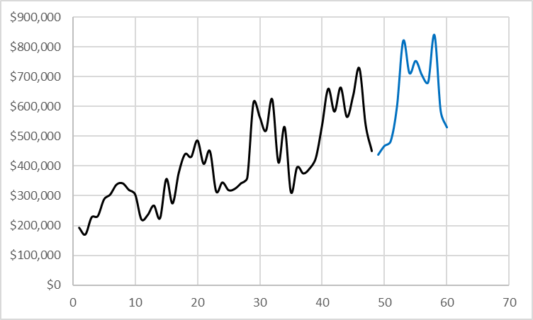
On problem 2c) of Take Home Exam 1, you included a graph of Ska’s seasonal data patterns after graphing the data in chronological order and it looked like this There are easier ways to do this, see below…

0) Stack the 48 months of Ska data in one column in chronological order. (You should have already done this on THE1, use it if you got it). Just the data this time, don’t worry about the forecasted values.

1) In Excel, create a Line “Sparkline” of this data. You can find “Sparklines” under the Insert tab. What does this (cool?) feature do? Copy the single cell you created and paste it below. You might have to Paste Special as a Picture to make it show up correctly.

2) Add the months 1 through 48 to the left of your data column. Create a “Forecast Sheet” of this data. You can find it under the Data tab. What does this (cool?) feature do? Copy and paste the graph this feature creates below.

