Seven Page (double-sided) PMBoK Cheat Sheet

|  |  |  |  |  |  |
| --- | --- | --- | --- | --- | --- |
|  | **A** | **B** | **C** | **D** | **E** |
| **1** | 23 | 4 |  |  |  |
| **2** | 15 | 4 | 8 | 1 |  |
| **3** | 1 | 3 | 23 |  |  |
| **4** | 11 | 6 | 7 | 3 |  |
| **5** | 22 | 4 | 1 |  |  |
| **6** | 4 | 10 | 6 | 3 | 5 |
| **7** | 17 | 10 |  |  |  |
| **8** | 12 | 14 |  |  |  |
| **9** | 8 | 6 | 13 |  |  |
| **10** | 13 | 13 |  |  |  |
| **11** | 4 | 10 | 13 |  |  |
| **12** | 26 | 1 |  |  |  |
| **13** | 7 | 18 |  | 2 |  |

**Chapter 1**

**A project** is a **temporary endeavor** undertakento create a **unique product, service, or result.**

**Project charter- a document issued** by the **project sponsor** that **formally authorizes** the **existence of a project** and **provides the project manager** with the **authority to apply** **resources** to **project activities.**

**A Project team** needs to be able to assess the **project situation**, **balance the demands,** and **maintain proactive communication** with **stakeholders** in order to **deliver a successful project.**

**Ten Knowledge Areas:**

1.Project **Integration** Management

2. Project **Scope** Management

**Process Groups are not the same thing as a project life cycle. A life cycle shows how the project moves from start to finish in different phases. Within one phase you might go through all the Process Groups, or just some of them.**

3. Project **Schedule** Management

4.Project **Cost** Management

5. Project **Quality** Management

6. Project **Resource** Management

7. Project **Communications** Management

8. Project **Risk** Management

9. Project **Procurement** Management

10. Project **Stakeholder** Management.

**5 PROCESS GROUPS:**

**Initiating, Planning, Executing, Monitoring, Control, and Closing**

**(“I Prefer Eating Mac and Cheese Cold”)**

Chapter 2

**Enterprise environmental factors (EEFs)** **refer to conditions, not under the control of the project team, that influence, constrain, or direct the project.**

**Organizations -systematic arrangements of entities (persons and/or departments) aimed at accomplishing a purpose, which may involve undertaking projects**

## **Organizational Structure-an enterprise environmental factor, which can affect the availability of resources and influence how projects are conducted**

## **Classic Functional Organization-a hierarchy where each employee has one clear superior**

## **Matrix Organizations- reflect a blend of functional and projectized characteristics.**

### **Stakeholder-an individual, group or organization who may affect, by affected by or perceive itself to be affected by a decision, activity or outcome of a project. Examples include: Sponsors / Customers and users / Sellers / Business partners / Organizational groups / Functional managers**

## **Project Governance-the alignment of the project with stakeholders' needs or objectives - is critical to the successful management of stakeholder engagement and the achievement of organizational objectives**

**LIFE CYCLES:**

**Project Life Cycle-the series of phases that a project passes through from its initiation to its closure**

## **Predictive Life Cycle-the product and deliverables are defined at the beginning of the project and any changes to scope are carefully managed**

## **Adaptive Life Cycle- the product is developed over multiple iterations and detailed scope is defined for each iteration only as the iteration begins**

Chapter 12

**Definitions for some vocabulary were obtained from. <https://www.brainscape.com/flashcards/pmbok-chapter-2-organizational-influence-3197968/packs/4823902>

**Chapter 3 – PROJECT MANAGER** (Page 51-68)

Definition of a project manager:

The project manager is the person assigned by the performing organization to lead the team that is responsible for achieving the project objectives.

The project manager leads the project team to meet the project’s objectives and stakeholders’ expectations. The project manager works to balance the competing constraints on the project with the resources available.

What a project manager does:

* Consulting with executive and business unit leaders on ideas for advancing strategic objectives
* A close up of text on a black background

  Description automatically generatedImproving organizational performance
* Meeting customer needs
* Manage or assist in business analysis

The three talents that project manager must have.

* Business case development

Should possess these skills:

* Project management knowledge
* Technical knowledge
* Understanding
* Experience
* Leadership
* Planning
* Coordination through communications

The project manager proactively interacts with other project managers.

How projects can impact other projects:

* Demands on the same resources
* Priorities of funding
* Receipt or distribution of deliverables
* Alignment of project goals and objectives with those of the organization

Trends project managers look for:

* Product and technology development
* New and changing market

To be a project manager you need to be a leader.

* Standards in managements
* Technical support tools
* Economic forces that impact the project
* Influences affecting project management discipline
* Process improvement and sustainability strategies

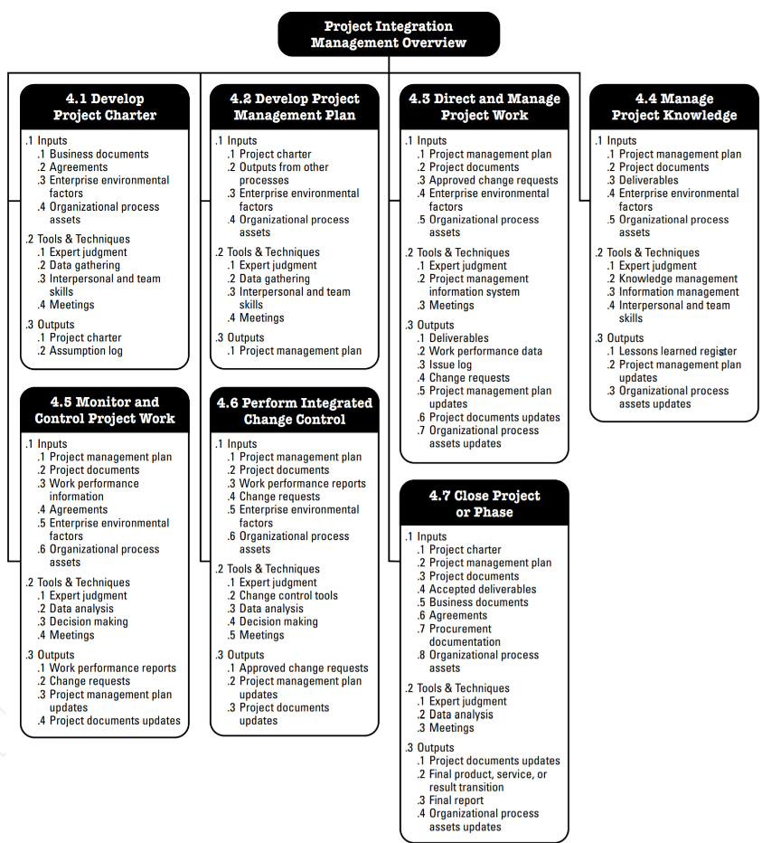

Chapter 4 Cheat Sheet

Project Integration Management is about: Ensuring plan is aligned, providing a plan to achieve the objectives, ensuring the appropriate knowledge, managing the performance and changes, making integrated decisions, measuring and monitoring the project’s progress, collecting data on the results achieved, completing all the work, and managing phasing transitions when necessary.

**4.1 Develop Project Charter**—The process of developing a document that formally authorizes the existence of a project and provides the project manager with the authority to apply organizational resources to project activities.

**4.2 Develop Project Management Plan**—The process of defining, preparing, and coordinating all plan components and consolidating them into an integrated project management plan.

**4.3 Direct and Manage Project Work**—The process of leading and performing the work defined in the project management plan and implementing approved changes to achieve the project’s objectives.

**4.4 Manage Project Knowledge**—The process of using existing knowledge and creating new knowledge to achieve the project’s objectives and contribute to organizational learning.

**4.5 Monitor and Control Project Work**—The process of tracking, reviewing, and reporting overall progress to meet the performance objectives defined in the project management plan.

**4.6 Perform Integrated Change Control**—The process of reviewing all change requests; approving changes and managing changes to deliverables, organizational process assets, project documents, and the project management plan; and communicating the decisions.

**4.7 Close Project or Phase**—The process of finalizing all activities for the project, phase, or contract.

**Chapter 5 - Project Scope Management**

**5.2 Collect Requirements-** determining what stakeholders want from the project; documenting requirements and managing stakeholder expectations

**Inputs:** project charter, project management plan, project and business documents, agreements, enterprise environmental factors, organizational process assets

**Tools&Techniques:** expert judgement, data gathering, analysis & representation, decision making, personal and team skills, context diagram, prototypes

**Outputs:** documented set of requirements

**5.3 Define Scope –** taking your requirements and transforming them into the project you are going to take on

**Inputs:** project charter, project management plan, project documents, enterprise environmental factors, organizational process assets

**Tools&Techniques:** expert judgement, data analysis, decision making, personal and team skills, product analysis

**Outputs:** project scope statement that you can refer to throughout the project

**5.6 Control Scope–** making sure, if there’s a need to change scope, that there is an effective change control

**Inputs:** project management plan, project documents, work performance, organizational process assets

**Tools&Techniques:** data analysis

**Outputs:** scope baseline is maintained throughout project, work performance info, change requests, project management plan updates, project document updates, requirements traceability matrix

**5.4 Create Work Breakdown Structure–** turning requirements into an organized vision of what needs to be done

**Inputs:** project management plan, project documents, enterprise environmental factors, organizational process assets

**Tools&Techniques:** expert judgement, decomposition

**Outputs:** scope baseline, project documents updates, smaller, well-defined tasks

**5.1 Plan Scope Management -** determines how scope is defined, developed, monitored, controlled, and validated

**Inputs:** project charter, project management plan, enterprise environmental factors, organizational process assets

**Tools&Techniques:** expert judgement, data analysis, meetings

**Outputs:** provides direction and guidance on how scope will be managed throughout the completion of the project

**5.5 Validate Scope–** process of formalizing acceptance of completed project deliverables

**Inputs:** project management plan, project documents, verified deliverables, work performance data

**Tools&Techniques:** inspection, decision making

**Outputs:** sign-off of project deliverables, work performance information, change requests, requirements traceability matrix

Chapter 6 Outline

Project Schedule Management

Overview

Project Schedule Management includes the processes required to manage the timely completion of the project.

The Project Schedule Management processes are:

**6.1** **Plan Schedule Management**: The process of establishing the policies, procedures, and documentation for planning, developing, managing, executing, and controlling the project schedule.

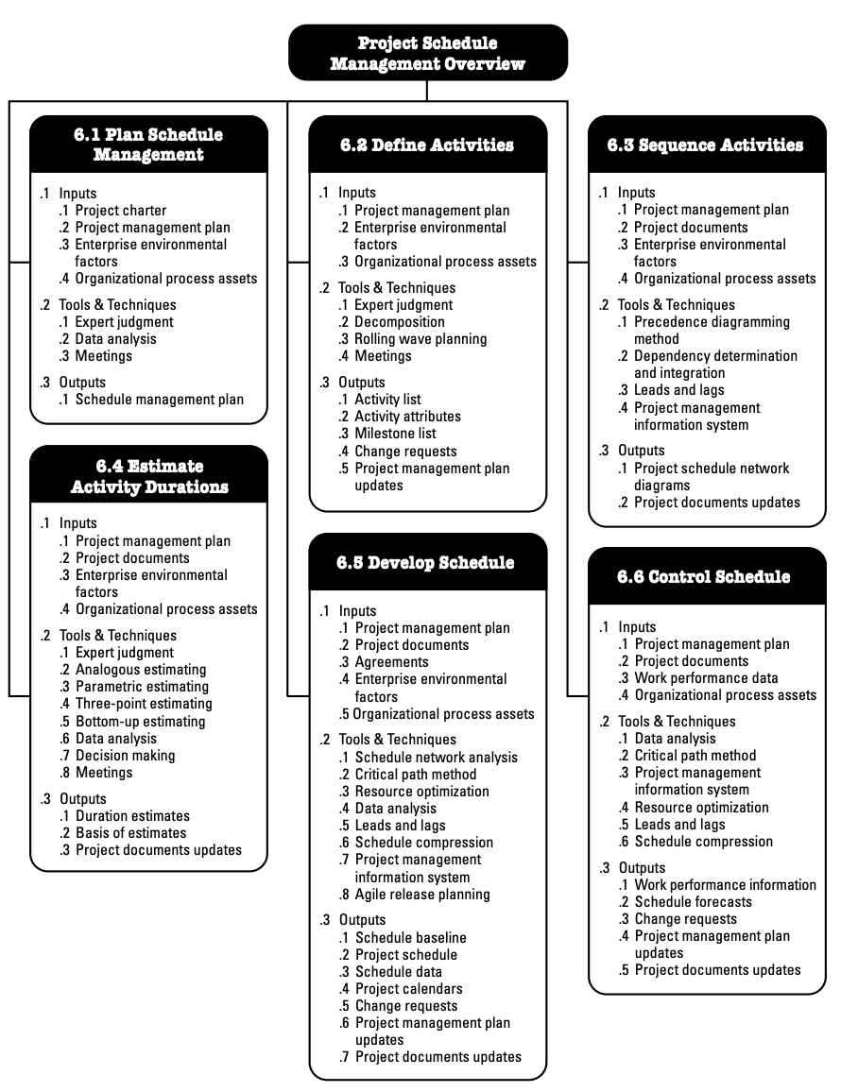

**6.2** **Define Activities**: The process of identifying and documenting the specific actions to be performed to produce the project deliverables.

**6.3** **Sequence Activities**: The process of identifying and documenting relationships among the project activities.

**6.4** **Estimate Activity Durations**: The process of estimating the number of work periods needed to complete individual activities with the estimated resources.

**6.5** **Develop Schedule**: The process of analyzing activity sequences, durations, resource requirements, and schedule constraints to create the project schedule model for project execution and monitoring and controlling.

**6.6** **Control Schedule:** The process of monitoring the status of the project to update the project schedule and manage changes to the schedule baseline.

PMBOK Chapter 7,

**PROJECT COST MANAGEMENT:**

Project Cost Management includes the processes involved in planning, estimating, budgeting, financing, funding, managing, and controlling costs so that the project can be completed within the approved budget. The Project Cost Management processes are: plan cost management, estimate costs, determine budget, and control costs.

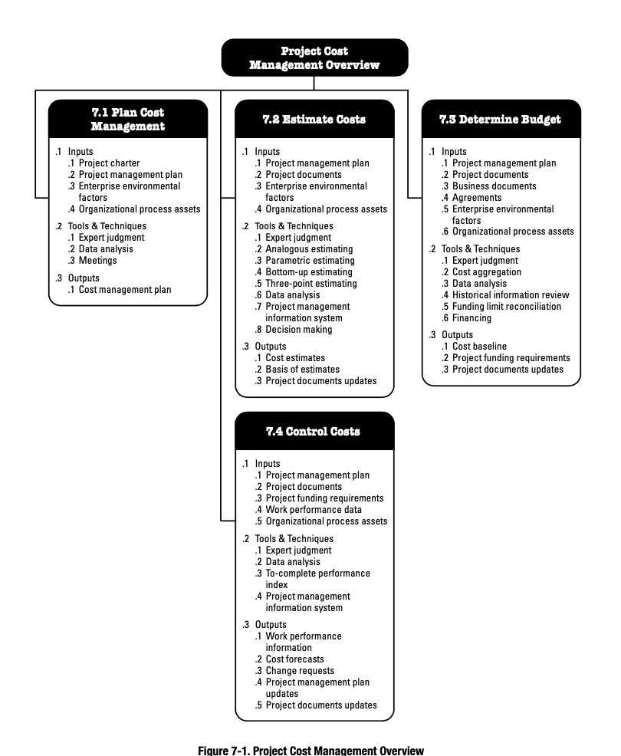 **TAILORING CONSIDERATIONS:**

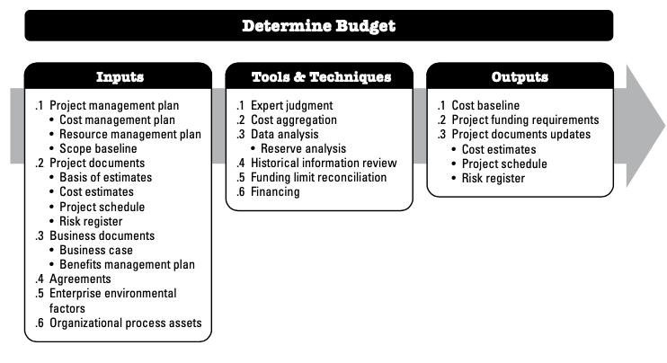Because each project is unique, the project manager may need to tailor the way Project Cost Management processes are applied. Considerations for tailoring include but are not limited to: Knowledge management, estimating and budgeting, earned value management, use of agile approach, and governance. Determine Budget is the process of aggregating the estimated costs of individual activities or work packages to establish an authorized cost baseline. The key benefit of this process is that it determines the cost baseline against which project performance can be monitored and controlled.

**HISTORICAL INFORMATION REVIEW:**

Reviewing historical information can assist in developing parametric estimates or analogous estimates. Historical information may include project characteristics (parameters) to develop mathematical models to predict total project costs. *All info came from PMBoK 6th edition.

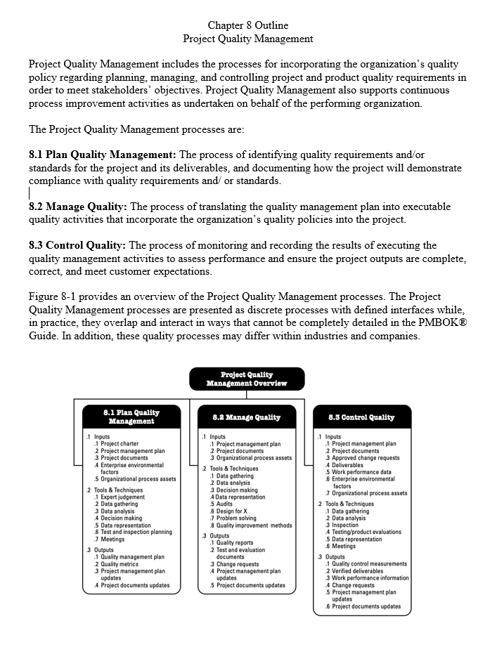

**Chapter 9: PLAN RESOURCE MANAGEMENT**

The Resource Management Plan is to organize and lead the project team as well as other resources including roles and responsibilities documented (ownership of deliverables) in RAM in the form of RACI chart (matrix) or in a chart/text form, org charts – an organizational breakdown structure (OBS) and staffing management plan

* Data Representation techniques:
  + Hierarchical-type charts – (Work, organizational & resource break down structures, RACI chart)
  + Assignment matrix & Text-oriented formats

What is a RACI chart / RACI matrix or RACI graph? - Responsible Accountable Consulted Informed

* The RACI chart is a tool for tracking the tools for tracking the roles and responsibilities of project members for specific project tasks during project execution.

### Estimate Activity Resources

closely related to Estimate Cost Process (in Project Cost Management knowledge area)

Data Analysis includes:

* + Various levels of resource capability or skills, Different sizes or types of machines, Different tools (manual versus automated), and Make-rent-or-buy decisions
* matches human resources to activities (as human resources will affect duration)
* effort (man day, work week, etc.) vs duration vs time lapsed (total time needed, including holidays, time off)
* Resource Requirements - details the types and amounts of resources required for each activity in a work package.
* The basis of estimates include methods, assumptions, constraints, the range of estimates, confidence levels, risks, etc.

**Acquire Resources**

* Management Plan Updates, Project Documents Updates, EEF Updates, OPA Updates
* to acquire team members/facilities/equipment/materials and other resources necessary to complete the project work
* pre-assignment is the selection of certain team members/resources in advance
* Physical Resource Assignments - physical resource assignments including material, equipment, supplies, locations
* Project Team Assignments - documents team assignments - who members are and their roles and responsibilities
* Resource Calendars - identifies the working days/shifts/holidays for each resource included in the assignment

**Develop Team**

* enhancing and improving overall team performance
* offer feedback, support, engage team members, manage conflicts, facilitate cooperation
* Colocation is considered the most effective and productive, should be arranged if allowed
* training cost can be set within the project budget or supported by the organization
* Communication Technology includes: Shared portal, Video conferencing , Audio conferencing, Email/chat
* Assessments: Attitudinal surveys , Specific assessments , Structured interviews, Ability tests and Focus groups
* Motivational Theories - Maslow’s Hierarchy of Needs,  Herzberg’s Hygiene Theory, Expectancy Theory, Achievement Theory, Contingency Theory, Leadership Theory and Theories XY & Z

**Manage Team**

* in the executing process group
* track team member performance, provide feedback, resolve issues and manage team changes
* when managed properly, differences of opinion can lead to increased creativity and better decision making
* conflicts: schedule, project priority, resources, technical opinions, administrative overhead cost, personality
* Interpersonal and Team Skills
* monitoring and controlling of the performance of the staff assigned is typically performed by functional managers/HR for functional org

**Control Resources**

* in the monitoring and controlling process group
* ensure that the physical resources assigned to the project are available as planned
* monitor the planned versus actual utilization of resources and take corrective action with changes requests (if needed)
* Data Analysis - Alternatives analysis, Cost-benefit analysis, Performance reviews, Trend analysis
* Problem-solving steps: Identify the problem, Define the problem, Investigate, Analyze, Solve, Check the solution

Chapter 10:

**PROJECT COMMUNICATIONS MANAGEMENT:**

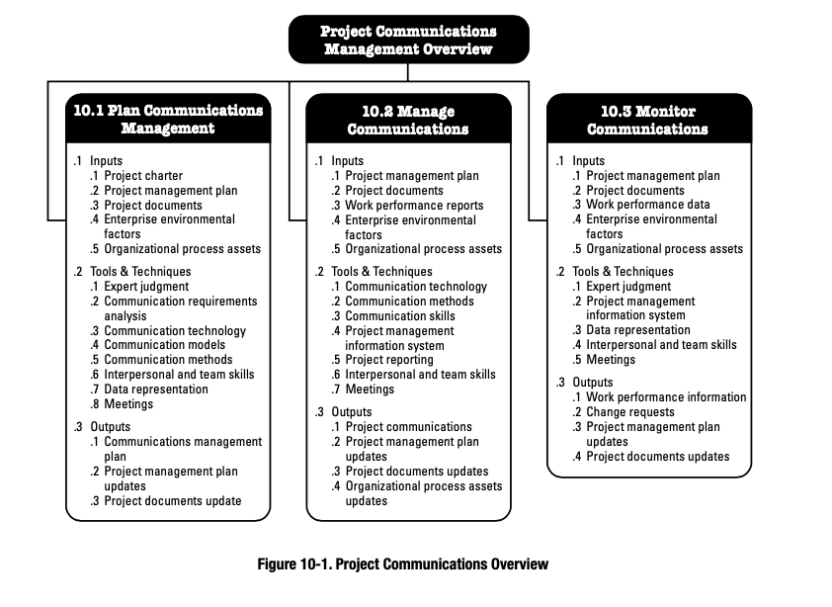Project Communications Management includes the processes necessary to ensure that the information needs of the project and its stakeholders are met through development of artifacts and implementation of activities designed to achieve effective information exchange. Project Communications Management consists of two parts. The first part is developing a strategy to ensure communication is effective for stakeholders. The second part is carrying out the activities necessary to implement the communication strategy. The project communications management processes are plan communications management, manage communications, and monitor communications

**PLAN COMMUNICATIONS MANAGEMENT:**

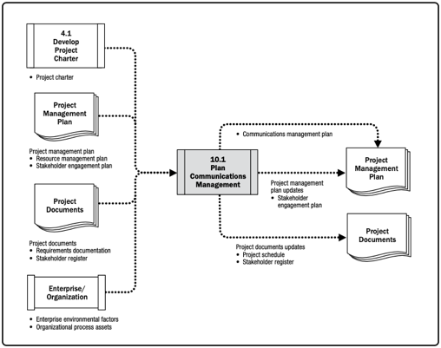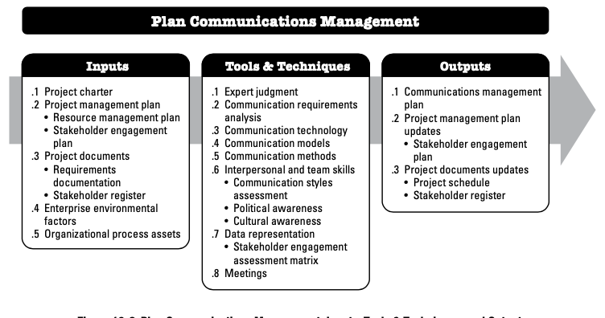Plan Communications Management is the process of developing an appropriate approach and plan for project communications activities based on the information needs of each stakeholder or group, available organizational assets, and the needs of the project. The key benefit of this process is a documented approach to effectively and efficiently engage stakeholders by presenting relevant information in a timely manner.

PMBok Chapter 11 Project Risk Management Cheat Sheet

* Project risk- An uncertain event or condition, that if it occurs, has a positive or negative effect on the project's objectives
* Risk Acceptance- The Project Team decides not to change the project management plan to deal with the risk, or is unable to identify any other suitable response.
* Risk Avoidance- Creates changes to the project management plan to either eliminate the risk or to protect the project objectives from its impact.
* Risk Management Plan- Describes how the project risk management will be structured and performed
* Risk Mitigation- Plan to reduce the probability of occurrence or impact of a risk to below an acceptable level
* Risk Register- Contains the results of the qualitative and quantitative risk analysis, along with the risk response planning
* Risk Tolerance- The degree, amount or volume of risk that a project team can tolerate
* Risk Triggers- Risk symptoms or warning signs that risk has or is about to occur.
* Variability risk- Uncertainty exists about some key characteristics of a planned event or activity or decision.
* Ambiguity risk-Uncertainty exists about what might happen in the future. Areas of the project where imperfect knowledge might affect the project’s ability to achieve its objectives include: elements of the requirement or technical solution, future developments in regulatory frameworks, or inherent systemic complexity in the project.

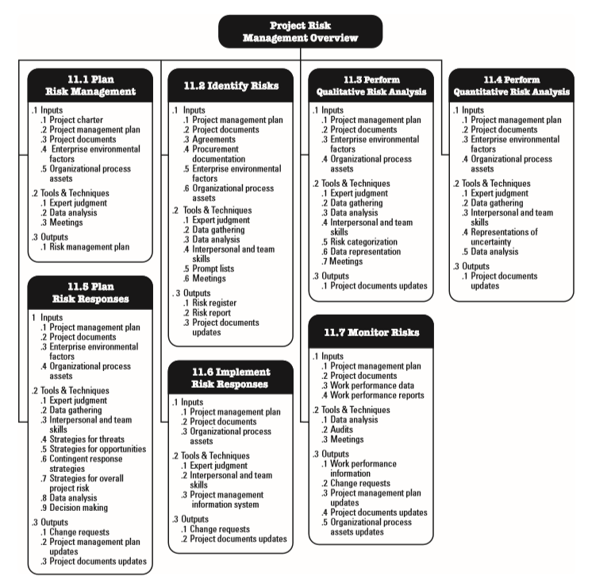

Chapter 12

**Plan Procurement Management** is the **process of documenting** project procurement decisions, **specifying the approach** and **identifying potential sellers**.

The **key benefit** of this process is that it **determines whether to acquire goods and services from outside the project** and, if so, what to acquire as well as how and when to acquire it.

**Conducting Procurements include** -**obtaining** seller responses, **selecting** a seller and **awarding a** contract.

**CONTRACTS**

* **Fixed Price Contract-**Places most risk on seller
* **Cost Plus Contract**-Places most risk on buyer
* **Firm fixed price contract**-Most common contract. Price of goods is set at outset and not subject to change without work scope change

**Early Termination of a contract**

* Mutual agreement
* Default of one party
* Convenience of buyer if provided for in contract

**Legally valid contract**

1.. Agreement  
2. Consideration  
3. Legal capacity  
4. Legal purpose

**OVERVIEW:**

**Project procurement management** involves acquiring goods and services for a project from outside the performing organization.

Processes include: Plan procurement management • Conduct procurements • Control procurements • Close procurements Information • Technology Project Management.

**PROJECT MANAGEMENT PLAN UPDATES** : **Any change to the project management plan goes through the organization’s change control process via a change request.**

Chapter 13



**13.1—Identify Stakeholder:**

The process of identifying project stakeholders regularly and analyzing and documenting relevant information regarding their interests, involvement, interdependencies, influence, and potential impact on project success. Key Benefit: It enables the project team to identify the appropriate focus for engagement of each stakeholder or group of stakeholders.

**13.2—Plan Stakeholder Engagement:**

The process of developing approaches to involve project stakeholders based on their needs, expectations, interests, and potential impact on the project. Key Benefit: It provides an actionable plan to interact effectively with stakeholders.

**13.3—Manage Stakeholder Engagement:**

The process of communicating and working with stakeholders to meet their needs and expectations, address issues, and foster appropriate stakeholder involvement. Key Benefit: It allows the project manager to increase support and minimize resistance from stakeholders.

**13.4—Monitor Stakeholder Engagement:**

The process of monitoring project stakeholder relationships and tailoring strategies for engaging stakeholders through modification of engagement strategies and plans. Key Benefit: It maintains or increases the efficiency and effectiveness of stakeholder engagement activities as the project evolves and its environment changes.