Technical Requirements to Solve an LP with Excel

Before you try to solve an LP with Excel, you need to do two things. First, you need to download MS Excel onto your device. The online version of Excel and Google Sheets will not work. (I’m not kidding. Some students always try to use Google Sheets and waste a lot of time.) Second, you need to make sure that you have the Solver function installed on Excel.
- To get Excel for your device, go to www.office.com, enter your Fort Lewis credentials into CAS, then click the Install Office button.
- You will need the Solver function to proceed. It normally sits here in Excel but you may not have it yet. Under the data tab, it should be on the right.

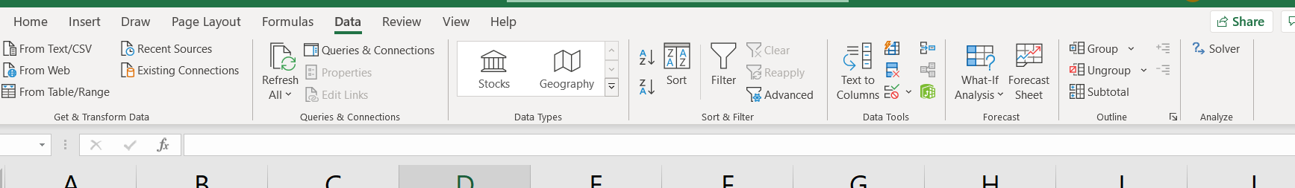

- If you don’t have Solver, then install it.
  - On a PC, open Excel, click the file tab on the far left then the Options choice at the very bottom. Click Add Ins on the left, then Go on the bottom. Check the box for Solver and you should be good to go.
  - On a Mac, it’s even easier. Open Excel, click the Tools tab at the top, then Add Ins, then check the box for Solver.
- Contact me if this doesn’t work on your device.

