Name ____________________________

BA 353: ICE 8

1) A groundskeeper is designing a sprinkler system to connect the 14 sprinkler heads shown in the network below. The distances are in feet. Each foot will cost $1.45 to install. Determine the minimal spanning tree that will connect all the sprinkler heads at minimum distance and calculate the total cost =
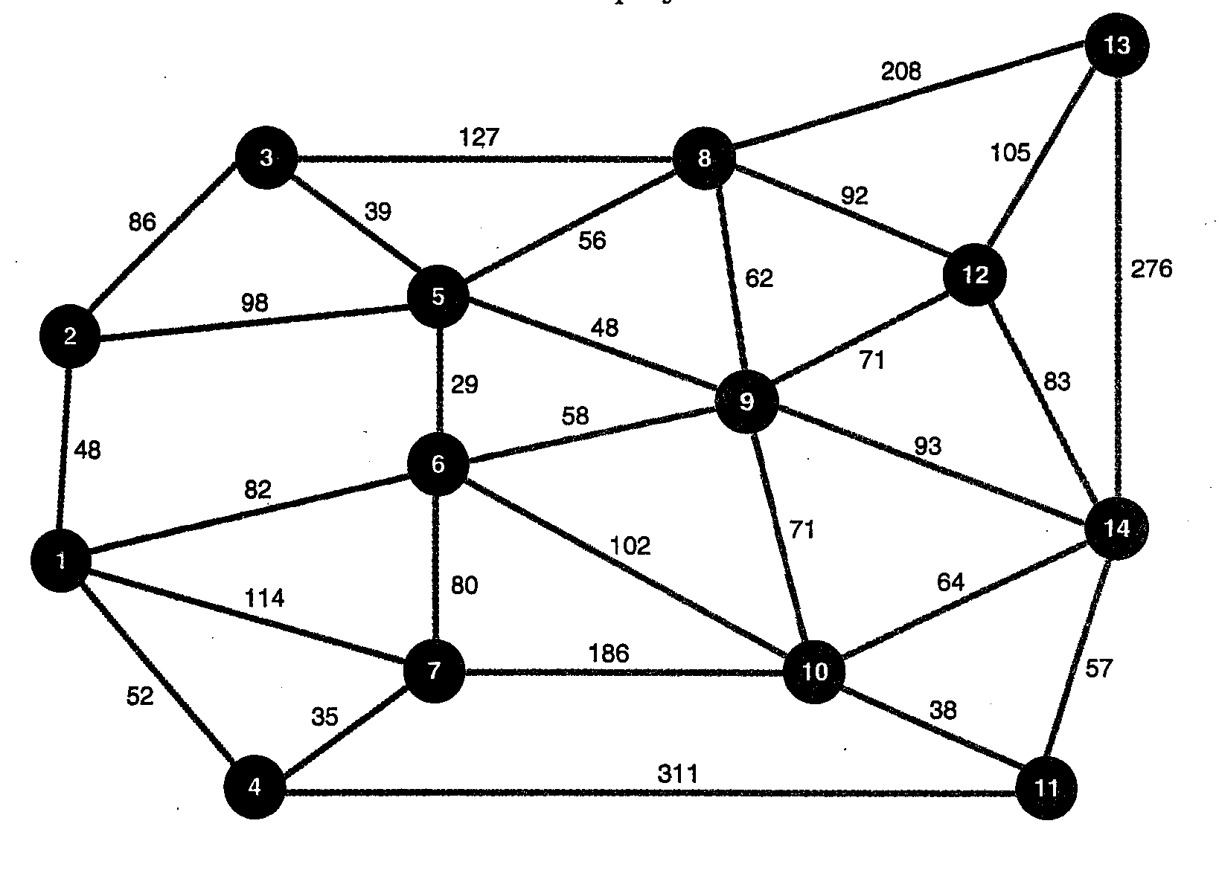

2) For the SPA Example 2 network available on the course web page, find the shortest distance from node A to every other node in the network. Fill in the distances from A to each other node in the table below.

A | B | C | D | E | F | G | H | I | J
0 |  |  | 17

3) a) Write a list of eight cities (or towns) you’d like to visit in the USA on the back of this page. b) Go to http://gebweb.net/optimap/, enter the eight cities and solve (Calculate Fastest Roundtrip) for the best TSP tour. For this webpage to work, you need to temporarily disable the pop-up blocker on your web browser (on IE, go to Tools → Pop-Up Blocker). c) Print the map with the highlighted TSP tour. d) What is the total distance for your trip?

If you are too lame to think up your own cities, visit the eight that I have lived in throughout my life (excluding Honolulu, HI and Auckland, NZ):

Missoula, MT; Olympia, WA; Claremont, CA; Seattle, WA; San Diego, CA; Ann Arbor, MI; St. Louis, MO; Durango, CO

