BA 353: Networks

Many problems can be solved by network analysis. For example, how can a building be wired for the internet at minimum cost? Or, what is the shortest distance between Durango and Los Angeles? Or, how can a traveling saleswoman visit several cities and return home while driving the shortest distance? We will consider three kinds of network analysis: the minimal spanning tree, the shortest path algorithm, and the traveling salesman problem.
The minimal spanning tree connects a network at minimum cost. For the minimal spanning tree, we assume that the different nodes of the network must all be connected, but that the distance between any two nodes is not that important. The shortest path algorithm connects a base city (usually node 1) to all other cities in the network at the minimum distance. Finally, the traveling salesman problem starts at node 1, visits each node exactly once, and returns to node 1 at minimum cost. Effective solution algorithms exist for both the minimal spanning tree and the shortest path, but not for the traveling salesman problem.

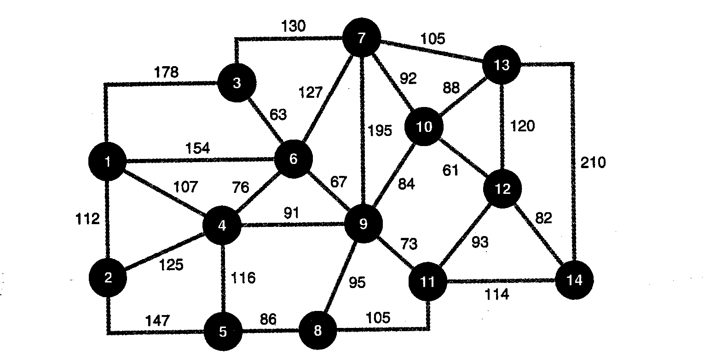
A) Assume that a sewer system must be built for a new subdivision. The sewer must connect to houses 1 thru 14 on the network below, and the distances are in meters. What is the minimal spanning tree for this network? If it costs $20 per meter (including digging, labor, and pipe), how much will the sewer system cost?
B) Find the minimal spanning tree for the network below.
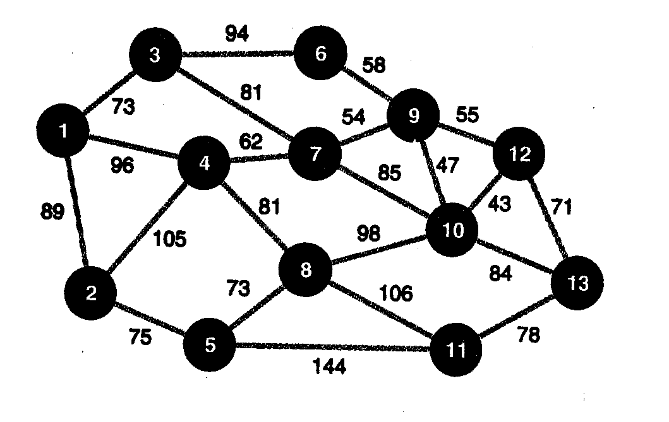
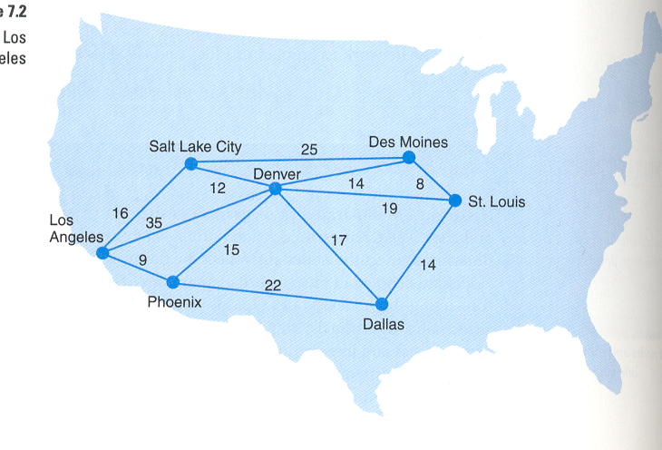
C) A shipping company ships goods from LA to all the cities listed on the network below. The data indicate the time in hours from one city to the next. (For example, it takes 9 hours from LA to Phoenix.) What is the shortest path from LA to all the cities on the network?

D) Find the shortest path from Jackson to all other cities on the network.

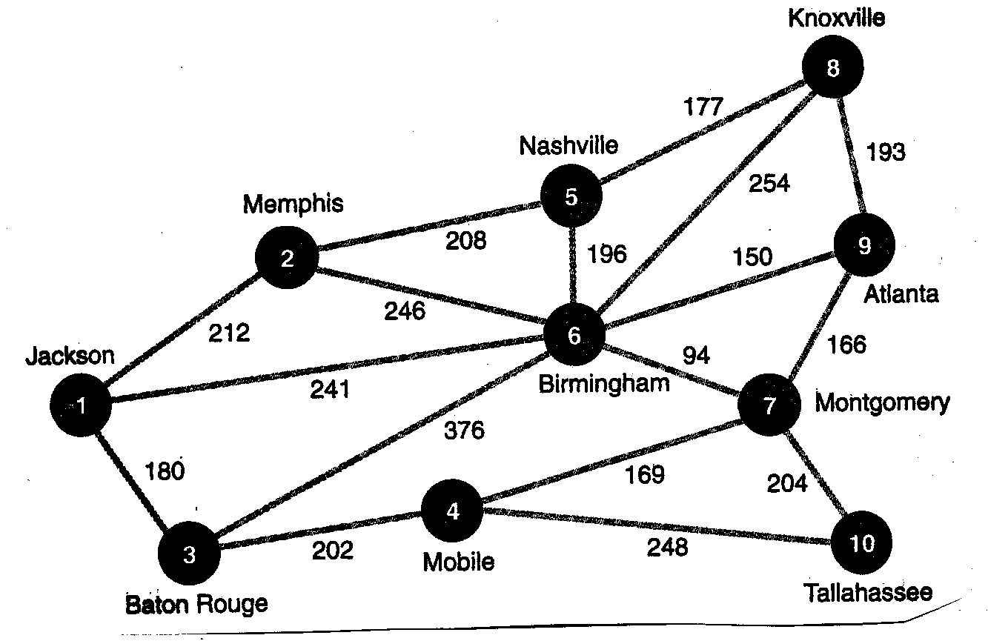
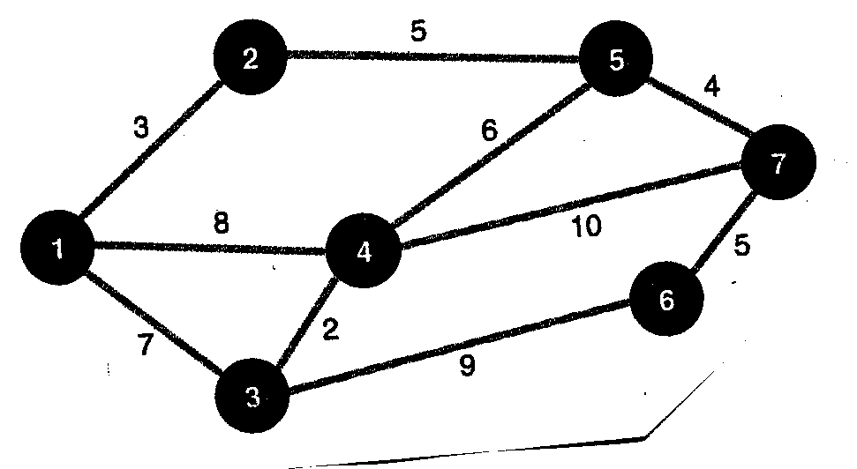
E) A delivery truck starts at a warehouse (node 1). The driver must then visit every stop (2 – 7) once and return back to the warehouse. How can the driver accomplish this task while driving the minimum distance? Assume the distances are in miles.

F) Solve the traveling salesman problem for the network below, starting in Inglewood. How many possible circuits are there?
