Biology 112: Introduction to Organismic and Evolutionary
Biology Course Packet

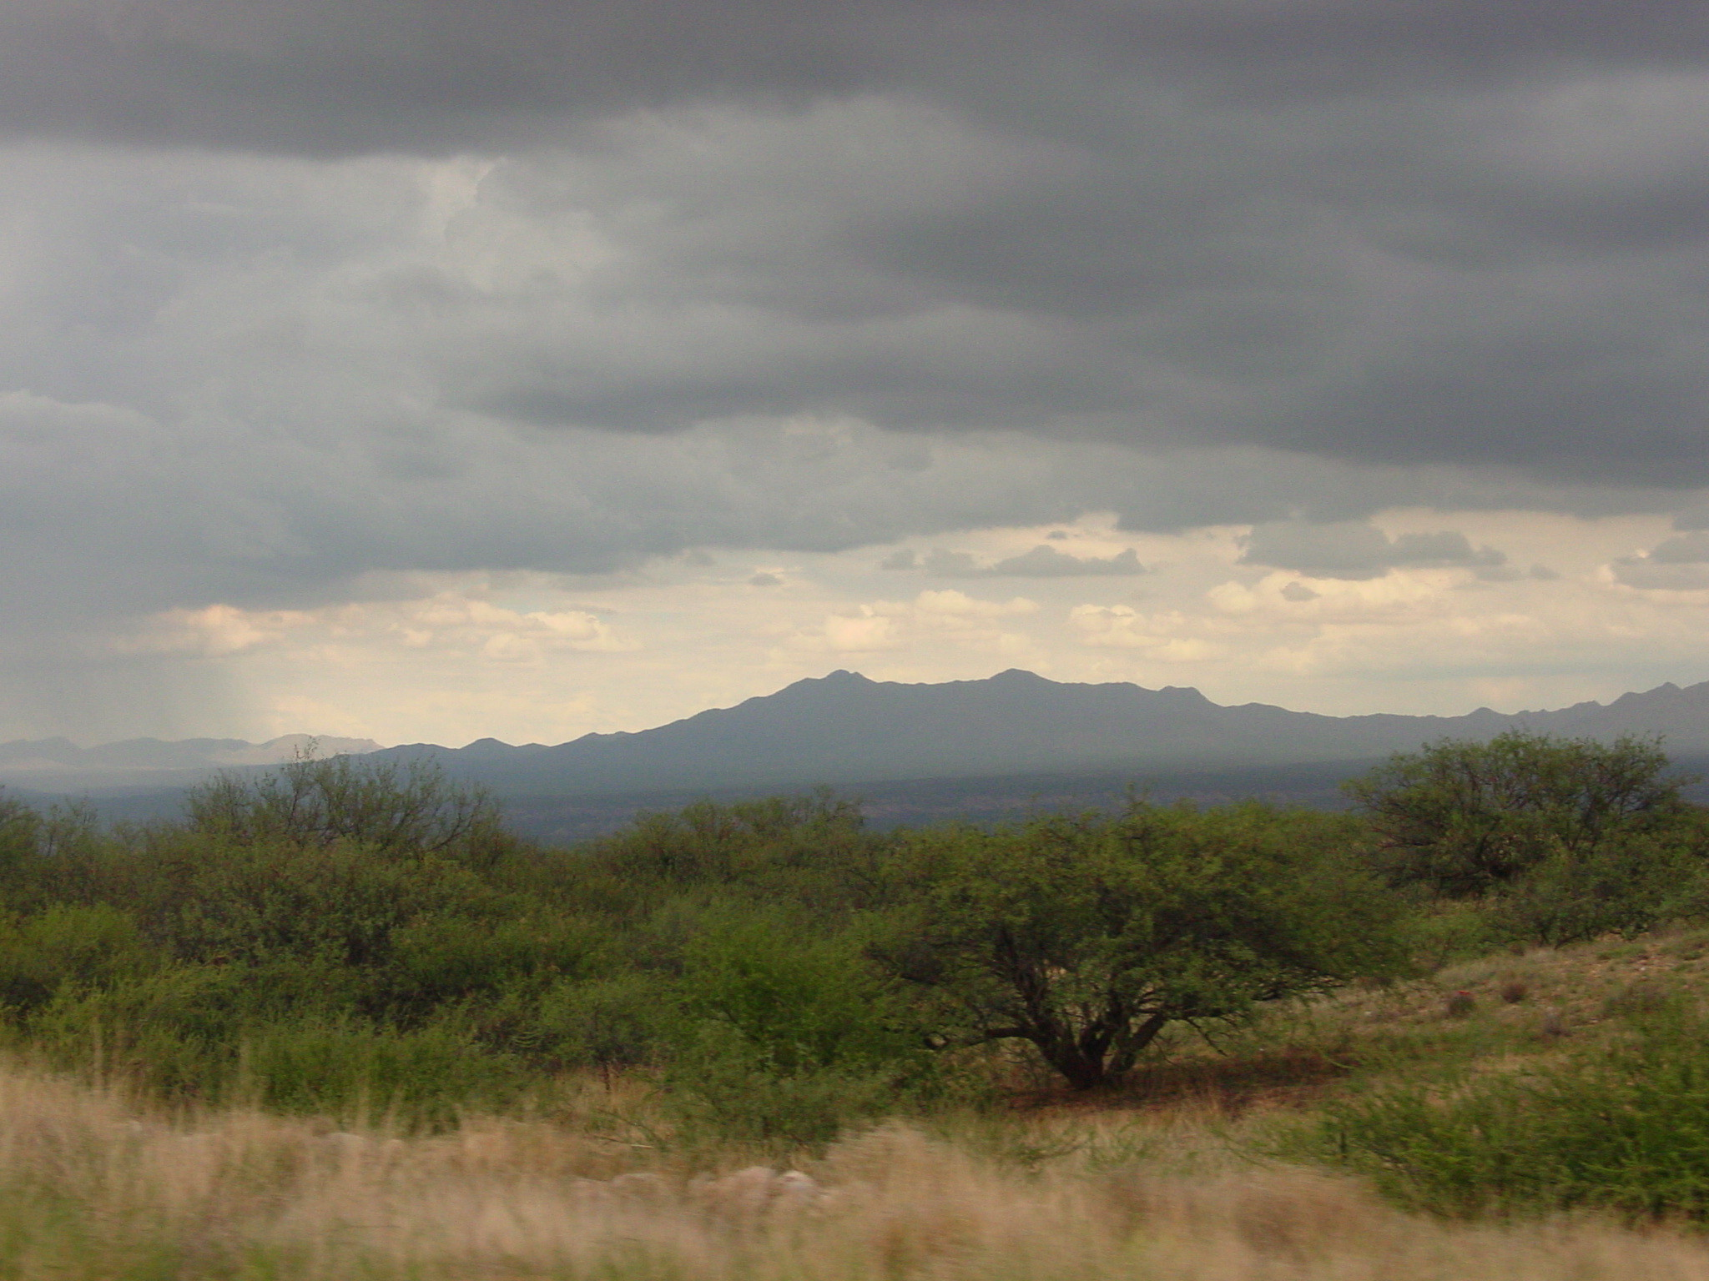

Fort Lewis College, Winter 2013
Tuesday and Thursday 10:10-12:10, Jones 174
Dr. Julie Korb

TABLE OF CONTENTS
Description Page #'s

Syllabus 3-7
Class Schedule 8-9
Student Information Sheet 10

In-Class Activities:
Centennial Nature Trail 11-12
Gall Lab Scientific Report 13-25
Species Interactions 26
Succession Activity 27-30
Winter Ecology Worksheet 31
Mitosis Computer Exercise 32
Meiosis Computer Exercise 33
What Darwin Never Knew Video Worksheet 34-35
Natural Selection Activity 36-38
Darwin Discussion Questions 39
Bottleneck Activity 40
Pollinator/Plant Activity 41-45
Genetic Exercises 46-56
Future of Food Video Worksheet
Mono-Hybrid Cross Review 57
Trip to Genetic Counselor Case Study 58-64
Salmon Trophic Level Article 65-79
Human Population Worksheet 80-81
Ecological Footprint 82-83
Conservation Biology Exercise 84-85
Ecosystem Services/Public Health Worksheet 86
Ecosystem Services/Public Health Article 87-94

Biology 112N: Introduction to Organismic and Evolutionary Biology

Fort Lewis College, Winter 2013

Tuesday and Thursday 10:10-12:10, Jones Hall 174

Julie Korb, Ph.D. korb_j@fortlewis.edu 382-6905 Berndt 2443 (2nd floor of new Biology building) Office Hours: Tuesday/Thursday 1:30-3pm or by appt.

Why Biology?
Some of you already know that you want to pursue a career in biology; others of you are unsure, and may be here to “test the waters,” and see what you think. Whatever your motives, I hope that you will begin to see that biologists have a particular world view, which is quite different from the view held by people in many other professions. You may already have such a view of the world; if not, I hope that this winter term you will begin to cultivate it. The biologist John Janovy, in his book On Becoming a Biologist (Harper & Row, 1985) discusses the distinctive world view that sets biologists apart from their peers in other disciplines:
“We [humans] share a common bond with even the most bizarre beetle of the Peruvian rain forest. A belief in that common bond might, in fact, be the most fundamental characteristic of a biologist… The decision to become a biologist demands an attachment to the world of living organisms… [I]f you exercise this kind of sensitivity… on your own, you have one of the… properties of people who would be nothing other than biologists.”
Janovy (1985; pp 2, 10, 15)

Biology is the study of life – of living things, how they work, how they interact with each other and their environment. It is the study of connections among all the intricate workings of cells, organisms, ecosystems, and the dynamic history of the earth that has allowed all of these processes to evolve.

The Syllabus:
This syllabus is your contract for Biology 112. It is an outline of what you may expect of me (and the course), and of my expectations of you. You will notice that the syllabus is quite long; there is a reason for this! Here I have described the goals of this course, some of the methods I will use in helping you to learn course material, and how I will assign grades this semester. The final pages of the syllabus include a week-by-week schedule of topics, reading assignments, exams and homework for the entire semester – examine this carefully! While it is subject to change, it is your responsibility to keep track of the various assignments and deadlines listed. Many of the questions you may have about the mechanics or logistics of the course are outlined here – read through the syllabus and get to know it!

About the Course -
Course Objectives and Description:
This course is designed to usher you into the Biology Major at Fort Lewis College. Therefore, I will introduce you to the fundamental principles of environmental biology and evolutionary thought. During lecture we will examine many basic paradigms of biology, such as ecology, evolution, systematics, and genetics. We will also discuss the nature of the scientific method, how biologists use the scientific method to understand the natural environment, and compare the scientific method with other ways of knowing. All of the paradigms we study will provide you with a strong foundation for a more detailed study of issues in evolution and the natural environment.

Class Format:
Our class meeting times will be 2 hours long (10:10-12:10 Tuesday and Thursday), and you should expect to be in class for the entire 2 hours every session. Every day we will take a 10 minute break mid-way through the class, so please hold off your hunger pangs, restroom needs, urgent phone calls or coffee crises for this break. We will reconvene promptly after the break, and usually continue with lecture begun in the first half of class or do activities related to the topic discussed earlier in lecture. These activities will be wide-ranging, including things like small group discussions, biology “games,” field outings, small-scale experiments, computer “labs,” videos, debates and other fun stuff. You will need to come to this class prepared to get involved and be an active participant.

You will also notice that we are not covering topics in exactly the order they are presented in your text. I feel that the order in which we will address topics reflects (to some extent) the logical unfolding of human curiosity and questioning of the natural world. Some of first “biologists” were people like Charles Darwin, who were fascinated with natural history. Darwin is often counted among the first ecologists, although he is most remembered for championing the theory of evolution by natural selection. Some of the questions raised by the Darwin’s theories were only answered when biologists rediscovered Gregor Mendel’s elegant studies of genetics. In turn, we cannot fully appreciate the mechanics of inheritance and genetics until we understand how cells work, what chromosomes are, and how cells divide in mitosis and meiosis. So, while most text books build from small-scale processes (cell structure & function) to larger scales (ecosystems), we will follow a path that I think you will find more logical – working from systems you can – and do – see every day, down to more and more abstract considerations.

General Education Requirements:
This course is a gT pathways course and will meet the SC1 AND SC2 Content Criteria: Lecture content shall:
· Develop fundamental knowledge in specific field of science
· Develop an understanding of an ability to use the scientific method
· Recognize that science as a process involves the interplay of observation, experimentation and theory
· Develop quantitative approaches to study natural phenomena
· Identify and highlight interconnections between specific science courses being taught and larger areas of scientific endeavor; and
· Distinguish among scientific, nonscientific, and pseudoscientific presentations, arguments and conclusion.
Competencies include: Critical thinking and Mathematics
Course Resources -
Required Texts:
- Biology, N. Campbell, and J. Reece 8th edition (or FLC Custom edition, volume 1), 2008; Pearson/Benjamin Cummings, ISBN 0-8053-7146-X
Computer Resources:
www.campbellbiology.com – contains textbook resources

This website is a great learning resource that serves to supplement your reading of the text and class sessions including chapter reviews, a glossary of terms, and interactive activities.

Computers are available for you to use throughout the campus. There are computer labs located in Jones, Noble, Education & Business (“EBH”) and Berndt Halls, as well as the library. If you need some help in using the internet or features of the course website, you should be able to get help from lab assistants in these computer labs. If that doesn’t work, feel free to come ask me for some help

Grades & Evaluation -
Below are the points possible from this course, and the grading scale that will be used to determine your overall grade for Biology 112:

Points Possible Grading
Exams: 4 (~100 pts) 400 pts A=90-100% of total pts possible
In Class Assignments 150 pts B=80-89%
Take Home Assignments 150 pts C=70-79%
Class Participation 50 pts D=60-69%

Total points: 750 pts F=<60%
Plus & minus final grades will be given.

Assignments:
I will give you various assignments throughout the course of the semester. Due dates for these are outlined in the course schedule, and you are responsible for turning them in on time! Some assignments will be completed in class, but most of them will require homework. The goal of these assignments is to give you practice in working with the material, and to help you gain a better understanding of the subject matter.
In-class activities:
These will include individual and group activities performed during class – attendance in class will therefore be essential for this portion of your course grade (~20%).
Exams:
You will have four exams in this course, including the final exam. All of these exams will contain multiple formats (i.e. multiple choice, fill in the blank, short answer/essay). Each exam will cover approximately 3-4 weeks of material. The final exam, will emphasize the last two weeks of lecture material, but will also contain short essay questions that will test your ability to synthesize information from the entire course.
Take note of the exam dates and write them down on your calendar or schedule book! A missed exam will result in zero points for you and will have a very negative impact on your grade.

Sample Exam Questions:
- For each statement list whether the statement is associated with prokaryotic or eukaryotic cells. a. chromosomes are located in the nucleus ____________________
b. membrane bound organelles are absent ____________________
c. this cell is the larger of the two ____________________

- Natural selection occurs at the level of a population or organism? (circle correct answer)

- Which of the following are characteristics associated with land adaptation?
  - multicellular gametophytes
  - alternation of generations
  - apical meristems
  - multicellular dependant embryos
  - A, B, C
  - All of the above

4. List the different phases of mitosis and draw a picture of a cell in metaphase and identify the sister chromatids and the metaphase plate.

Attendance Policy:
I expect that you will attend every class. If you miss a class, you are responsible for learning the material covered on your own. In the event that you miss a class, make sure you acquire notes for that day from your classmates (I suggest more than one). Make-up exams will not be given without a Dean’s excuse or making prior arrangements.
I also expect you to arrive to class on time and to return from breaks on time. Coming in late to class is not just discourteous, it shows a lack of respect for your professor and your classmates, and it really disrupts a class session.
What do I need to do to get an A in this course?:
Based on past experience, the following list compares student knowledge and skills versus their final class grade.
“D” students- Are unclear about basic material. They are usually unwilling to admit this and ask for help.
“C” students- Know most of the basics but are short on details. Such students usually memorize the material without really understanding it. They lack the ability to create crosslinks between related pieces of information, and fail to see overall patterns in that information; this leads to difficulties in problem-solving. In the words of one C student: “the light bulb hasn’t come on yet.” In our course, “C” is an average grade!
“B” students- Know most basics and lots of details. They have good understanding in most areas but often lack confidence in their problem-solving abilities. May be reluctant to be wrong. B students perform above average in putting together concepts from the course.
“A” students- Know all the basics and most details. They have a global understanding of the big picture and can apply what they know to solve novel problems. They are willing to take chances and be wrong. An A student has shown excellent understanding of how the ideas and information in the course fit into larger frameworks.

Tips & Practicalities -
Tips for success in this course:
Introductory Biology classes will be some of the toughest classes you take at Fort Lewis College. We will cover vast amounts of information at a seemingly break-neck pace. During this course, I will challenge you to have command of detailed information and to develop an understanding of how all of these details relate to each other through general themes of biology. This means that you will be responsible for seeing and understanding both “the forest” and “the trees.”
- Read the assigned material before coming to class so that you are familiar with the material before we discuss it in class.
- Tests will be over what we cover during lecture. If you read something in your text and I did not discuss this material in class at all, this material is not likely to be on the exams. However, you will be responsible for more detailed information on subjects that I have discussed in class.
- Study for this class EVERY DAY. Biology is, in some ways, a foreign language that will take daily study and practice. The only way to keep up in this class will be to study new information as we cover it in class. Do not wait until the night before, or even the week before, an exam to study. Study in manageable bits along the way. By doing this you will be able to: i. avoid frantic cramming and its related test anxiety; and ii. be able to gradually build a body of knowledge by adding new information in small amounts.
- As you learn details, ask yourself questions: Why is this detail important? How does this detail relate to what I already know? I find that by trying to relate new details to my current understanding of a subject, I can better remember those details. This will make you think about the “big picture” and how individual details fit into it. You can be guaranteed that I will ask you to think about Big Picture ideas on your exams.
- Do the assignments given, and more. The assignments will be aimed at helping you understand what I consider to be important details and concepts in this class. Thus, by thinking through and doing the assigned problems, you are actually studying for the exams. In addition, there are plenty more problems, activities, and quizzes for you to do at the Campbell Biology web site, and at the end of each chapter.

Tips for Efficient Reading: adapted from http://www.shepherd.wvnet.edu/scwcweb/web18.htm
I. Reading Preparation
- Make reading part of your studying schedule. Set aside time to accomplish your reading assignment BEFORE class.
- Gather reading material and supplies (e.g., paper, pencil, highlighter).
- Find a comfortable spot to read.
II. Reading Overview (2-3 minutes for a book, chapter, or article)
- Review all titles and subtitles and ask yourself what information these sections contain.
- Briefly review charts and figures and try to understand how they related to the titles and subtitles.
- While reviewing your reading assignment ask yourself, “what can I learn from this?” and “how does this relate to what I am learning in class?”
III. Read Actively
- While reading you should use a simple shorthand scheme for taking notes.
- For example, you can underline all main points or make a parallel line in the margin for more than one sentence that has a significant/interesting point. You can make the letter “D” in the margin to note something you want to discuss. You can make a “?” in the margin for something you don’t understand or put a box around numerous sentences that you don’t understand our something you need to think more about.
- You should write down your thoughts in the margins or on a separate piece of paper.
- You should write down or mark sentences that you don’t understand.
- You should reread a paragraph before going on if you don’t understand it. If you still don’t understand it after rereading it then you should mark it so you don’t forget to clarify it later.
- Relate your reading assignment to charts and figures.
IV. Relate your reading assignment to what you currently know regarding the subject during and after completing the reading assignment.

Campus Resources:
If you find you are struggling in this course or any other courses this semester, or if you are simply having a hard time with the whole college “scene,” bear in mind that you are not alone. The first semester of your first year in college can be extremely stressful, and the first 4-6 weeks are probably the most difficult. You are making many adjustments in your personal and social lives, as well as embarking on a challenging academic journey.
At Fort Lewis College there are many options open to you in over-coming such obstacles. Here are some of the places you can go if you find you need help:
First: Admit to yourself that you could use some help.
Second: If you prefer, ask one of your professors for advice, or a recommendation of where else to go for assistance. Professors often know the names of majors in their field who are interested in tutoring.
Third: Try one of the many centers on campus that are here for you. Below is a partial list:
Learning Assistance Center 280 Noble Hall
- help with study skills
- tutoring
Disability Services 280 Noble Hall
[If you do have a disability that requires special accommodations, please notify me at the beginning of the course so that I can be sure to meet your needs.]
Academic Readiness Center 460 Berndt Hall
- outreach for 1st generation college students
Counseling Center 260 Noble Hall
- help dealing with extreme stress or emotional difficulties
Scholastic Ethics:
Academic dishonesty in any form (i.e. plagiarism, cheating, aiding in cheating) will not be tolerated because such dishonesty undermines the academic endeavor. Any act of academic dishonesty will result in the student earning zero points on the dishonest work, referral to the Academic Standards Committee, and possible dismissal from the College. If you are caught doing academic dishonesty in any form twice in this class you will FAIL the course and asked to no longer attend class. Students are also expected to comply with the College's Student Code of Conduct (Fort Lewis College Student Handbook, 1999, pp 5-14.).
Although you will be graded on your own work, you may wish to study and work problems together with other students. Science is a process and is usually most exciting and rewarding when done collaboratively; we all get ideas from others. If you are in doubt as to how to cite the work of others or wondering if group work on a particular assignment is okay, just ask. Remain above suspicion of dishonesty.

Date | Topics (subject to revision) | Reading | Assignment Due

ECOLOGY
Week 1: Jan 8, 10 | T: Introduction to Ecology  R: Introduction to Ecology | T/R: Chapter 1; pp. 4  Chapter 52; pp. 1148-1159; 1166-1171 | T: Student info. sheet (in-class assignment); Studingo  R: Nature Trail worksheet (OUTSIDE)
Week 2: Jan 15, 17 | T: Scientific Method  R: Community Ecology | T: Chapter 1; pp. 18-24  R: Chapter 54; pp. 1198-1210 | T: Begin gall study (OUTSIDE)  R: Continue gall study /Data entry/analysis (class split) (OUTSIDE/COMPUTER LAB)
Week 3: Jan 22, 24 | T: Disturbance/Succession  R: Restoration Ecology | T: Chapter 54; pp.1211-1214  R: Chapter 56; pp. 1260-1263 | T: Continue gall study/data entry/analysis (class split) (OUTSIDE/COMPUTER LAB)  R: Succession Game
Week 4: Jan 29, 31 | T: Dendrochronology  R: Winter Ecology | T/R: No reading assignment | T: Fire Scar Dating Exercise; Scientific report on galls due  R: winter ecology worksheet/OUTSIDE

CELL BIOLOGY
Week 5: Feb 5, 7 | T: Exam 1  R: Cell Cycle, Mitosis | T: No reading assignment  R: Chapter 12; pp. 228-237
Week 6: Feb 12, 14 | T/R: Mitosis, Meiosis and Life Cycles | T/R: Chapter 13 entire chapter | T: computer lab mitosis assignment due (complete in class)  R: computer lab meiosis assignment due (complete in class)
Week 7: Feb 19, 21 | T: Meiosis  R: Exam 2 | T: Chapter 15; pp. 289-290; 297-300
EVOLUTION & GENETICS
Week 8: Feb 26, 28 | T: What Darwin Never Knew Video  R: History of Evolutionary Thought/Natural Selection | T/R: Chapter 1; pp. 12-17; Chapter 22 entire chapter | T: Darwin Video-Worksheet  R: Speciation Game
Week 9: March 4-8th | SPRING BREAK
Week 10: Mar 12,14 | T/R: Natural Selection/Speciation  R: Plant/Pollinator Adaptations | T: Chapter 23; pp. 468-471; 475-484; Chapter 24; 487-498  R: Plant/Pollinator Activity | T: Bottleneck Activity/Darwin Discussion with Current Science Literature  R: Pollination Activity
Week 11: Mar 19, 21 | T/R: Mendelian Genetics | T/R: Chapter 14 entire chapter | T/R: Genetic worksheets
Week 12: Mar 26, 28 | T: Mendelian/Population Genetics/Future of Food Video  R: Trip to the Genetic Counselor Case Study | T: Chapter 15; pp. 286-287; 294  R: Read Case Study Introduction | T: Genetic worksheets/video worksheet  R: Trip to the Genetic Counselor Worksheet
Week 13: Apr 2 | T: Exam 3
CONSERVATION/BIODIVERSITY
Week 13: Apr 4 | R: Salmon: Running the Gauntlet Video | R : Salmon, Bears, Nutrient Ecoystem Article | R : Video Worksheet/Paper Discussion
Week 14: Apr 9, 11 | T: Human Population Ecology/Ecological Footprint  R: Conservation Biology/  Division Street Video | T : Chapter 53; 1181-1195;  R: Chapter 56; pp. 1245-1260; 1264-1265 | T : Human Population Worksheet/  Ecological Footprint Activity (Computer Lab)  R: Video Worksheet
Week 15: Apr 16, 18 | T: Conservation Biology  R: Ecosystem Ecology/Ecosystem Services Public Health | R: Climate Change/Ecosystem Disruption article | T: Conservation Biology In-Class Exercise  R: Article Discussion
Final Exam: Monday April 22nd noon |  |  | In-class final exam

Student Background and Interests

Name

E-mail address

Year, major

What do you want to learn from this course?

What classes related to biology have you taken?

What are your career goals?

How do you learn best (e.g., lecture format, group discussions, hands-on activities, reading assignments)?

Use your syllabus to answer the following questions:
What is considered an “average” grade in this course?

When is the Final Exam?

What happens if you miss an exam?

Why am I teaching subjects in a different sequence than they appear in your text?

What computer resources are available to you with this text book?

Centennial Nature Trail Worksheet

Instructions: Use the Centennial Nature Trail Self-Guiding Trail Booklet to aid you in answering the question on this worksheet and also to help you locate yourself along the trail (numbered posts along the trail correspond to points of interest in the Guide). Please work in pairs with half of the group starting at the bottom of the trail and half of the group starting at the top of the trail. Note: the group working from the bottom up will do the worksheet backwards.

Please stay on the trail at all times and do not cut switchbacks because the trail is prone to erosion.

1). Exhibit A: Locate and identify a pinyon pine and Utah juniper tree. List their scientific names. How can you tell the difference between these two dominant trees on the trail? Describe how their leaves and fruits are different.

2). Exhibit C-D: Large-scale patterns. Try to find the landmarks in the Trail Guide.
- Look for a patch of Douglas-fir trees near the Greenmount Cemetery. Douglas-fir trees are normally found on cool, moist sites at slightly higher elevations. Why do you think they may be growing in this particular “pocket” as shown in the Guide? Hint: they were not planted.

- Find Perins Peak and the sharp ridge in front of it. This ridge is called “The Hog’s Back” (it is not labeled in the Guide). What patterns of vegetation distribution do you see on the flank of the Hog’s Back? Why do you see this particular pattern?

3). Exhibit G-H: Large-scale patterns. What large-scale differences in the vegetation do you notice in the residential streets of Durango compared to the hillsides and ridges surrounding town?

4). Exhibit J (approximately): Stop and notice where you are and how steep the hillside is. What direction does the hillside face (this is called the slope aspect)? What type of influence does aspect have on vegetation?

5). Locate and identify two plants that have been used by early native peoples of the region. Name each plant and list its uses. Many of the plants are covered under snow. Look for shrubs and try to identify them based on the Trail Booklet (note—the majority of the leaves on the deciduous plants have fallen off, look for the remaining ones to help you identify species).

i)

ii)

6). Exhibit Q-R: Look at the plants around you that aren’t covered under snow. Identify yucca. What is unique about this plant compared to other plants you have seen on the trail?

7). Exhibit U and others: Locate and identify two plants that are used extensively by native animals (note—the majority of the leaves on the deciduous plants have fallen off, look for the remaining ones to help you identify species). What animals use them and for what? Have you seen any signs of animals along the trail (e.g., footprints in snow, animal droppings, caches of food)?

8). Write one new thing you that you learned in lecture about ecology that you could apply to what you saw along the Nature Trail (what patterns did you see?)-ecologists observe before explaining what they see.

Gall Laboratory Exercise

Why Galls?
Scientists have been fascinated with trying to understand the mysterious origin of galls (growths) on stems, leaves, flowers, and roots for centuries. Galls represent a unique interaction between two species that are in direct contact called symbiosis (greek word for living together) (Campbell and Reece 2002). There are three types of symbiosis. Symbiosis can be (1) beneficial to one species and have no influence (harm or benefit) on the other species (commensalism), (2) beneficial to one species and harmful to the other (parasitism), or (3) beneficial to both species (mutualism). Galls develop from rapid mitosis of plant tissues and come in numerous colors, shapes, and sizes. Galls can be both beneficial and harmful to their host plant. Galls, which benefit their host plant, include species that have created little “condos” to house their symbiotic insects (Armstrong 2001). These symbiotic insects then help the host plant either through pollination or protection. In contrast, some galls are formed to prevent bacteria, fungi, mistletoe, mites, nematodes, viruses and insects from attacking the plant. All galls do not necessarily harm plants, but it can result it parasitism. For example, some galls are harmful such as the peach leaf curl, which is caused by the fungus Taphrina deformans and can seriously damage orchid trees (Armstrong 2001).

Our Study
For our study, we are going to look at two common shrub species in pinyon-juniper ecosystems of the Southwest that form galls. These species are rabbitbrush (Chrysothamnus nauseosus) and Big Sagebrush (Artemisia tridentata). Our study will take place on the Fort Lewis College campus. The objective of our study is to determine the effect of plant height and diameter on gall abundance for two shrub species. Why do we want to measure plant height and diameter? Do you think plants with more galls will be taller or shorter than plants with fewer galls? Do you think plants with more galls will have a larger or small diameter than plants with fewer galls? Why??? After we form our hypotheses, we will begin our data collection.

Data Collection
We will divide you into groups of 4 to collect data. You will need a ruler and data sheet to record your data. Measure the plant height and diameter and number of galls found on 10 rabbitbrush plants and 10 big sagebrush plants. Make sure your data is entered in correctly and is LEGIBLE. Inaccurate data is the same as NO DATA!

Data Entry
We will do our data entry in the computer lab (Sage 163). We will use the Word computer program EXCEL to enter and analyze our data. EXCEL is an easily accessible computer program found on all campus computers that you should get familiar with. You will work in a workbook when you enter your data. To get a new workbook, go to “FILE” and click and then move your cursor down to “NEW” and click. EXCEL is set-up in a spreadsheet format divided into columns and rows. Across the top are letters, which represent your columns and vertically down are rows that are numbered. You can now begin entering your data as shown on your data sheet. Remember you need to include your column and row headings in your table. Your data will not mean anything unless you have this information along with numbers. First enter in your data for rabbitbrush and then you will enter your data for big sagebrush on another sheet in the same workbook. Click on the tab “SHEET 2” at the bottom of your spreadsheet to open a new spreadsheet for your second species. To save your data, go to “FILE” and then move your cursor down to “SAVE” and click. You will now be prompted to give your workbook a “FILE NAME”. Before you do this, you need to tell the computer WHERE you want to save your workbook. Click on the “SAVE TO” and scroll down to the directory where you want to store your information (e.g., “A Drive” for a floppy disk; “D drive” for a ZIP disk). Next, give your workbook a name that you will remember that relates to this assignment (e.g., BIO112GallLabAssignment). You are not allowed to enter dashes (-) or slashes (/) in your name. Make sure you SAVE your data. If you don’t SAVE your data, you will have to retype your data for the data analysis lab.

Data Analysis
We will be creating tables and graphs from our data. For our table data we will summarize the mean (average), maximum and minimum plant height, diameter, and number of galls for both species.

HOW DO I DETERMINE MY MEAN, MAX, & MIN??? Move your cursor into a new box below the numbers you want to average and click on the “fx” icon in the toolbar above the spreadsheet. It will then require you to select a “FUNCTION CATEGORY” which you should select “STATISTICAL”. You then need to select a “FUNCTION TYPE” which you should select “AVERAGE”. A box will emerge and you will need to select the range you want to average. Highlight the numbers you want to average and select “OK”. Now that you have your mean for one variable do this for all three of your variables for both species. You can determine your maximum and minimum numbers the same way but instead under “FUNCTION TYPE” you need to choose “MAX” or “MIN” rather than “AVERAGE” or you can visually determine these numbers.

HOW DO I CREATE A TABLE???
To create a table, you will need to go into MICROSOFT WORD. In WORD, you can create a table that has a title and data. Below is an example for our study.

WHAT IS REGRESSION ANALYSIS???
Regression analysis looks at how a dependent variable (in our study gall numbers) is affected by one or more independent variables (in our study, plant height and plant diameter). By doing regression analysis, you can create equations to help you predict or estimate responses. For our study, we are interested if the number of galls a plant has is related to its plant height or diameter. The simplest type of model relating a response (y) to a single quantitative independent variable (x) is given for the equation of a straight line. Y=B₀ + B₁x where B₀ is the y-intercept (value of y when x=0) and B₁ is the slope change in y for a unit change in x.

HOW DO I CREATE A REGRESSION FIGURE???
To create a regression figure, you need to create two columns side-by-side with your dependent (number of galls) and independent (plant height or diameter) data and highlight these columns including the headers. You then need to select “INSERT” and select “SCATTER” and click on the scattered dots. To show a trendline, you need to click on the figure and select “TRENDLINE” and click “ LINEAR TRENDLINE”. Finally, to get an R2 value to determine how correlated the two variables are, select “TRENDLINE” and the click “MORE TRENDLINE OPTIONS” and then check the box at the bottom that states “DISPLAY R-SQUARED VALUE ON CHART”. Label X & Y axes by clicking on the chart and selecting “LAYOUT” and then “AXIS TITLES” and choose and label the vertical (y) and horizontal (x) axes. Remove or change the name of the chart title by clicking on the chart and selecting “LAYOUT” and then click “CHART TITLE”. Finally, delete the linear (# of galls) in the legend box by clicking on the legend and highlighting the text and hitting delete.

Scientific Lab Report

Now that you have asked questions, generated hypotheses, collected data, entered data, and analyzed your data it is FINALLY time to put it all together into a cohesive scientific report. Writing a scientific lab report is something that you will be doing A LOT as a biology major or in any scientific field of inquiry. A scientific lab report is different from compositional writing in numerous ways. Attached to this handout are guidelines for writing a scientific report by Iowa State University professor Warren D. Dolphin. This is an excellent reference that you will WANT to keep throughout your college career; USE IT!! For this lab report, we are NOT requiring you to get additional outside resources for your discussion section; however, it would be helpful to add outside resources if you already know how to access information off the web or from scientific articles in the library. We will have an exercise later in the semester that will help you get familiar with how to access outside resources and the scientific literature.

What to include in your lab report (see guidelines for writing a report for specific details):

Title

Introduction

Methods
Results—In addition to written text, you will need to include: 1) a table with the mean, maximum, and minimum plant height for both species; 2) a table with the mean, maximum, and minimum plant diameter for both species; 3) a table with the mean, maximum, and minimum number of galls for both species; and, 4) two figures (one for each species) of regression equations for either plant height or plant diameter regressed on the number of galls
Discussion-no outside source is required. You should cite this handout if you use it in your discussion or the Weis and Berenbaum article. Also, you may choose to use and cite the websites listed in this handout.

Literature Cited
Acknowledgments-acknowledge any individual that helped you with this study

Grading Rubric Final Report 100 points—see guidelines below for specifics of what should be included in each section
- Title 5 pts
- Introduction (3 main questions-5 pts each)—see guidelines for specific questions) 15 pts
- Methods (3 main questions-5 pts each)—see guidelines for specific questions) 15 pts
- Results (written—see sample text) 15 pts
- Results (three tables; two figures) 25 pts
- Discussion 15 pts
- Literature cited 5 pts
- Acknowledgements 5 pts

Data Collection Sheet-Gall Study BIO 112

Date:
Field Crew:
Location:

RABBITBRUSH (Chrysothamnus nauseosus)
Plant Number | Controlling Variable | Plant Height | Plant Diameter | Number of Galls
1
2
3
4
5
6
7
8
9
10

Big Sagebrush (Artemisia tridentata)
Plant Number | Controlling Variable | Plant Height | Plant Diameter | Number of Galls
1
2
3
4
5
6
7
8
9
10

Writing Lab Reports and Scientific Papers

by Warren D. Dolphin; modified Julie E. Korb

Information from: http://www.mhhe.com/biosci/genbio/maderinquiry/writing.html

Verbal communication is temporal and easily forgotten, but written reports exist for long periods and yield long-term benefits for the author and others.
Scientific research is a group activity. Individual scientists perform experiments to test hypotheses about biological phenomena. After experiments are completed and duplicated, researchers attempt to persuade others to accept or reject their hypotheses by presenting the data and their interpretations. The lab report or the scientific paper is the vehicle of persuasion; when it is published, it is available to other scientists for review. If the results stand up to criticism, they become part of the accepted body of scientific knowledge unless later disproved.
In some cases, a report may not be persuasive in nature but instead is an archival record for future generations. For example, data on the distribution and frequency of rabid skunks in a certain year may be of use to future epidemiologists in deciding whether the incidence of rabies is increasing. Regardless of whether a report is persuasive or archival, the following guidelines apply.

Format
A scientific report usually consists of the following:
- Title
- Introduction
- Materials and methods
- Results
- Discussion
- Literature cited
- Acknowledgements
There is general agreement among scientists that each section of the report should contain specific types of information.

Title
The title should be less than ten words and should reflect the factual content of the paper. Scientific titles are not designed to catch the reader's fancy. A good title is straightforward and uses keywords that researchers in a particular field will recognize.

Introduction
The introduction defines the subject of the report. It must outline the scientific purpose(s) or objective(s) for the research performed and give the reader sufficient background to understand the rest of the report. Care should be taken to limit the background to whatever is pertinent to the experiment. A good introduction will answer several questions, including the following:
Why was this study performed?
Answers to this question may be derived from observations of nature or from the literature.
What knowledge already exists about this subject?
The answer to this question must review the literature, showing the historical development of an idea and including the confirmations, conflicts, and gaps in existing knowledge.
What is the specific purpose of the study?
The specific hypotheses and experimental design pertinent to investigating the topic should be described.

Methods
As the name implies, the methods used in the experiments should be reported in this section. The difficulty in writing this section is to provide enough detail for the reader to understand the experiment without overwhelming him or her. When procedures from a lab book or another report are followed exactly, simply cite the work, noting that details can be found in that particular source. However, it is still necessary to describe special pieces of equipment and the general theory of the assays used. This can usually be done in a paragraph format. Generally, this section attempts to answer the following questions:
Where and when was the work done? (This question is most important in field studies.)
What methods were used? (This needs to be detailed enough so that someone could read your paper and conduct the same experiment).
How was the data analyzed? (This includes the software program and analyses).

Results
The results section should summarize the data from the experiments without discussing their implications. The data should be organized into tables, figures, graphs, photographs, and so on. But data included in a table should not be duplicated in a figure or graph.
All figures and tables should have descriptive titles and should include a legend explaining any symbols, abbreviations, or special methods used. Figures and tables should be numbered separately and should be referred to in the text by number,

Sample Required Written Results Text for Report

Mean rabbitbrush height was 10 inches taller than sagebrush (Table 1). Similarily, mean rabbitbrush diameter (24 inches) was larger than mean sagebrush diameter (17.5 inches) (Table 2). There was no significant correlation between the number of galls present on rabbitbrush and the mean diameter of rabbitbrush (Figure 1).

Figures and tables should be self-explanatory; that is, the reader should be able to understand them without referring to the text. All columns and rows in tables and axes in figures should be labeled. See appendix B for graphing instructions.
This section of your report should concentrate on general trends and differences and not on trivial details. Many authors organize and write the results section before the rest of the report.

Sample Required Tables and Figures for Report

Table 1. Plant height (cm), mean, maximum, and minimum for rabbitbrush (Chrysothamnus nauseosus) and big sagebrush (Artemisia tridentata) at Fort Lewis College, Durango. N=5/aspect.
Mean (cm) Maximum (cm) Minimum (cm)
North-facing
Rabbitbrush
Sagebrush
South-facing
Rabbitbrush
Sagebrush

Table 2. Plant diameter (cm), mean, maximum, and minimum for rabbitbrush (Chrysothamnus nauseosus) and big sagebrush (Artemisia tridentata) at Fort Lewis College, Durango. . N=5/aspect.
Mean (cm) Maximum (cm) Minimum (cm)
North-facing
Rabbitbrush
Sagebrush
South-facing
Rabbitbrush
Sagebrush

Table 3. Number of galls, mean, maximum, and minimum for rabbitbrush (Chrysothamnus nauseosus) and big sagebrush (Artemisia tridentata) at Fort Lewis College, Durango. N=5/aspect.
Mean Maximum Minimum
North-facing
Rabbitbrush
Sagebrush
South-facing
Rabbitbrush
Sagebrush

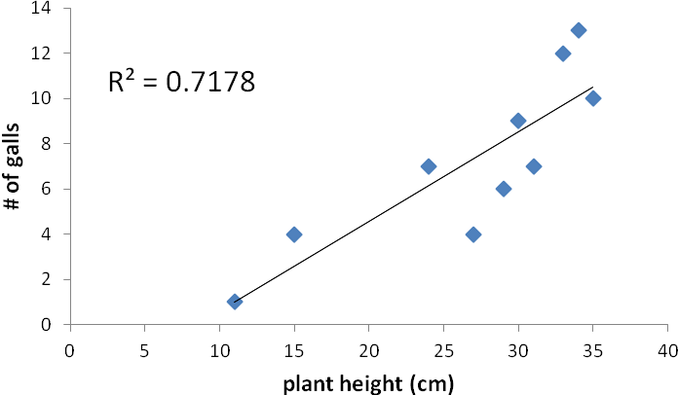
Figure 1. Regression analysis for rabbitbrush (Chrysothamnus nauseosus) between plant height (cm) and the number of galls at Fort Lewis College, Durango. . N=10.

Discussion
This section should not just be a restatement of the results but should 1) emphasize interpretation of the data, relating them to existing theory and knowledge. Speculation is appropriate, if it is so identified. 2) Suggestions for the improvement of techniques or experimental design may also be included here and you should also be able to suggest future experiments that might clarify areas of doubt in your results. In writing this section, you should 3) explain the logic that allows you to accept or reject your original hypotheses.

Literature Cited
This section lists all articles or books cited in your report. It is not the same as a bibliography, which simply lists references regardless of whether they were cited in the paper. The listing should be alphabetized by the last names of the authors. Different journals require different formats for citing literature. The format that includes the most information is given in the following examples:
For articles:
Fox, J.W. 1988. Nest-building behavior of the catbird, Dumetella carolinensis. Journal of Ecology 47: 113-17.
For Books:
Bird, W.Z. 1990. Ecological aspects of fox reproduction. Berlin: Guttenberg Press.
For chapters in books:
Smith, C.J. 1989. Basal cell carcinomas. In Histological aspects of cancer, ed. C.D. Wilfred, pp. 278-91. Boston: Medical Press.
When citing references in the text, do not use footnotes; instead, refer to articles by the author's name and the date the paper was published. For example:
- Fox in 1988 investigated the hormones on the nest-building behavior of catbirds.
- Hormones are known to influence the nest-building behavior of catbirds (Fox, 1988).
When citing papers that have two authors, both names must be listed. When three or more authors are involved, the Latin et al. (et alia) meaning "and others" may be used. A paper by Smith, Lynch, Merrill, and Beam published in 1989 would be cited in the text as:
Smith et al. (1989) have shown that...
This short form is for text use only. In the Literature Cited, all names would be listed, usually last name preceding initials.
There are a number of style manuals that provide detailed directions for writing scientific papers. Some are listed in further readings at the end of this section.

General Comments on Style
- All scientific names (genus and species) must be italicized. (Underlining indicates italics in a typed paper.)
- Use the metric system of measurements. Abbreviations of units are used without a following period.
- Be aware that the word data is plural while datum is singular. This affects the choice of a correct verb. The word species is used both as a singular and as a plural.
- Numbers should be written as numerals when they are greater than ten or when they are associated with measurements; for example, 6 mm or 2 g but two explanations of six factors. When one list includes numbers over and under ten, all numbers in the list may be expressed as numerals; for example, 17 sunfish, 13 bass, and 2 trout. Never start a sentence with numerals. Spell all numbers beginning sentences.
- Be sure to divide paragraphs correctly and to use starting and ending sentences that indicate the purpose of the paragraph. A report or a section of a report should not be one long paragraph.
- Every sentence must have a subject and a verb.
- Avoid using the first person, I or we, in writing. Keep your writing impersonal, in the third person. Instead of saying, "We weighed the frogs and put them in a glass jar," write, "The frogs were weighed and put in a glass jar."
- Avoid the use of slang and the overuse of contractions.
- Be consistent in the use of tense throughout a paragraph--do not switch between past and present. It is best to use past tense.
- Be sure that pronouns refer to antecedents. For example, in the statement, "Sometimes cecropia caterpillars are in cherry trees but they are hard to find," does "they" refer to caterpillars or trees?
- After writing a report, read it over, watching especially for lack of precision and for ambiguity. Each sentence should present a clear message.
The only way to prevent errors is to read and think about what you write. Learn to reread and edit your work.

Readings
CBE Style Manual Committee. 1983. CBE style manual: A guide for authors, editors, and publishers in the biological sciences. 5th ed. Bethesda, Md.: Council of Biology Editors.
McMillan, V.E. 1988. Writing papers in the biological sciences. New York: St. Martin's Press, Inc.

Species Facts
Rabbitbrush (Chrysothamnus nauseosus)-from Fire Effects Information System Database Website www.fs.fed.us/database/feis
*for information on citations (numbers in brackets) and more information on species, go to website and type in species name in SEARCH FEIS

Rubber rabbitbrush is an erect round or pyramidal native shrub that typically reaches 12 to 90 inches (31-229 cm) in height [17,55]. Certain populations have been reported to reach heights of 10 to 12 feet (3.3-3.6 m) [77]. Plant spread is generally between 0.2 and 3.3 feet (0.6-1 m) [60]. Several more or less upright stems arise from the base and branch to give plants a rounded appearance.
Rubber rabbitbrush exhibits a number of adaptations for surviving in an arid environment. Leaves and stems are covered with a felt-like layer of trichomes that insulate the plant and reduce transpiration [3]. Leaves are linear and less than 0.04 inch (0.1 cm) wide [17]. Rubber rabbitbrush has a deep taproot with less well-developed laterals [8,18,19]. Flowers are perfect [17]. Stanton [123] reports that plants may be "full grown" within 4 years.
Rubber rabbitbrush occurs in the cold deserts of the Colorado Plateau, throughout much of the Great Basin, and in warm deserts of the Southwest from lower-elevation Sonoran to subalpine zones [55,115]. Rubber rabbitbrush favors sunny, open sites throughout a wide variety of habitats including open plains, valleys, drainage ways, foothills, and mountains [26,60,123,142]. It is particularly common on disturbed sites [54]. Rubber rabbitbrush is cold hardy to temperatures of -40 degrees Fahrenheit (-40 ºC) and tolerant of both moisture and salt stress [55,115]. The subspecies of rubber rabbitbrush may overlap in their ranges, but they often have somewhat different ecological requirements.

Rubber rabbitbrush is generally regarded as an early seral species that rapidly invades and colonizes disturbed sites [55,134]. It is commonly found in seral communities such as along roadsides and on degraded rangelands [88,142]. Although it colonizes sites with little topsoil, it also invades fairly productive low-elevation riparian areas and deeper soils adjacent to drainage bottoms [23,86,122]. Rubber rabbitbrush often increases after the removal of big sagebrush [112]. On some sites, seedlings may be unable to become established until herbaceous pioneers increase soil stability [16].
Rubber rabbitbrush is a fire-adapted species that is typically unharmed or enhanced by fire [99,148]. Recovery time is often rapid to very rapid. Rubber rabbitbrush is often one of the first species to colonize burned areas by sprouting or from off-site seed [107,148]. Sprouts originate from adventitious buds located on the stem and root crown [24]. This species reproduces abundantly from heavily seed crops [148]. Seeds are easily dispersed to burned sites over long distances by wind.
Big Sagebrush (Artemisia tridentata)-from Fire Effects Information System Database Website www.fs.fed.us/database/feis

Basin big sagebrush is an erect, rounded or somewhat spreading evergreen shrub which normally grows 3 to 10 feet (1-2 m) in height [110]. It occasionally occurs as a dwarf shrub or can be treelike in appearance, reaching a height of 16 feet (5 m). Maximum stature is reached on deep, well-drained soils in sheltered areas. Variability in plant height occurs along a moisture gradient, with larger plants occurring on more mesic sites [6].

Basin big sagebrush has a multistemmed form with a relatively thick trunk and an irregular crown. It is often characterized by a discernible main trunk [44]. It commonly reaches 40 to 50 years of age, and some plants may exceed 100 years. Slow-growing individuals on unfavorable sites attain the greatest age.
The root systems of all subspecies of big sagebrush are well adapted to extract moisture from both shallow and deep portions of the soil profile. This makes them highly competitive with associated grasses and forbs [19,101].

Basin big sagebrush grows in relatively more mesic habitats than other subspecies of big sagebrush [6,72]. It commonly grows on well-drained soils in valley bottoms, lower foothill areas or in areas adjacent to drainages. Basin big sagebrush is associated with deep, seasonally dry, well-drained soils on plains, valleys, and foothills [5]. It frequently coincides with high water tables or deep moisture accumulations [96].
Big sagebrush is the climax species on most of its present day range [23]. Research suggests that invasion into other vegetation types was uncommon [23,31,50,52,78,101,124]. Humphrey [57] describes big sagebrush as a "late successional" species in southeastern Idaho.

Basin big sagebrush may increase in disturbed pastures which have been seeded to grasses such as crested wheatgrass (Agropyron cristatum) [85]. In many instances, basin big sagebrush shows only a moderate increase in density on disturbed sites, but may exhibit large increases in crown density [118]. Seedling establishment may begin immediately following a disturbance, but it usually takes a decade or more before big sagebrush dominates the site. Many basin big sagebrush sites are now depleted of "normal" perennial grasses and are now dominated by cheatgrass (Bromus tectorum) [24].

Big sagebrush plants are killed by most fires. Prolific seed production from nearby unburned plants coupled with high germination rates enables seedlings to establish rapidly following fire. Wind-, water-, and animal-carried seed contribute to regeneration on a site [43,60,99].

Literature Cited
Armstrong, N. P. 2001. Wayne’s word: 9 May 2001. Available: http://waynesword.palomar.edu/wayne.htm [August 28, 2002]
Campbell, N. A., and J. B. Reece 2002. Biology, 6th edition. San Francisco: Benjamin Cummings, pp. 1247.
U.S. Department of Agriculture, Forest Service, Rocky Mountain Research Station, Fire Sciences Laboratory (2002, July). Fire Effects Information System, [Online]. Available: http://www.fs.fed.us/database/feis/ [August 28, 2002].

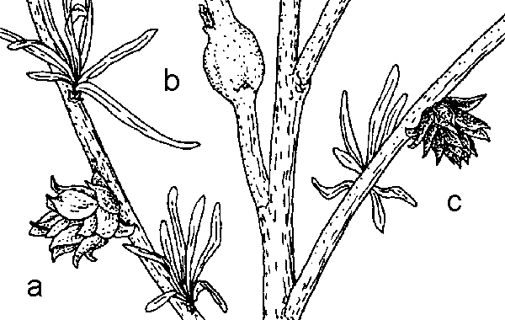 Floate, K.D., G.W. Fernandes and J.A. Nilsson. 1996. Distinguishing intrapopulational categories of plants by their insect faunas: galls on rabbitbrush. Oecologia 105:221-229.
Homes of such creatures as tiny wasps and flies were observed in the form of galls on rabbitbrush, shadscale, sage and other plants. These are odd growths formed when the female insect involved lays an egg, and either it or the hatched larva secretes a hormone to stimulate the plant to form an odd-shaped mass or gall. The form is specific for the insect and plant involved.

These galls were used to alleviate toothaches and stomach problems (Dunmire and Tierney 148-149).
- Dunmire, William W. and Tierney, Gail D. Wild Plants of the Pueblo Province. Santa Fe, New Mexico: Museum of New Mexico Press, 1995.
The leaves contain aromatic volatile oils to prevent herbivores from digesting their leaves. Many animals, however, will feed upon sagebrush when other food resources are scarce. The leaves have a turpentine fragrance, and after a rainstorm, they perfume the air with a sweet, pungent aroma.
Often, purplish insect galls occur on the plant. These are caused by the chemical secretions of insects that alter the plant’s growth cells, which then form a protective covering around the insect's larvae.

Big sagebrush gets its name from its stature and its relation to members of the sagebrush group. Artemisia (ar-tay-MIS-ee-a) is from Artemisia, wife of Mausolus, ancient ruler of Ceria (southwest Asia Minor). She was named after Artemis, the Greek virgin goddess of the hunt and wild nature. Tridentata (tri-den-TAH-ta) means "three toothed," in reference to the three lobes on the tips of most leaves. Also called big sage, common wormwood or basin sagebrush.
The leaves contain aromatic volatile oils to prevent herbivores from digesting their leaves. Many animals, however, will feed upon sagebrush when other food resources are scarce. The leaves have a turpentine fragrance, and after a rainstorm, they perfume the air with a sweet, pungent aroma.
With leaves remaining on the plant during the winter, the plant can photosynthesize later in the year and earlier in the spring than many other plants. Sagebrush can take advantage of the long growing season, photosynthesizing even when temperatures are near freezing.
Often, purplish insect galls occur on the plant. These are caused by the chemical secretions of insects that alter the plant’s growth cells, which then form a protective covering around the insect's larvae.
Prehistoric Use
Big sagebrush was commonly used by many Native Americans. The wood was burned for fuel or used in construction of dwellings. The leaves and the seeds were eaten. The leaves, which contain camphor, were also used medicinally for coughs, colds, headaches, stomach aches, fevers and to relieve pain during child birthing. Poultices of wet leaves were applied to bruises to reduce swelling. Navajo weavers boiled the leaves and flowers to create a yellow-gold color, used to dye wool. Ute Indians wove the shredded bark into wicks for candles, and they made sacks of woven bark and lined them with the grass.

Species Interaction Worksheet

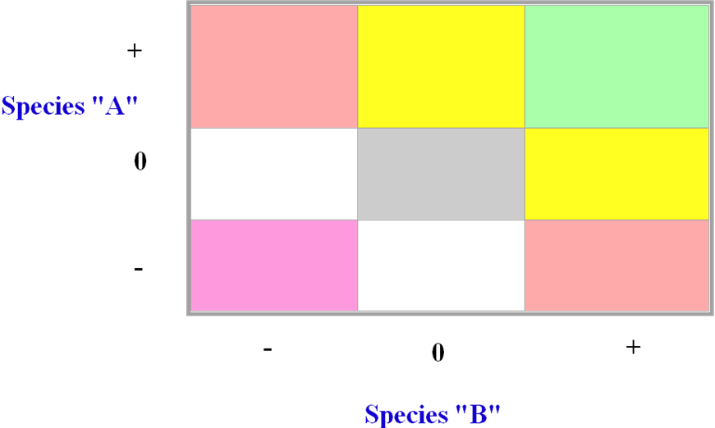

Succession Activity
The Floristic Relay Game:
The Rules

Number of players: 4-6
Object of the game: First player to reach the “Finish” square wins.

Step 1: Choose a dealer.

Step 2: Dealer shuffles the three decks one at a time. All players, including dealer, choose a game piece. Place game pieces in the “Start” square.

Step 3: Dealer places Event Cards face down in Future Events spot on the playing board. Place the Interaction Cards face down in their spot, and deal one character card to each player.

Step 4: Players will play with the same character card for the duration of the game.

Step 5: The dealer chooses the first Event Card and places it face up in the Current Event spot.

Step 6: Each player then plays according to the Character card directions, starting with the dealer and going clockwise.

Step 8: After all players have their turn, check the board for players who landed on the same square. These players are interacting.
- Interactions are played in the same order as Events (clockwise starting at the dealer)
- Two at a time, the interacting players draw one Interaction Card.
- Play according to the card.
- The interaction part of the round is over when no players are sharing squares.

Step 9: Repeat Steps 5-8 until all players have left the “Start” square. Write the order of the players on the sheet titled “How did the plant community change?” Continue with Steps 5-8 until a player wins. Write the order again at the end of the game.

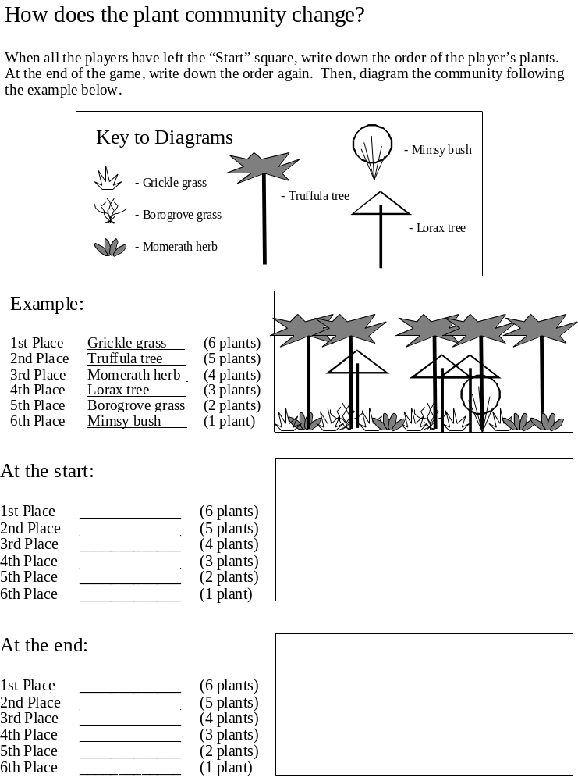
The Floristic Relay Game:
Discussion Questions:

Count the Event cards that were played. How many are in each category?

Event | Number of cards
Fire
Landslide
Grazing
No Disturbance

Which character did you play? What needs to happen in order for your character to win?

Will the winner always be the same?

Which plant did best when there were wildfires? What about when there was grazing or landslides?

Which plant did worst when there were wildfires? What about when there was grazing or landslides?

What do you predict will happen if all the Event Cards were No Disturbance cards?

Try it... Was your prediction correct?

Additional Succession Worksheet Questions

- Is this simulation based on the equilibrium or non-equilibrium model? Support your answer.

- How realistic is this succession simulation if it took place over 10 years, 100 years? What is missing in regards to the disturbance events?

- Based on the results of this simulation, how do you think the vegetation in the burned area of the Missionary Ridge fire responded? Will all the species prior to the fire exist after the fire? Will there be new species? Will all the species respond to the disturbance in the same way?

Winter Ecology Exercise

1. Prior to going outside and observing “winter ecology” list some ways in which plants and animals adapt to winter conditions?

2. As you walk around campus identify five specific examples of how plants adapt to winter (these can be some of the same ones listed above in question #1).

3. As you walk around campus identify five specific examples of how animals adapt to winter (these can be some of the same ones listed above in question #1)

4. List and/or draw any animal tracks you see. Where are the tracks located (e.g., near trails, in open areas, near vegetation, etc.) Provide any additional information regarding why you might be seeing tracks where you saw them as it relates to the distribution and abundance of species (think of the chart we discussed in class).

Mitosis Computer Activity

Log into: http://biog-1101-1104.bio.cornell.edu/biog101_104/tutorials/cell_division.html

Complete the following questions on this page regarding mitosis.

Name, identify, and describe the important events of mitosis.
- Review--Whitefish Mitosis
- Review--Onion Root Tip
- Question 1
- Question 2
- Question 3
- Question 4
- Question 5
- Question 6

At the bottom of the web page, find “Model mitosis and meiosis with the Cell Division Construction Kit (CDCK) and open this activity. Complete the activity by choosing 1) stage to simulate (choose one from mitosis); and 2) 2n ploidy of cell and click on “assignment” and the follow the instructions. You need to complete this activity 10 times using different ploidy numbers to insure you understand the phases of mitosis. Before you leave, you need to let me choose a simulation for you to do on your own and get CORRECT. In the space below, please draw two of your simulations to help you study for the exam.

Mitosis Stage: __________________ Mitosis Stage: __________________
2n Ploidy of Cell: __________ 2n Ploidy of Cell: __________

Meiosis Computer Activity

Log into: http://biog-1101-1104.bio.cornell.edu/biog101_104/tutorials/cell_division.html

Complete the following questions on this page regarding meiosis.

Name, identify, and describe the important events of meiosis.
- Review--Microsporocyte in Lily Anther
- Questions 1-6

Describe important similarities and differences between mitosis and meiosis.
- Question 1
- Question 2

Differentiate between the following pairs of terms: chromatid and chromosome; single- and double-chromatid chromosomes; homologous and nonhomologous chromosomes; haploid and diploid.
- Questions 1-6

At the bottom of the web page, find “Model mitosis and meiosis with the Cell Division Construction Kit (CDCK) and open this activity. Complete the activity by choosing 1) stage to simulate (choose one from meiosis); and 2) 2n ploidy of cell and click on “assignment” and the follow the instructions. You need to complete this activity 10 times using different ploidy numbers to insure you understand the phases of meiosis. Before you leave, you need to let me choose a simulation for you to do on your own and get CORRECT. In the space below, please draw two of your simulations to help you study for the exam.

Meiosis Stage: __________________ Meiosis Stage: __________________
2n Ploidy of Cell: __________ 2n Ploidy of Cell: __________

What Darwin Never Knew – Video Questions
Modified from : http://teachers.sduhsd.net/dmain/Biology/Evolution/What%20Darwin%20Never%20Knew%20Video%20Questions.pdf
1. How many living species are there on Earth?
2. What question could Darwin not answer?

3. What evolves to become the ancestor of all four-limbed animals?
4. Where was Darwin's most important stopping place on his voyage?
6. What was seen on the developing embryos of snakes?

7. What are humans supposedly ancestors of?
8. The Whippet is created by combining what two breeds of dogs?
9. What master work did Darwin publish?
10. What happened to the fur of the mice that lived on the darker rocks?

11. What letters does DNA contain?
12. What is needed to cause DNA variations?

13. How many genes are there in a human genome?
14. What percent of genes make our bodies?
15. What turns genes on and off?

16. What have the lake Sticklebacks lost on their bellies?

17. How many genes created the different finch beaks?
18. Land animals must be descendant of what?
19. What is found in the 375 million year old fish?
20. How much of our DNA is identical to the DNA of a chimp?
21. How many people had the gene that was missing letters?

22. What do the un-fused plates in a human head allow for?

23. What was the most interesting thing you learned from this video?

Natural Selection Activity

Background Information
In the book, The Origin of Species by Means of Natural Selection, Charles Darwin (1859) presented the following four postulates:

- Individuals within a species are variable.
- Some of these variations are passed on to offspring
- In every generation, more offspring are produced than can survive.
- Reproduction of individuals is not random, but rather it is selective. Some individuals will survive to reproductive age and produce fertile offspring. Those individuals that produce larger numbers of offspring will have greater reproductive fitness and contribute larger numbers of their genotype to successive generations.

Simulation of Evolution by Natural Selection

To learn how natural selection operates we will complete the following simulation. Each person represents an individual randomly sampled from a large population of a scavenging species of crab. The crabs in this population have four different possible claw shapes (cupped, dissected, flat, or tubed) which will be represented in our simulation by spoons, forks, knives and straws, respectively. The crab’s favorite (and only) food item is a bean. Crabs that collect fewer beans than the median crab will die.

We will begin the simulation with equal proportions of the four crab phenotypes. Each generation will last 1 minute or until the beans are all collected. When time is called, you will count your beans and I will get a total number of beans for each crab phenotype and a median for all phenotypes. If you are above the median value you were a REPRODUCTIVE crab. If you fall below the median value you were a NOT a reproductive crab. If you were reproductive, you will hold on to your feeding appendage and become your offspring for the next generation. If you were not reproductive, you need to get rid of your old appendage and you will be given a new appendage and will represent another crab’s offspring for the next generation (I will let you know what new appendage you need to use which will be based upon the proportion of individuals that reproduced for each phenotype. I will record these data from each generation on the board. At the end of the simulation, you will need to copy these data into the table.

Table 1. Raw Data

Number of Individuals of Each Phenotype
Generation Cupped Dissected Flat Tubed Total
0
1
2
3
4
5
6

Assignment

Figure 1. Number of individuals of each phenotype present per generation

0
1
2
3
4
5
6
4
8
12
16
20
Cupped

Dissected

Flat

Tubed

Generation

# in population

Questions

- Does this simulation include the three conditions necessary for evolution by natural selection to occur?

- Examine the graph. Have the frequencies of the variants changed across generations? If yes, describe these changes.

- Has evolution occurred in this population? Explain your answer and include your definition of evolution.

- What do you predict would happen in this population if we continued the simulation for another 50 generations?

Darwin Discussion Article Questions

Are theories and concepts from Charles Darwin still relevant today 150 years later?? Within your groups, divide into smaller groups of 2 and choose one of the current science articles to read. Each group with share within their smaller group after answering the questions below and will present one article to the entire class that they found most interesting addressing following questions.

1) What are the main findings of the research article summary?

2) What theory or concept of Charles Darwin does the research article address and provide an explanation or define this theory of concept in your own words.

3) Does the research article support or refute the theory or concept of Darwin? Support your answer with an example from the article summary.

Bottleneck Activity
Experiment
Examine phenotypes (colors) for entire bag and record this information. Count out the number of each phenotype for your bag. Randomly remove 20 M&Ms from the bag and count your phenotypes again. Randomly remove another 20 M&Ms from the bag and count phenotypes. Randomly remove 20 more M&Ms from the bag and count phenotypes.
Data Recording
# of phenotypes in original bag: _______________________

# of phenotypes and # of individuals after removing 20 from population

# of phenotypes and # of individuals after removing 20 from population

# of phenotypes and # of individuals after removing 20 from population

Questions:
1) What happens to the phenotypic distribution as the population shrinks? Has genetic diversity been lost? How do you know this?

2) Choose one endangered species (plant or animal) and explain how their population has declined. What are the causes of the population decline and what is needed to restore populations?

Pollinator/Plant Exercise adapted and modified from: https://www.msu.edu/course/bs/110/lab/Labs/Lab7_Pollination/Pollination%20Lab%20Spring%2009_final.

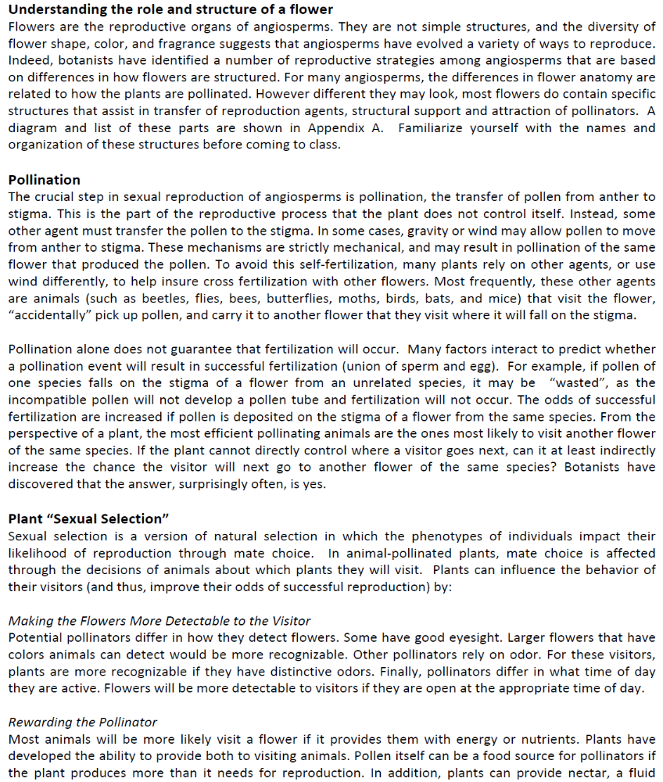
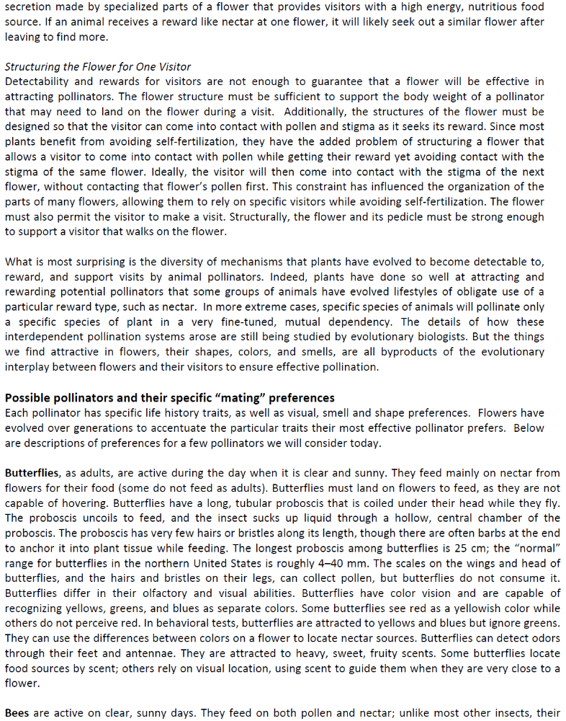

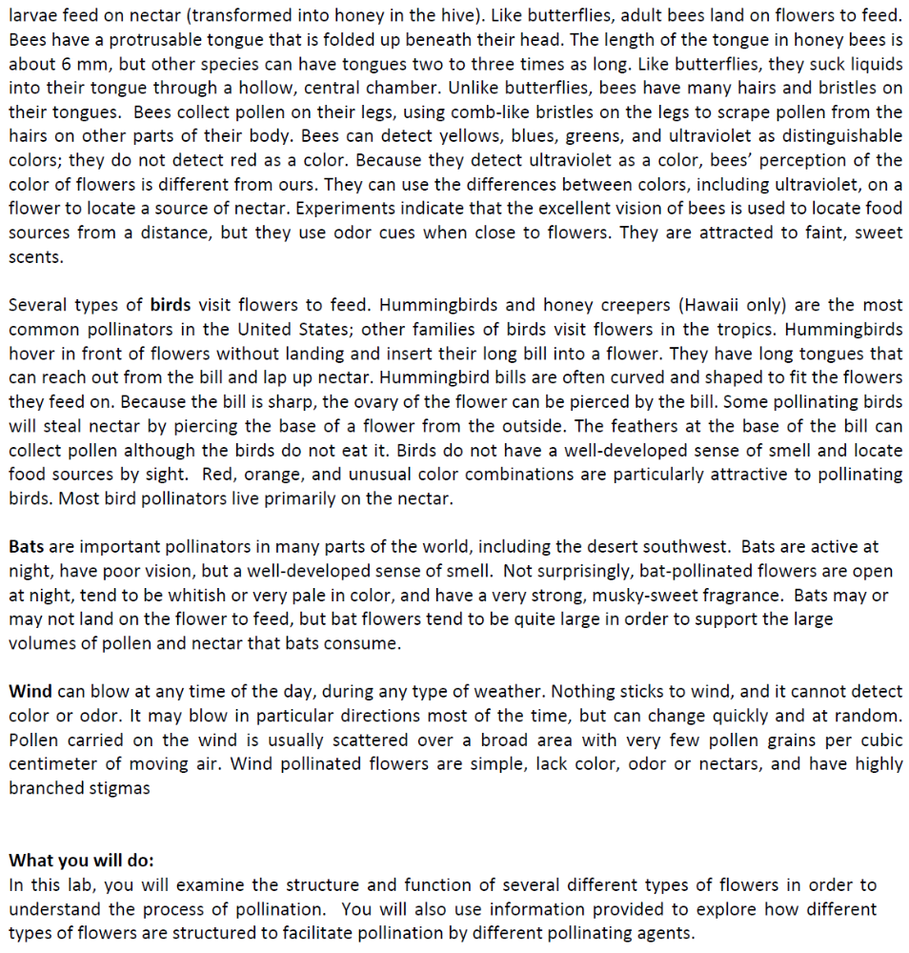

We will watch parts of the following video

to illustrate the intricate relationship between plants and pollinators. During the video think about the advantages and disadvantages of the highly adapted relationships between some of the plant/pollinator examples.

Complete the chart below using information from your reading and the video clips. Fill in as much information as possible. Some of the information you might not know but can guess or it might not have a specific adaptation and you can put “general” if it is generic or “n/a” if it doesn’t apply to that pollinator. Extra spaces are provided for additional pollinators or plant characteristics that you want to describe.

Pollinator | Flower Size | Flower Color | Flower Shape | Flower Smell | Flower Nectar
Butterfly

Bee

Bird

Wind

Bat

Ant

Water

Next look at the flower specimens you have in front of you and try to identify what type of pollinator it might have based on your chart above and fill in the chart below.

Pollinator | Flower

Next sketch and label the flower parts of at least three of the flowers you have (more if you have time) using the information provided below on separate pieces of paper. Do any of the flowers have a reward for their pollinator?

Monohybrid Cross:
In humans, brown eyes (B) are dominant over blue (b)*. A brown-eyed man marries a blue-eyed woman and they have three children, two of whom are brown-eyed and one of whom is blue-eyed. Draw the Punnett square that illustrates this marriage. What is the man’s genotype? What are the genotypes of the children?
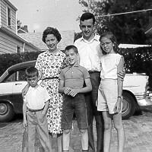
(* Actually, the situation is complicated by the fact that there is more than one gene involved in eye color, but for this example, we’ll consider only this one gene.)

If blue is recessive, what must the woman’s genotype be?

If that’s her genotype, what kind(s) of gametes (eggs) can she produce?
and/or

If the man has brown eyes, but has a blue-eyed child what must his genotype be?
(if you don’t understand why, review the testcross problem)
If that’s his genotype, what kind(s) of gametes (sperm) can he produce?
and/or
If they have children:

Testcross:
In dogs, there is an hereditary deafness caused by a recessive gene, “d.” A kennel owner has a male dog that she wants to use for breeding purposes if possible. The dog can hear, so the owner knows his genotype is either DD or Dd. If the dog’s genotype is Dd, the owner does not wish to use him for breeding so that the deafness gene will not be passed on. This can be tested by breeding the dog to a deaf female (dd). Draw the Punnett squares to illustrate these two possible crosses. In each case, what percentage/how many of the offspring would be expected to be hearing? deaf? How could you tell the genotype of this male dog? Also, using Punnett square(s), show how two hearing dogs could produce deaf offspring.

A deaf female is genotype dd. What kind(s) of gametes (eggs) can she produce?
and/or
If the hearing male is DD, what kind(s) of gametes (sperm) can he produce?
and/or
If he is Dd, what kind(s) of gametes can he produce?
and/or
If he is DD: what percentage of offspring can hear? )_______

If he is Dd: what percentage of offspring can hear? )_______

If two hearing dogs were both Dd, what kind(s) of gametes (eggs/sperm) could each produce?

If they are bred with each other: what percentage of offspring can hear? )_______

Sex-Influenced Traits:
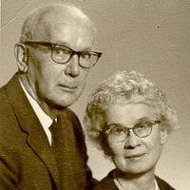
Baldness in humans is a dominant, sex-influenced trait. This gene is on the autosomes, not the sex chromosomes, but how it is expressed is influenced by the person’s sex (due to hormones present, etc.). A man who is BB or Bb will be bald and will be non-bald only if he is bb. A woman will only be bald if she is BB and non-bald if she is Bb or bb (it’s almost like B is dominant in males and b is dominant in females). Actually, because of the influence of other sex-related factors, most women who are BB never become totally bald like men do, but rather, their hair becomes “thin” or sparse. If two parents are heterozygous for baldness, what are the chances of their children being bald? Use a Punnett square to illustrate this. Note: because the sex of a person does make a difference in how the gene is expressed, you need to set this up as a dihybrid cross to account for the sex of the children.

The woman is XXBb. What kind(s) of gametes (eggs) can she produce?
and/or and/or and/or
Her husband would be XYBb. What kind(s) of gametes (sperm) can he produce?
and/or and/or and/or
If they have children: _____of the children will be bald daughters, _____will be normal daughters,
______will be bald sons, and _____will be normal sons;
* |  | * | *
 |  | *

A non-bald man marries a non-bald woman. They have a son and a daughter. If the son becomes bald, what are the chances that his sister will, too? Use a Punnett square to show this cross.

A non-bald man has to be XYbb. What kind(s) of gametes (sperm) can he produce?
and/or and/or and/or
Any non-bald woman can be XXBb or XXbb. The bald son could be XYBB or XYBb, but since the father is XYbb, we know the son cannot be XYBB (remember the first problem?). The son has to be XYBb, therefore this mother has to be XXBb (if she was XXbb he couldn't have a B). What kind(s) of gametes (eggs) can she produce?
and/or and/or and/or

If they have children:
*

The child marked with an asterisk (*) is the son in the problem.
The daughter could be ______or______, bald: _____% chance.

A woman’s mother is bald, but her father is not. Her older brother is rapidly going bald. She is an acrobat who hangs by her hair. Should she change her profession before she goes bald, too? Use a Punnett square to show this.

If the mother is bald, she has to be XXBB. What kind(s) of gametes (eggs) can she produce?
and/or and/or and/or
If the father is not bald, he has to be XYbb. What kind(s) of gametes (sperm) can he produce?
and/or and/or and/or

What will the genotype of all their male children (like her brother) be?
What will the genotype of all their female children (like her) be?
Will she go bald? || Yes, get a different job. || No, keep hanging by her hair.

From: http://biology.clc.uc.edu/courses/bio105/geneprob.htm

Practice Genetics Problems—Computer Lab Exercise

The following link http://www.ksu.edu/biology/pob/genetics/intro.htm
will take you to pages containing genetics practice problems. Students who already understand the material can use these questions to review. Students who are having trouble understanding how to work all or just some of the problems are provided with hints that will take you stepwise through the problem. Additionally, you can use these pages for vocabulary review. As you go through the problems, if you are unsure of the meaning one or more of the terms highlighted in blue, just click on it and you will be taken to a definition page. Review the formation of gametes, monohybrid crosses and dihybrid crosses. You may see one or more of these questions on your exam.

Monohybrid Crosses
For each of the following monohybrid crosses, you will need to solve them using a Punnett square. Be sure to identify the parent genotypes, what your letters represent, and answer each of the questions. Show all of your work. Answer on another sheet of paper and turn in.

- The Jones family has eight children, all of whom are girls. What is the chance that the next child will be a boy? Explain.

- In a certain animal, black fur (B) is dominant to white fur (b). Determine the expected genotypic ratios and phenotypic ratios resulting from crosses between:

- Homozygous black x white
- Two heterozygous blacks
- Heterozygous black x white

- In bats, long wings (L) are dominant to short wings (l). Two long wing bats produced 49 short wing and 149 long wing offspring. What were the probable genotypes of the parents? What proportion of the long wing bats should be heterozygous?

- In garden peas, inflated pods (P) are dominant to constricted pods (p).
- If a homozygous plant for inflated pods is crossed with a homozygous plant for constricted pods, what ratio of phenotypes would you expect in the F2 generation? Why?
- What ratio of genotypes would you expect in the F2 generation?

- In summer squash, white fruit color is dominant (F) and yellow (f) is recessive. A squash plant that is homozygous for white is crossed with a yellow one. Predict the appearance of:
- The F1 generation
- The F2 generation
- The offspring of a cross between an F1 individual and a homozygous white individual.

Dihybrid Crosses
For each of the following dihybrid crosses, you will need to solve them using a Punnett square. Be sure to identify the parent genotypes, what your letters represent, and answer each of the questions. Show all of your work. Answer on another sheet of paper and turn in.

- Cross a black long haired mouse with a white, short haired mouse. Black coat color and long hair are dominant. Both animals are homozygous for their traits. What is phenotype ratio of the F2 generation?

- Cross a blue, fat aardvark with a white, skinny aardvark (nocturnal ant eating mammal in South Africa). Blue and fat are dominant. What is the phenotype ratio of the F1 generation?

- Cross a white spotted dog with a black, non-spotted dog. White and non-spotted are dominant. The white dog is heterozygous for color. The non-spotted dog is heterozygous for spots. What is the phenotype ratio for the F1 generation?

The Future of Food Movie Worksheet Name _______________________
1. What was the green revolution?

2. What are huge fields with only one variety of crop called?

3. What is the problem with genetic uniformity (all one type of crop)?

4. What does an herbicide do?

5. What is a patent?

6. What happened to Percy the farmer?

7. How did GM Monsanto corporation seeds end up in Percy’s field?

8. What % of farmers save their seeds?

9. What was the courts decision against Percy?

10. What are some disease that have been cured by biotechnology?

11. How are genes placed into corn?

12. Why are bacteria used in genetic engineering?

13. Why are antibiotic marker genes used?

14. When did GMOs first become an issue to the public?

15. How many US government agencies are responsible for food safety?

16. Why aren’t American foods labeled as GMO?

17. What are some threats to crop yields (the amount of crop harvested)?

18. How are super weeds controlled?

19. What has happened to the number of acres planted with GM crops in the U.S. over time?

20. How did GM corn get into Mexico?

21. What do you think genetic diversity is?

22. What happened around the world to U.S. GM made crops?

23. How much money is left for a farmer after they sell their crops?

24. How do farmers stay in business when they are losing so much money?

25. What happened to the rats and butterflies that ate GM crops?

26. What industries have been consolidated (controlled by a few big businesses)?

27. What is the main reason so many people around the world are starving?

28. What is terminator technology?

29. What other organisms are being genetically engineered?

30. How will sustainable agriculture be used?

31. What are some alternatives to GM crops?

32. What is the most interesting this you learned from this video?

Review of Mono and Dihybrid Crosses

1a. Free ear lobes are dominant to attached ear lobes humans. If a homozygous, recessive male marries a homozygous dominant female, what will be the phenotypic and genotypic ratios of their offspring?

1b. If one of these female children were to marry a man with her genotype, what would be the phenotypic ratio of their offspring?

2. Cross a black eyed and black haired cat with a blue eyed and white hair cat. Black eyes and black hair are dominant traits. Both animals are homozygous for their traits. What is the phenotypic ration of the F2 generation?

3. Cross a pink stripped butterfly with a yellow, non-stripped butterfly. Pink and non-stripped are dominant. The pink butterfly is homozygous dominant for color. The non-stripped butterfly is heterozygous for strips. What is the phenotype ratio for the F1 generation?

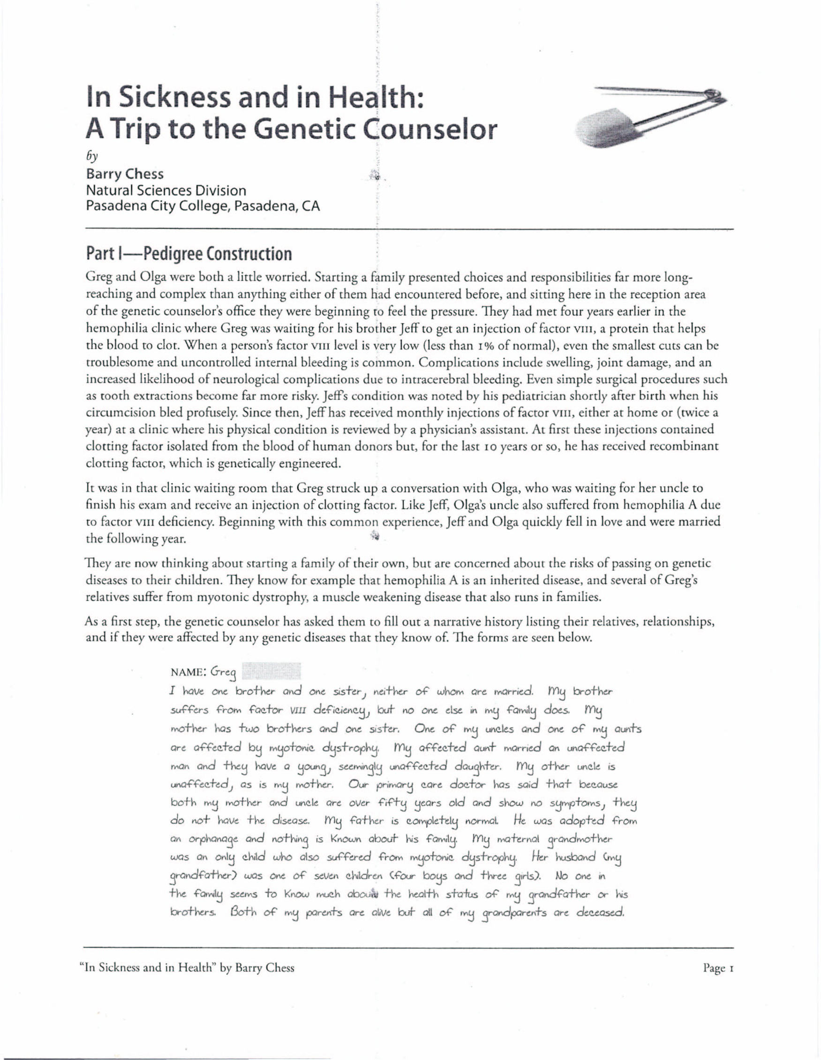

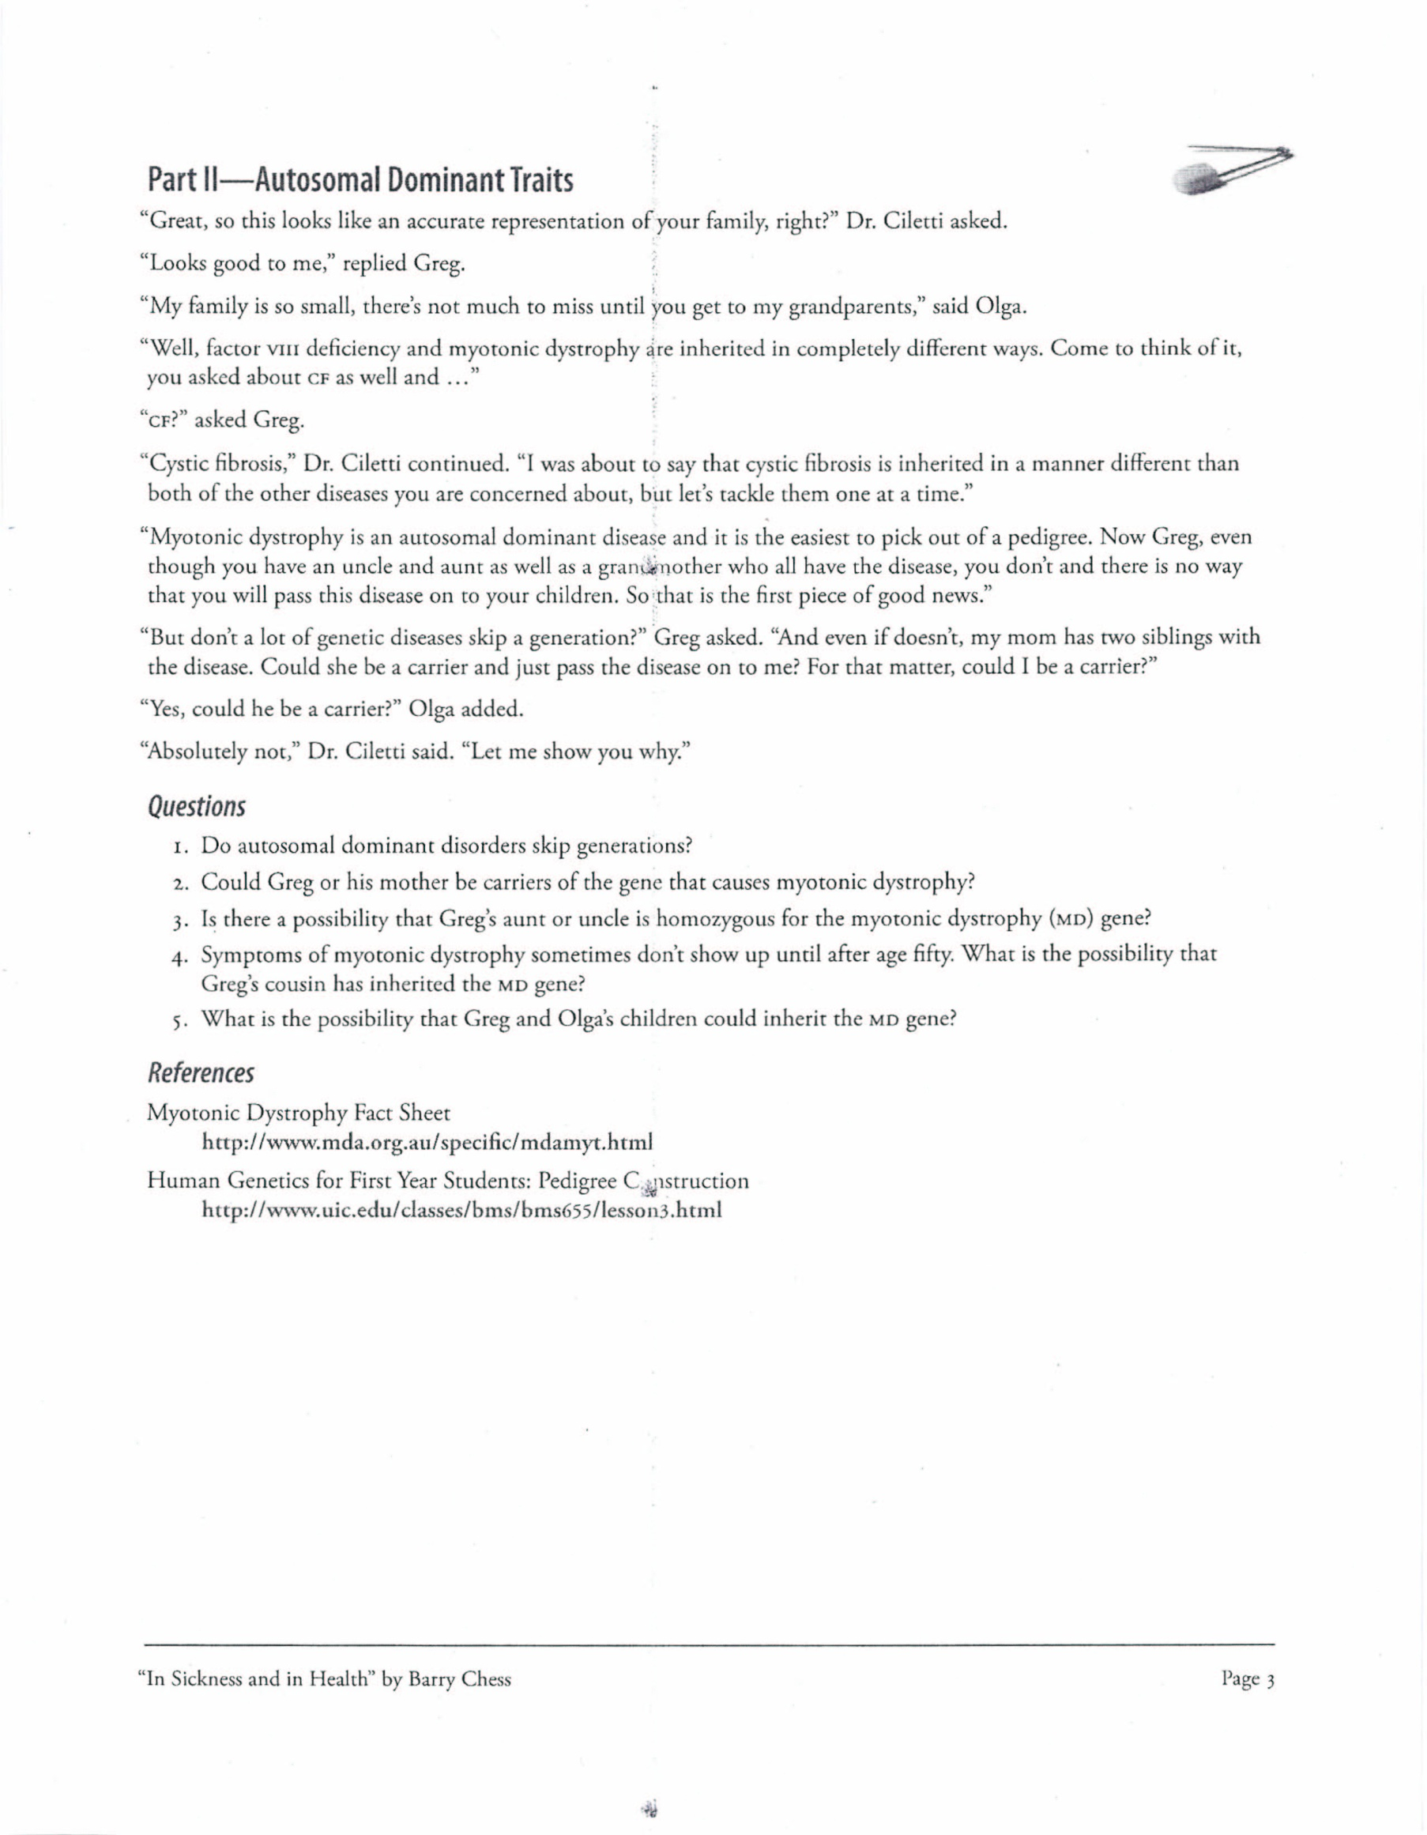
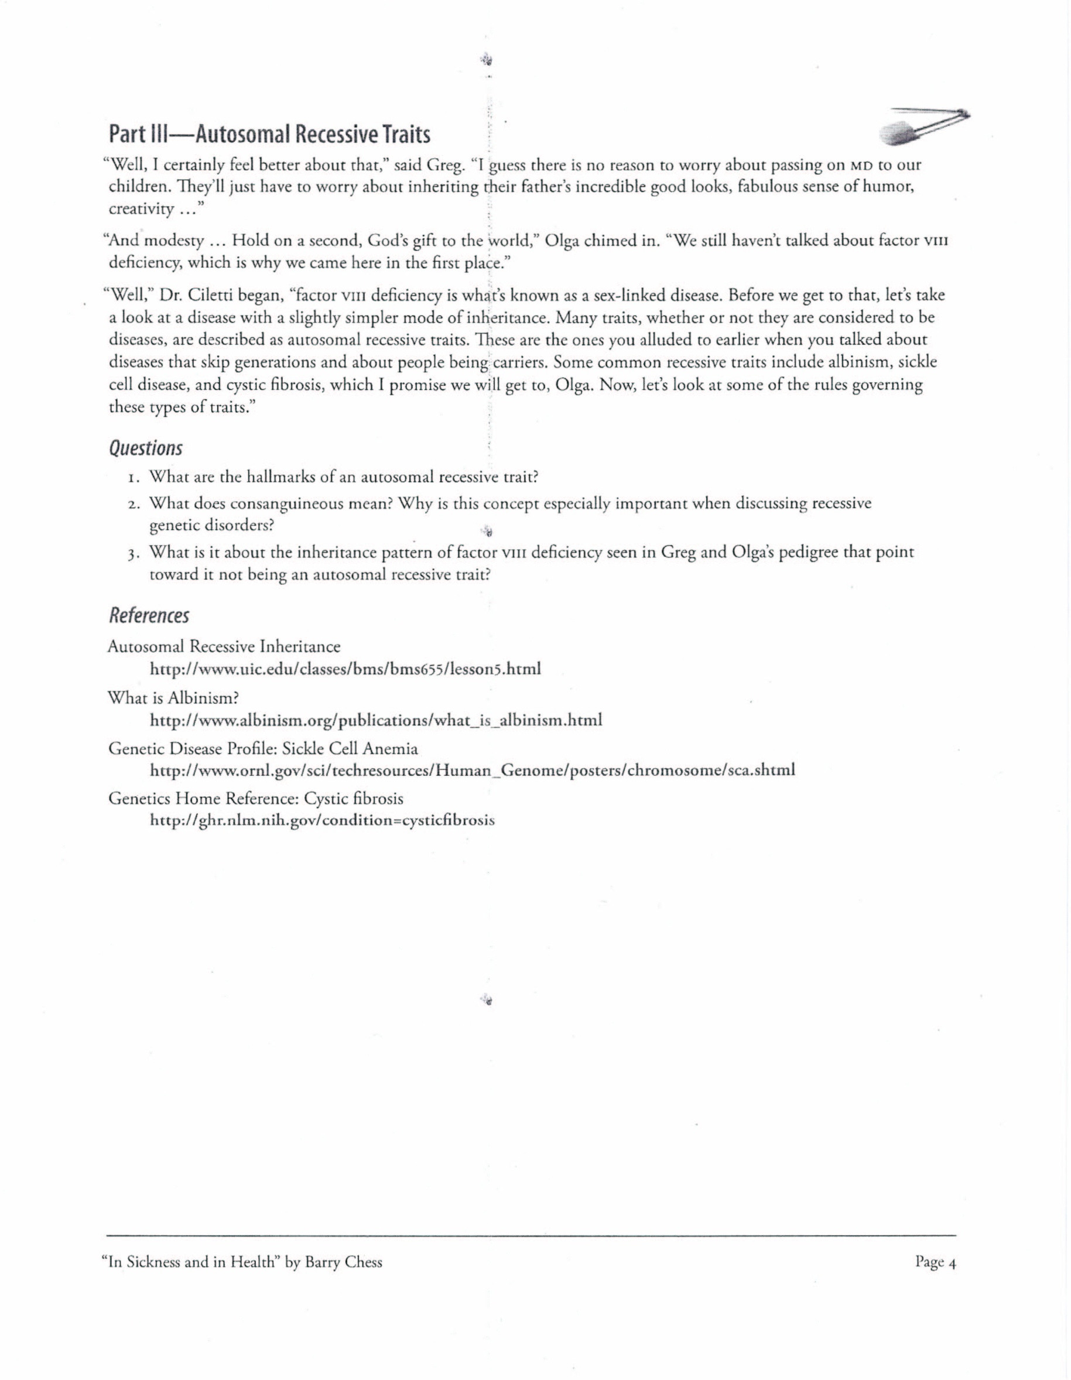
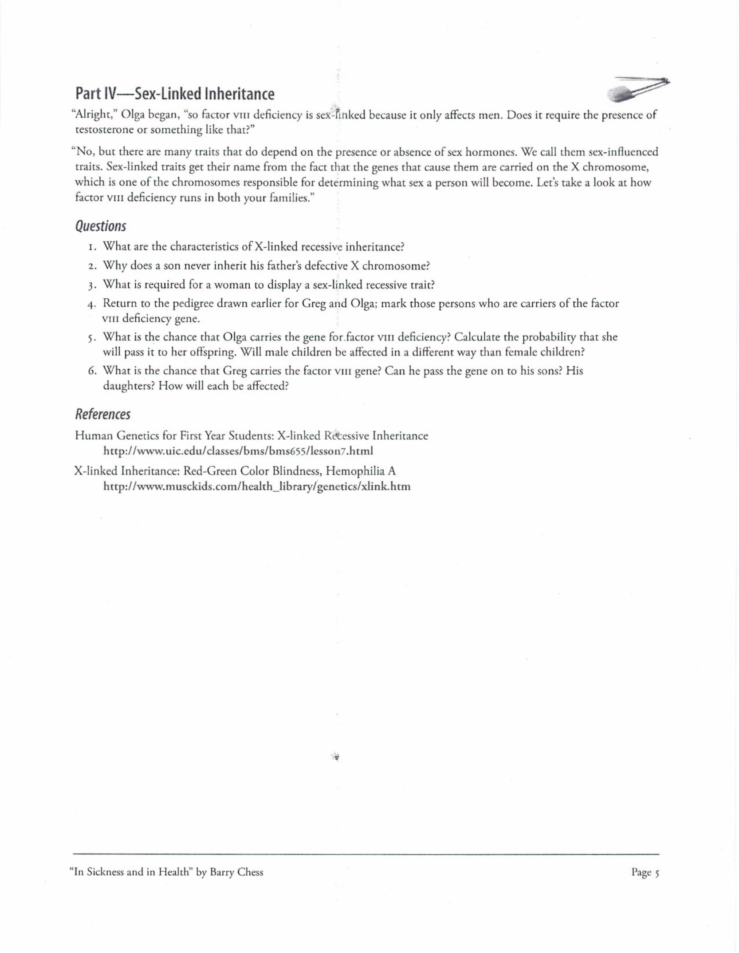
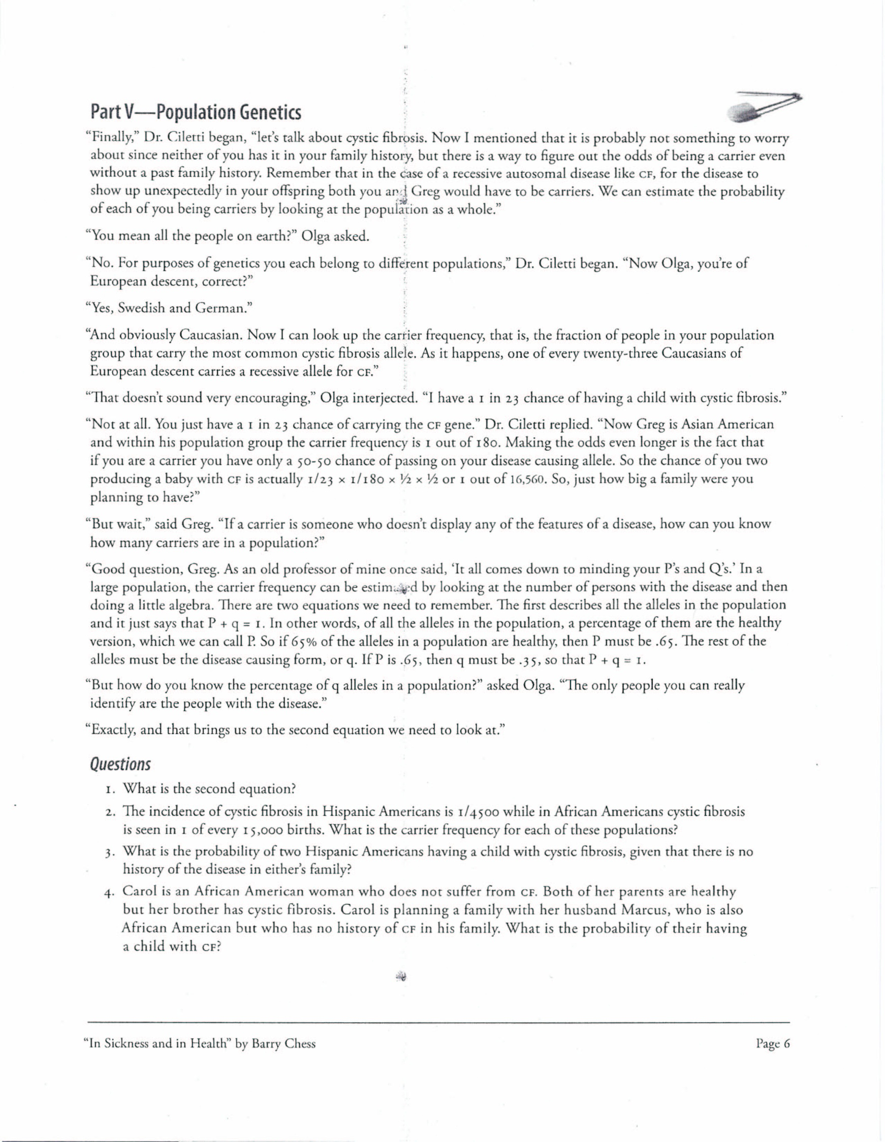
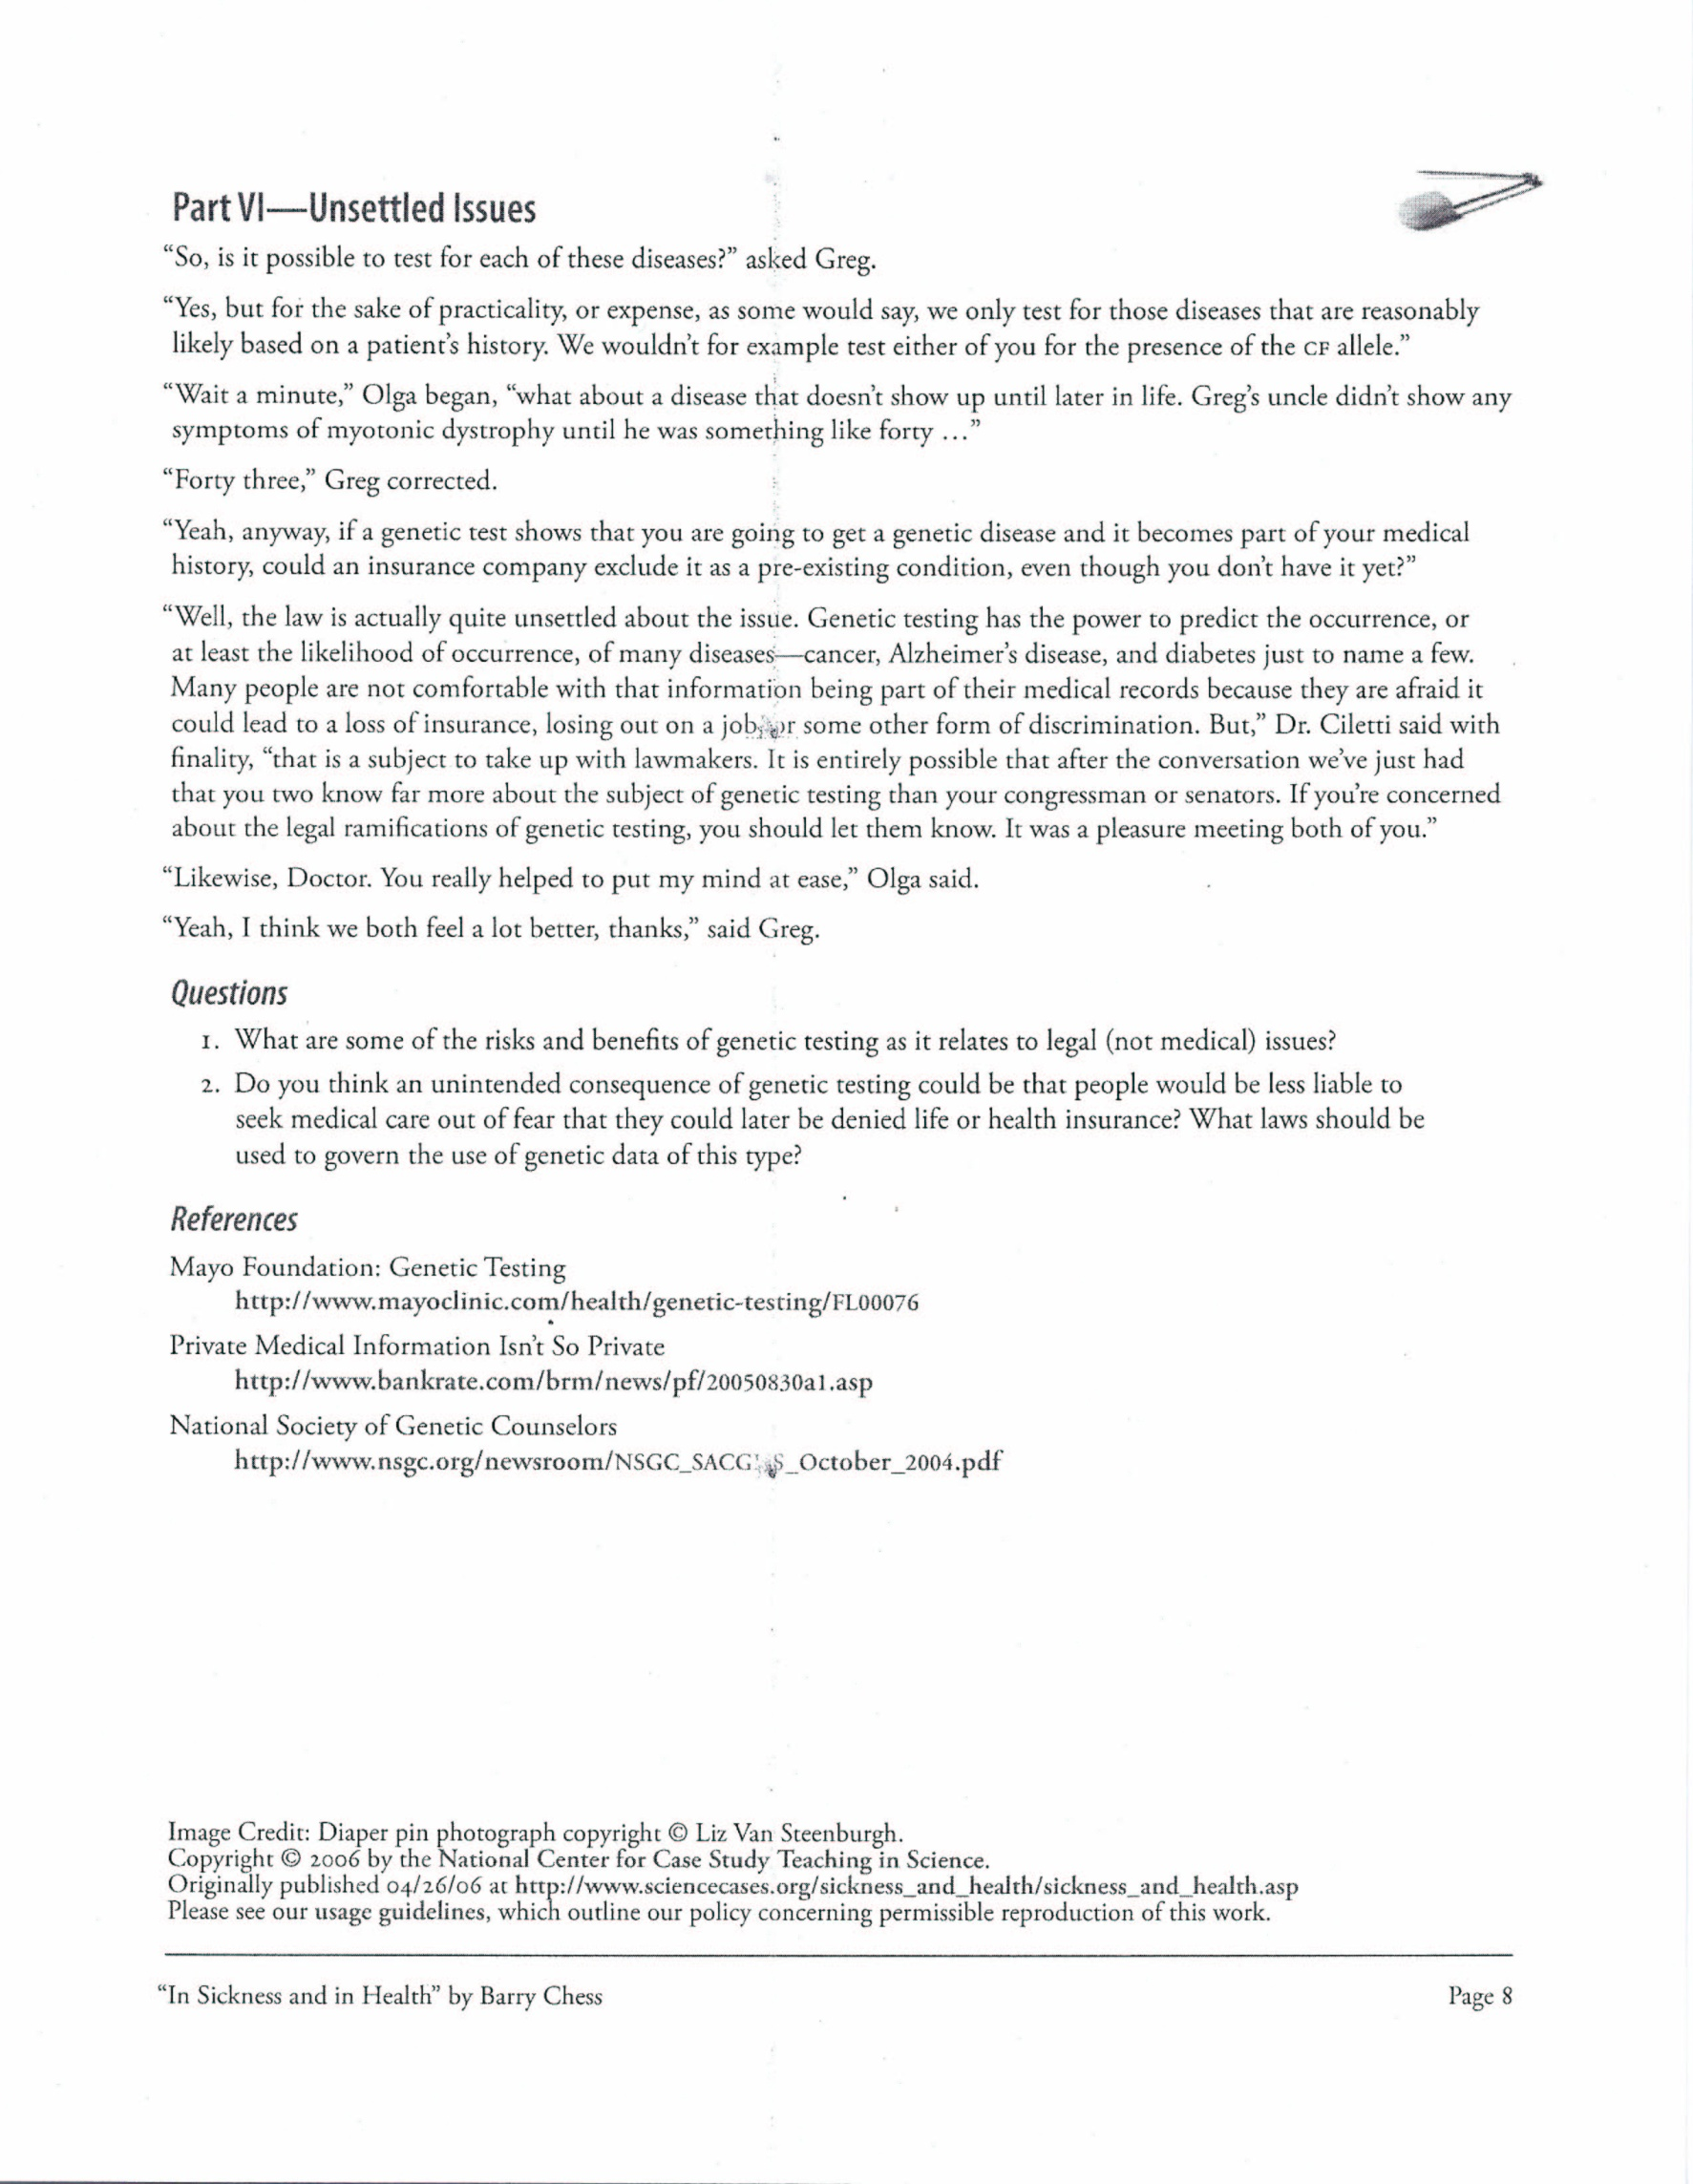
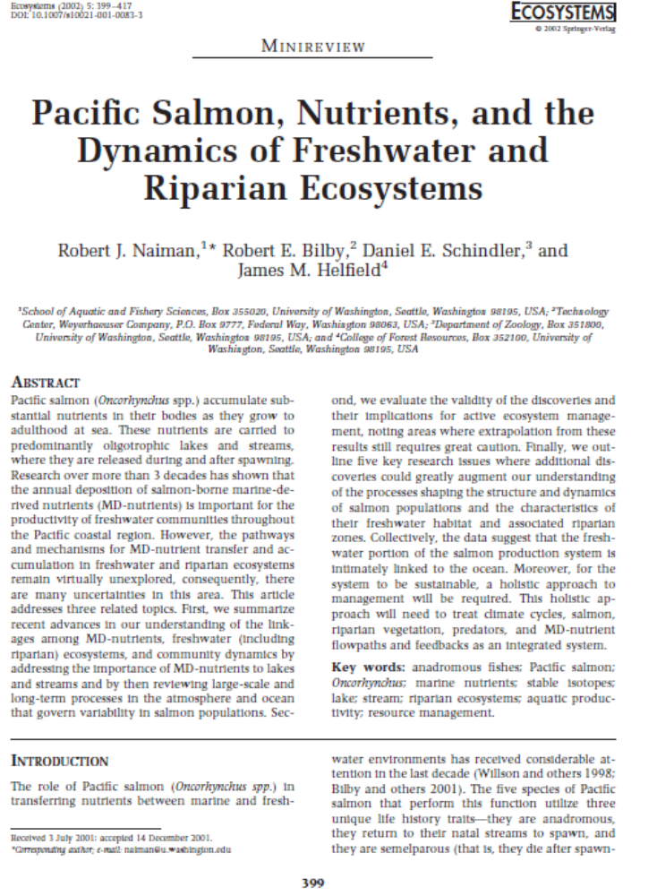
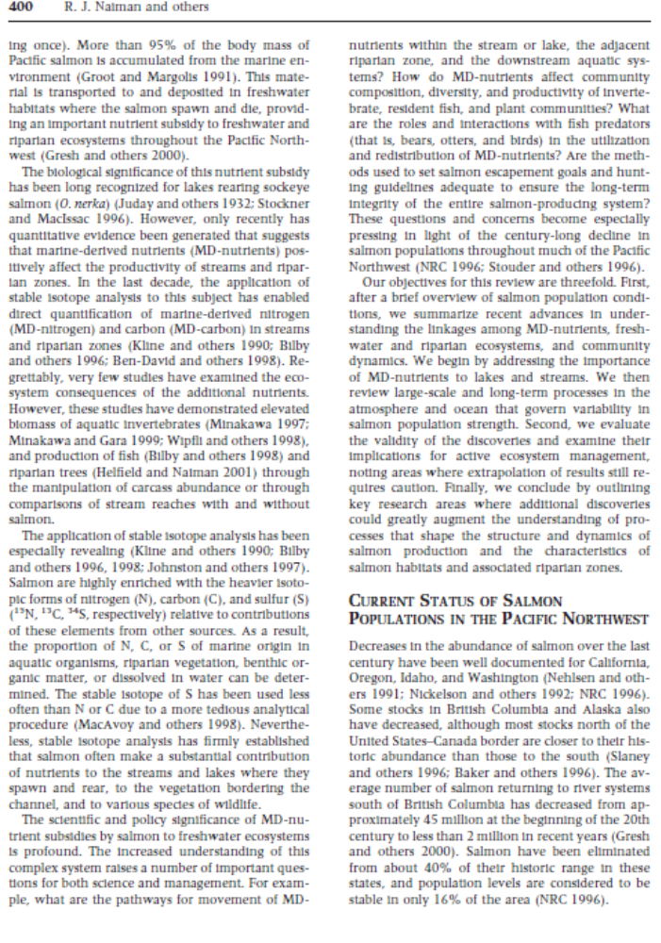
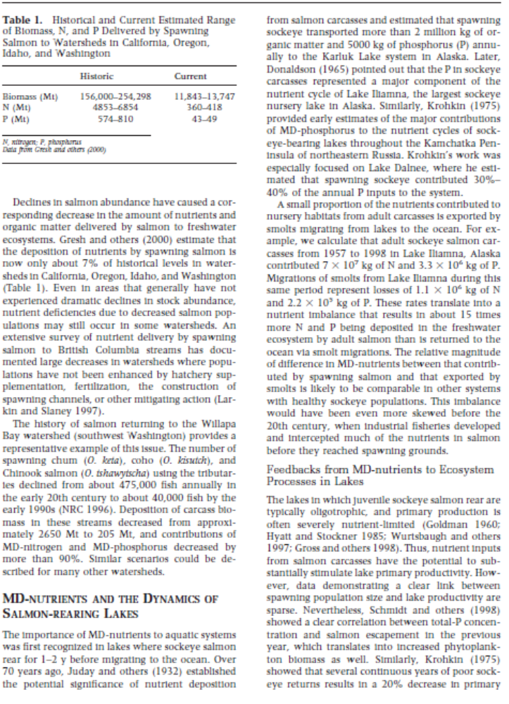
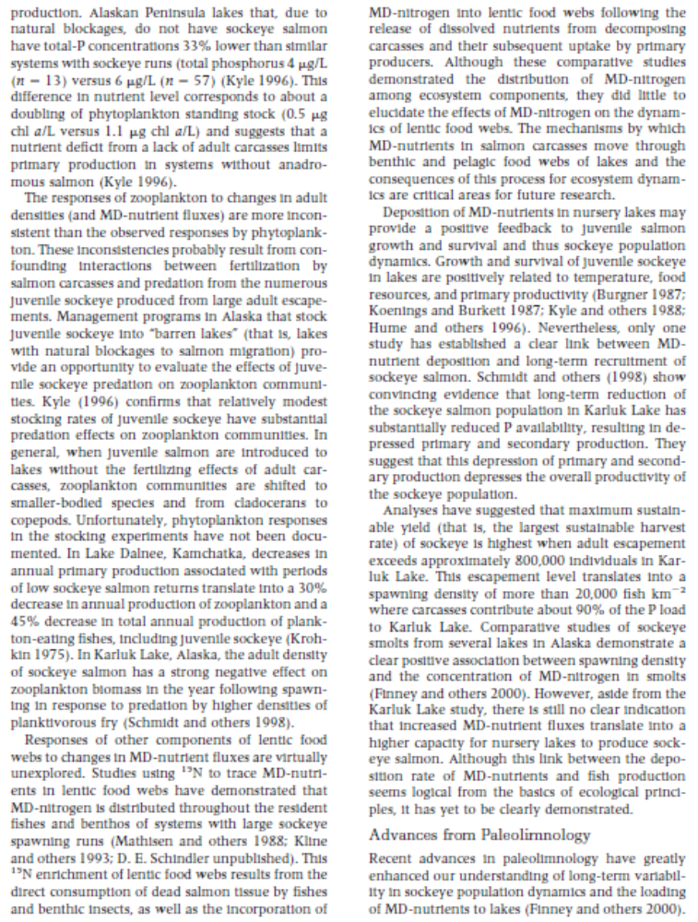
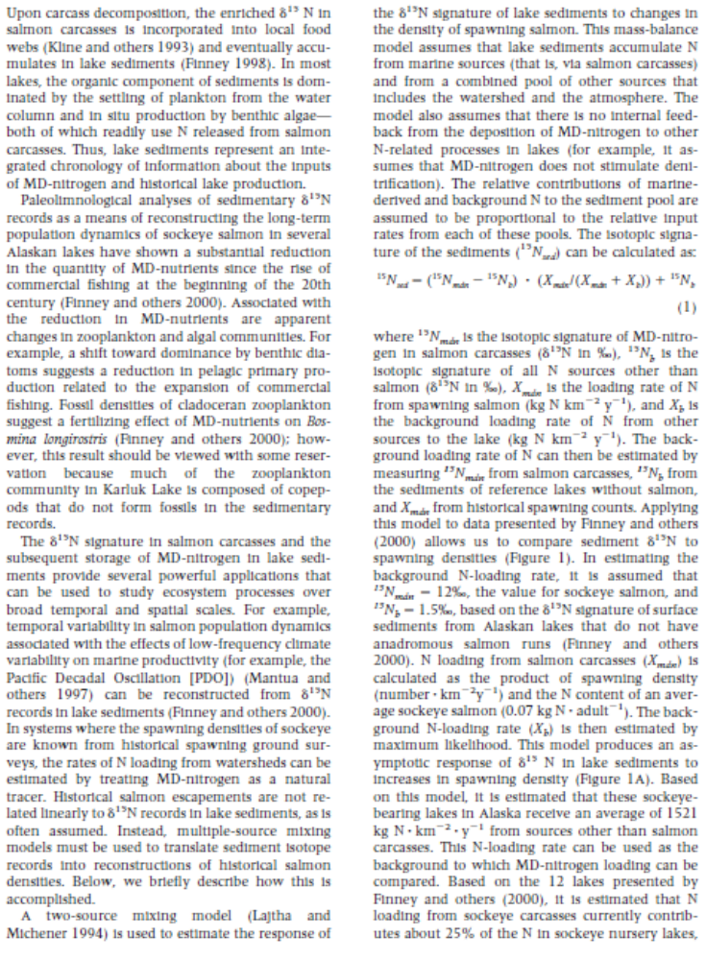
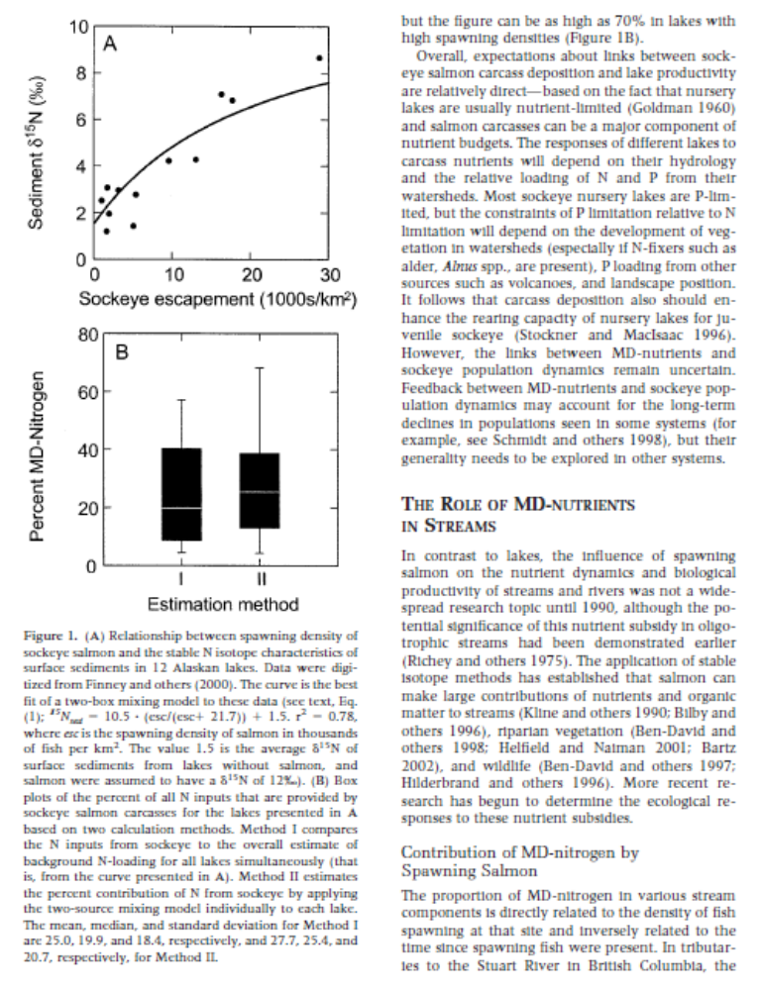
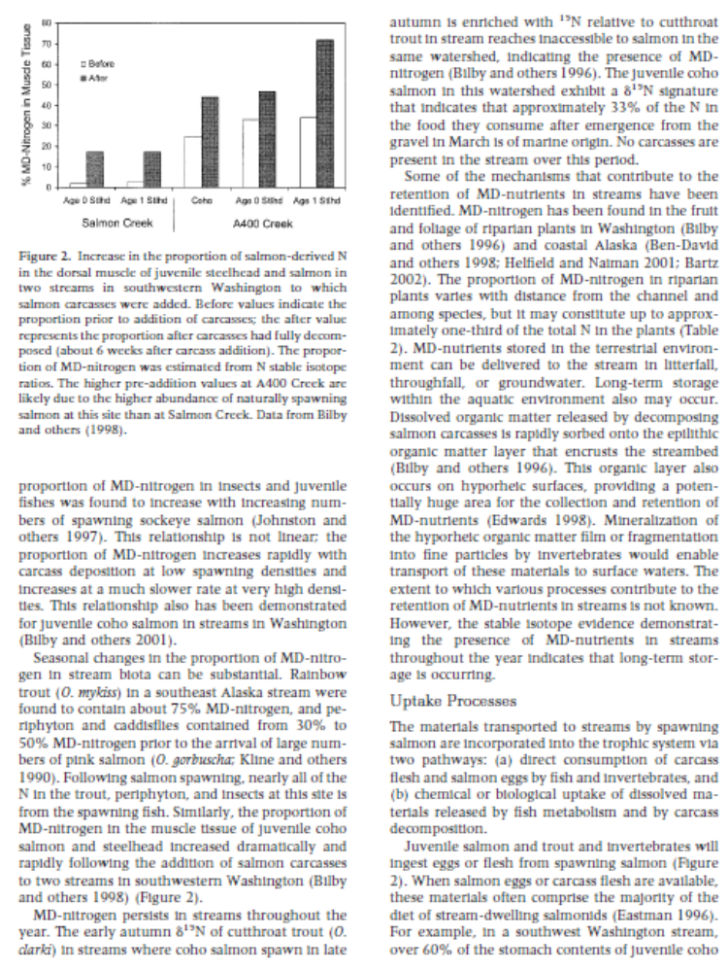
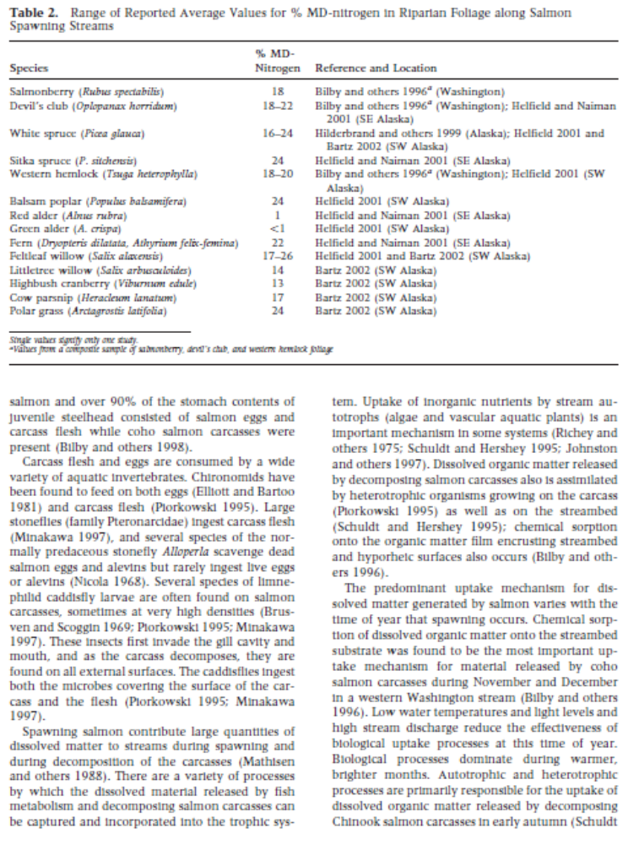
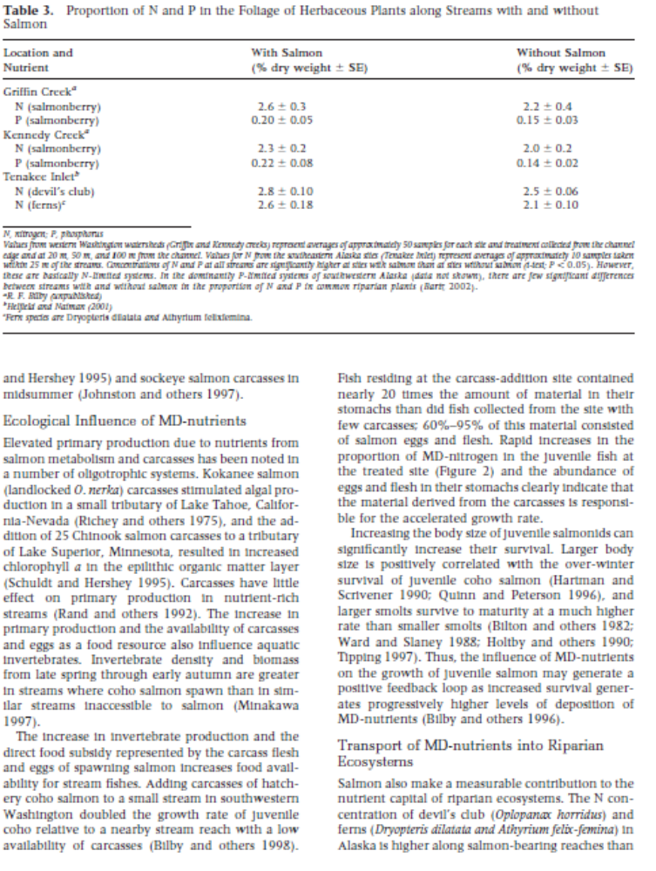
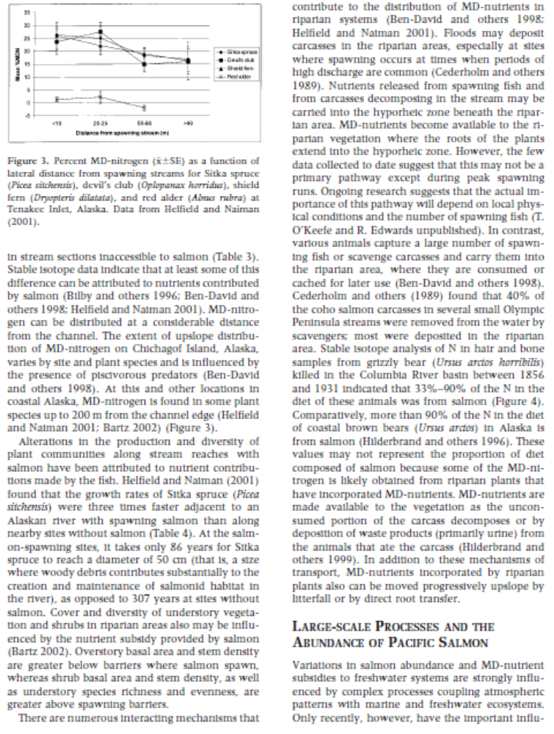
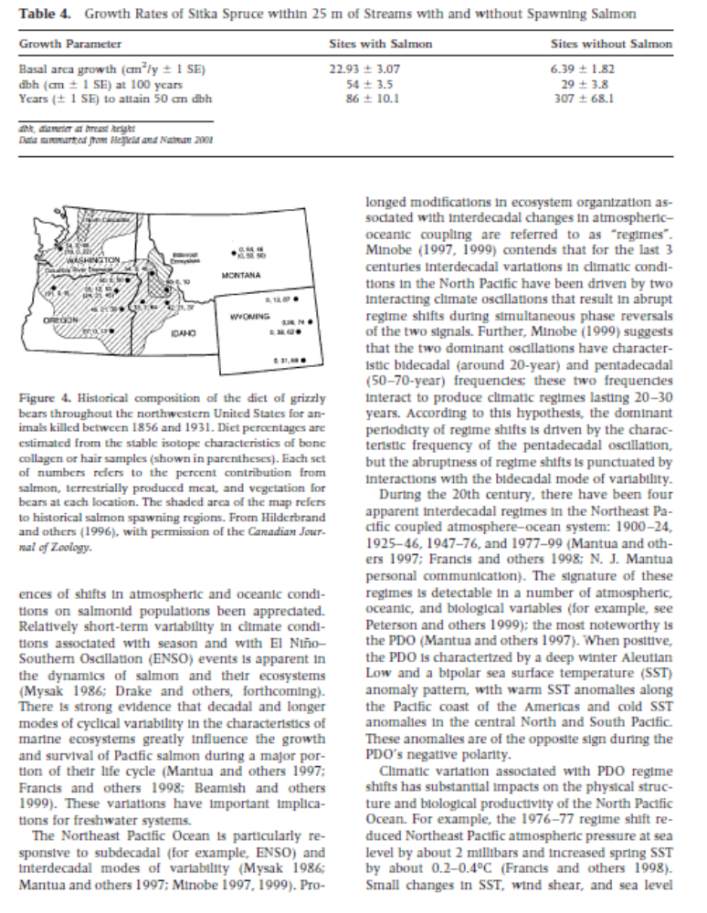

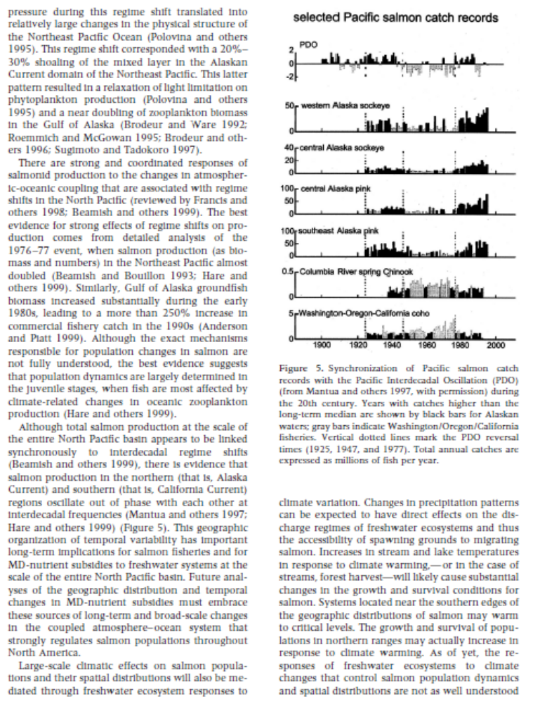
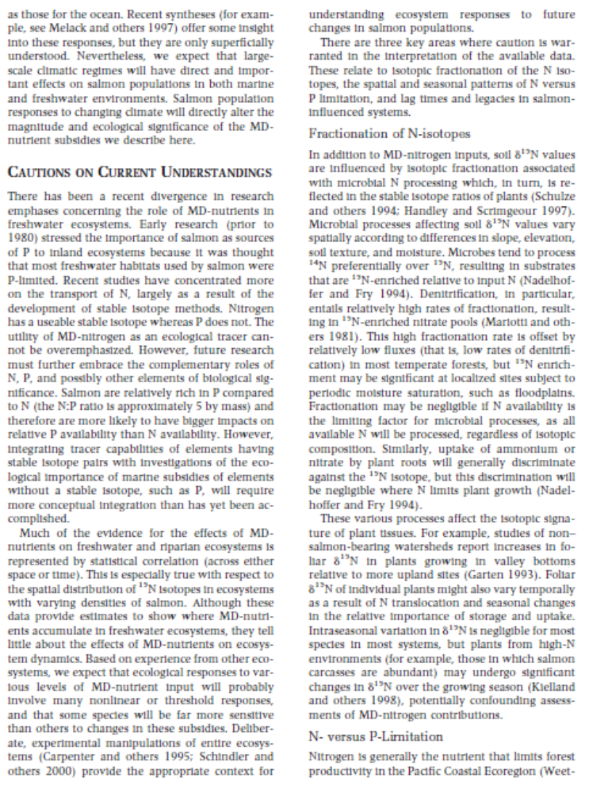
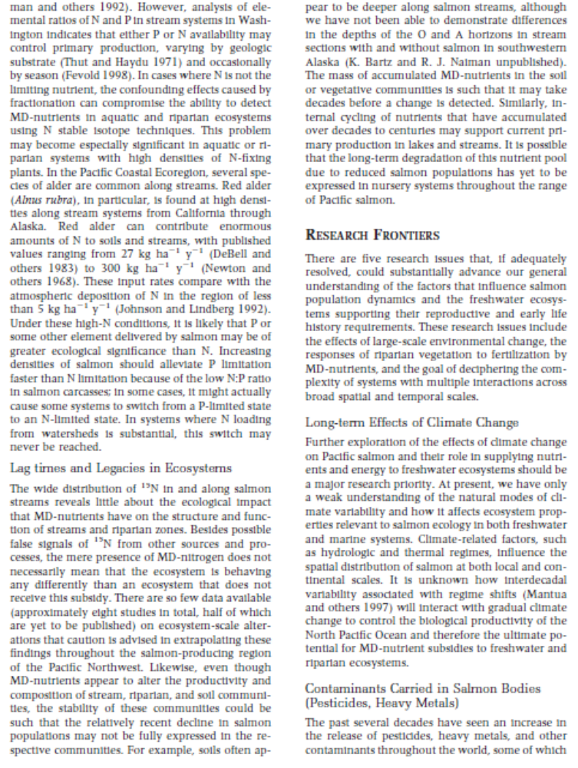
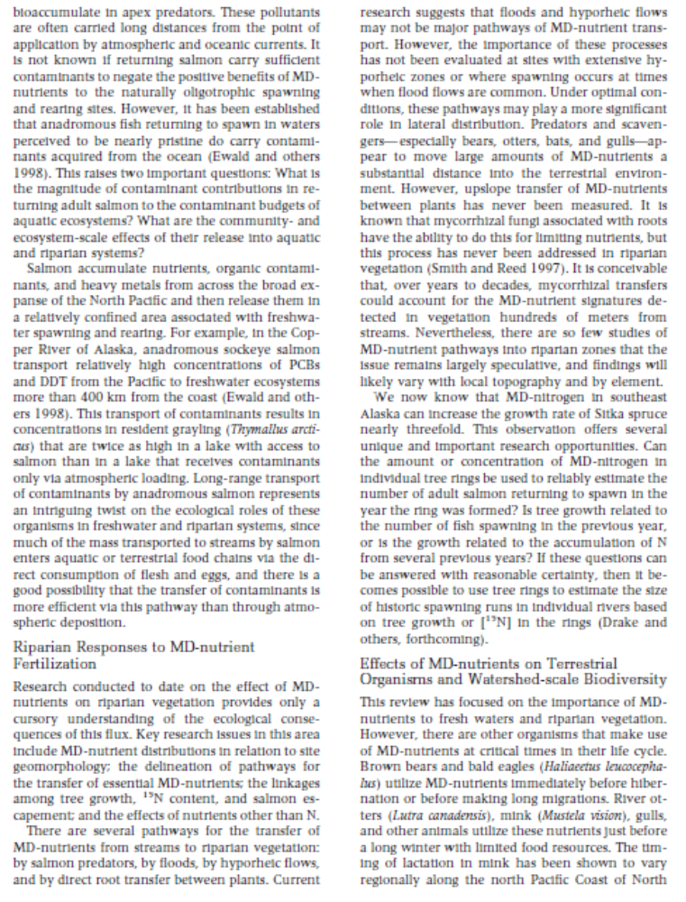

Human Population Worksheet
- How would you describe the life history strategy of humans?

- What type of population growth does the human population exhibit presently?

- How has the human population been able to continue growing?

- What environmental limitations have define K throughout human history? (You should identify at least four)

- What even in human history caused the single largest drop in the human population?

- Which type of growth curve model best describes human population growth between 600 & 400 years before present (BP)?

- What do you predict will be the future of human population growth?

- What is likely to be the next limiting variable (i.e., what will impose the next K)?

Measuring your Ecological Footprint

Objectives:
- Understand the impact your lifestyle has on the natural environment.
- Learn ways to reduce your lifestyle impact on the natural environment.

Background:

How much nature does your lifestyle require? This Ecological Footprint Quiz estimates how much productive land and water you need to support what you use and what you discard. After answering 15 easy questions you'll be able to compare your Ecological Footprint to what other people use and to what is available on this planet. (Redefining Progress Webpage http://myfootprint.org/en/).
We will go to the computer lab to calculate our ecological footprint using the updated Ecological Footprint Quiz designed by Redefining Progress and the Earth Day Network.

Methods:
- Open up the following website: http://myfootprint.org/en/
- Move curser over the US and choose English for language.
- Answer the quiz questions honestly and as accurately as possible.
- Record your results below.
- Click on the take action button and calculate how you could reduce your ecological footprint and record these results on the same paper.
- Answer the questions below.

Results:

Questions:
  - What was missing from the ecological footprint survey?

  - Do you feel your ecological footprint was accurate?

  - Do you feel everyone should have the opportunity to live your lifestyle (why or why not)? If so, how would you propose to acquire the resources necessary for this to occur?

  - How do you think your ecological footprint compares to your classmates, other individuals in the U.S., in Europe, in third world countries? Try calculating your footprint as if you lived in Africa, India, or China. How does footprint compare to your original footprint?

  - Which of the four categories (food; mobility; shelter; goods/services) contributed to the most to your ecological input? What steps, if any, are you willing to take to reduce your ecological footprint? How much would this reduce your ecological footprint (refer to your take action results)?

In-Class Activity: Conservation Biology

1) What are some issues to consider when thinking about designating core areas? For example, what characteristics of the landscape (both physical & social) would make for a high quality core area, low quality core area?

2) What are some issues to consider when thinking about designating corridors? Again, what characteristics of the landscape (both physical & social) would make for a high quality corridor, low quality corridor?

3) Look at the Durango 1:250,000 map. If you were trying to create a linkage of core areas and corridors for black bear from Vallecito Reservoir to Telluride how would you do this?

4) What about from Vallecito Reservoir to Bayfield? How would you do this?
You need to think about major water drainage basin, different vegetation communities, land ownership (BLM, NPS, other federal, private, state, tribal lands, USF&WS, USFS), roads (highways, state, dirt roads, roadless areas), livestock density, # of recreationists, human population, housing density, density of dams, total timber harvested, road edge effect, wilderness areas, major animal suitable habitat (wolf, bear, lynx, wolverine, pronghorn), mining, etc.

Biology 112 Climate Change and Ecosystem Disruption Assignment
Answer the following questions:
1) Define Ecosystem Services

2) Describe the current Rocky Mountain Pine Beetle outbreak in North America and how it related to climate change.

3) List and give examples and describe the four classes of ecosystem services. If you had to prioritize efforts on two of these classes are any more important than the other classes? Explain your rationale.

4) Discuss the three prevention categories of the beetle infestation as it relates to public health.

5) List three ways to educate the general public that the health of ecosystems and their personal health are related?



