Validation of the Hydraulic-Open Channel Flow Model
August 2000
HEC-RAS with Observed Data

D.R. May¹, A. Lopez², L. Brown²

Abstract: Validation of the HEC-RAS water surface profile model is completed by comparing measured profiles for two study reaches at two different flowrates to modeled results. Straight, uniform reaches are chosen to aid in controlling the model variables. The model is calibrated using the Manning's roughness coefficient and data associated with the lower flowrate. The calibrated coefficients are then used in the validation process using data associated with the second, higher flowrate. Results show that the HEC-RAS model does quite a good job modeling the water surface on the low gradient study reach with a 1.2% validation error. However, on the very steep study reach the error is much larger at 20.8%. The author's best estimated n-values were consistently lower than the calibrated values.

INTRODUCTION

For several decades the hydraulic-open channel flow model HEC-2 had been the accepted standard for performing flood studies in the United States and to a large extent worldwide. The model was developed by the U.S. Army Corps of Engineers, Hydrologic Engineering Center (HEC), for calculating water surface profiles for one-dimensional, steady, gradually varied flow in natural or man-made channels (USCOE 1982).
During the late 1990's HEC developed the river analysis system (HEC-RAS) as part of its "Next Generation" of hydrologic engineering models. It replaces the well accepted HEC-2 model. When fully implemented it will be capable of modeling one-dimensional steady flow, unsteady flow and sediment transport (USCOE 1998).

OBJECTIVES AND PROCEDURE

Engineers frequently must apply the HEC-RAS model to channels with vastly different geometries and hydraulic conditions. Overbank flow during flood stage, meandering channels, varying roughness and other factors make this a complicated task. It is usually difficult for the modeler to verify the accuracy of the results beyond an order of magnitude check or rough comparison with documented, historic flood levels, when available. The objective of this study is to begin the development of a set of model validation data that can be used to gain an intuitive feeling for the accuracy of the HEC-RAS model under varying hydraulic conditions.
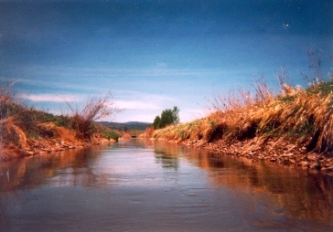
The validation process consists of comparing computed water surface profiles with observed data. To gain an understanding of what parameters effect model accuracy as many variables as possible must be controlled. To accomplish this, two study reaches are chosen that have straight channels, with no overbank flow and relatively uniform geometry and bed material composition.
Since the channel roughness is a dominant model parameter an attempt is made to control this variable as
¹ Prof., Engrg. Program, Dept. of Physics and Engrg., Fort Lewis College, Durango, CO.
² Undrgrad. Res. Asst., Dept. of Physics and Engrg., Fort Lewis College, Durango, CO.
well. Water surface profiles are measured at two different flowrates for each study reach. The first data set is used to calibrate the model with the Manning's roughness coefficient, n. Calibrated n-values are then used with the data from the second measured profile to validate the model. In this way it can be asserted that the differences (errors) between the computed and measured profiles are not wholly or substantially due to any one of these variables: magnitude or variability of the roughness coefficient, channel sinuosity, overbank flow or cross sectional variability. Errors can then be attributed to the basic accuracy of the model's computational algorithm applied to specific geometry, small contributions from the supposedly controlled variables mentioned here and the influence of other uncontrolled minor variables e.g.(one-dimensional, gradually varied flow, inaccurate discharge, channel geometry,etc.). This process is repeated for both study reaches.

STUDY REACHES

The first study reach is a 380 m (1246 ft) stretch of the Florida Canal located east of Durango, Colorado. The canal is part of a US Bureau of Reclamation irrigation project which supplies water to farms on the Florida Mesa. The canal, shown in Figure 1 is a stable
manmade channel with a gradient that is controlled by a series of drop structures. Water runs in the canal from mid-May through October. The maximum capacity is

FIG. 1. Florida Canal.
about 5 m³/s (176 ft³/s). The channel bed consists mainly of sands, silt and some scattered, small
cobble. The average bed slope for study reach is 0.00078 m/m. The sinuosity for this reach is 1.00.
The second study reach is located on the Florida River just below Lemon Reservoir, north of Durango, Colorado. It is a high gradient mountain river with an average bed slope of 0.0145 m/m. See Figure 2.

FIG. 2. Florida River.
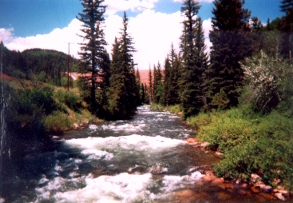
The length of the study reach is 238m (781 ft) and the sinuosity is 1.02. Bed material consists of cobbles
and boulders. Flow in this river is controlled by releases
from Lemon Reservoir, which is located immediately upstream of the study site. The Florida River is the diversion source of water for the Florida Canal and hence the shared name.

DATA COLLECTION

HEC-RAS is dependent on geometric, hydraulic,

and hydrologic data. Geometric data consists of cross-sectional geometry collected at periodic stations along the study reach. Fifteen cross-sections are uniformly distributed at about 28 m (92 ft) intervals along the Florida Canal. Seven sections on the Florida River have separation distances ranging from 23 m to 66.5 m (75 ft to 218 ft).
Sections are surveyed from the top of the left bank to the top of right bank. Cross sectional data are collected using an electronic total station and data collector. Elevations are based on an assumed, local datum.
Cross-section plots are shown for the Florida Canal and Florida River in Fig. 3 and 4 respectively. Sections are oriented from left to right looking downstream.
Modeling results can vary depending on the number sections. Typically, it is suggested that sections be spaced on the order of 90 m (300ft) to 150 m (500 ft) apart.
If sections are spaced too far apart the computational algorithm may become unstable and have difficulties balancing the energy between sections. A common remedy is to insert additional sections. In practice the additional sections are frequently interpolated from the immediate upstream and downstream sections, thus alleviating the need for further fieldwork.
In this study, section spacing on the Florida Canal is well within the range to assure proper model operation based on surveyed sections. No interpolated cross-sections are required. On the Florida River however, the steep gradient produces more dramatic energy changes between cross-sections and the default model settings result in a recommendation to include additional sections. Runs made with just the surveyed sections are compared to those made with the

FIG. 3 Sample cross-sections for the Florida Canal
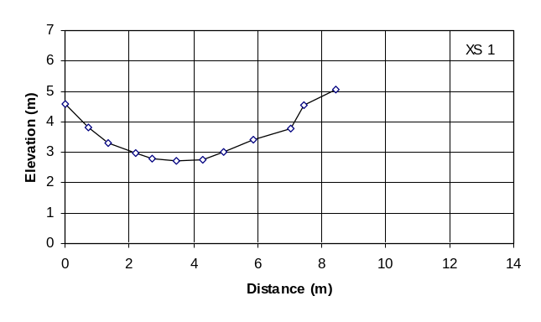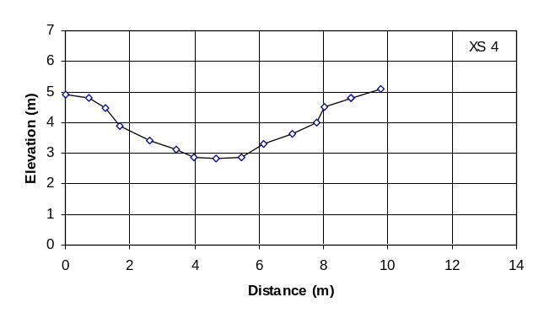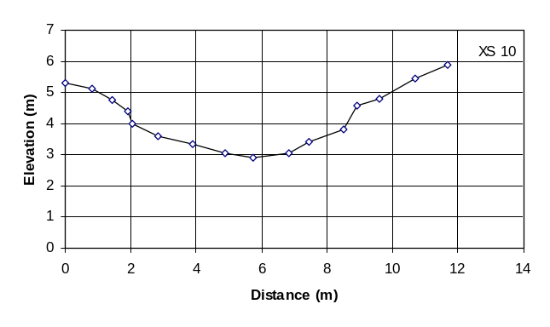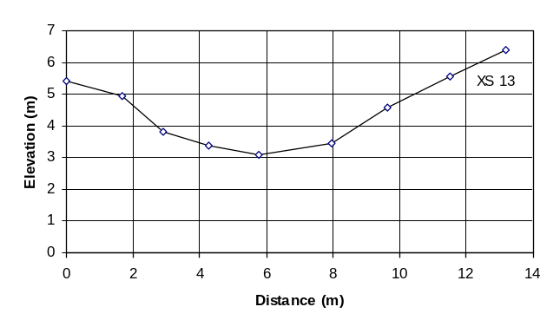

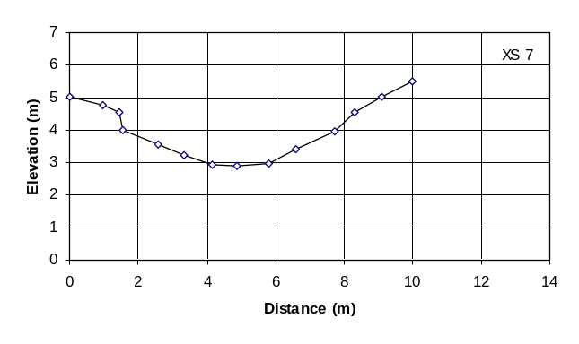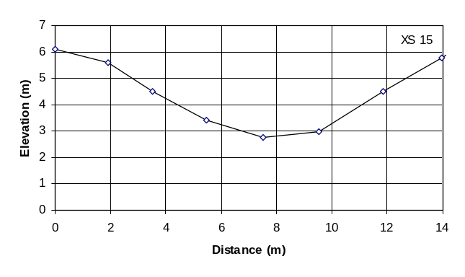FIG. 4. Sample cross-sections for the Florida River.

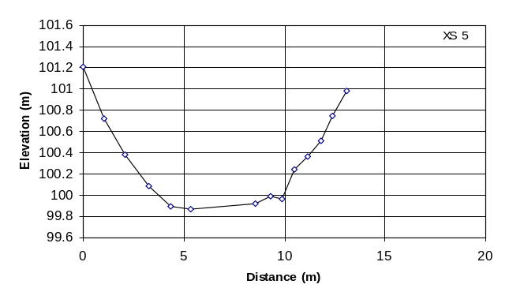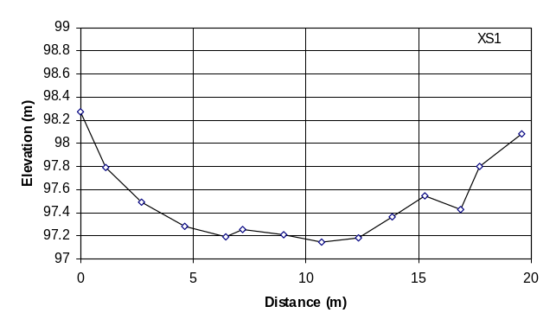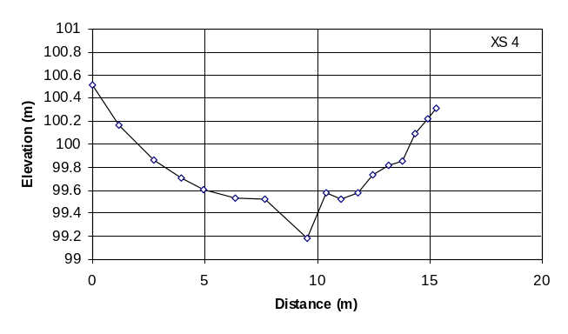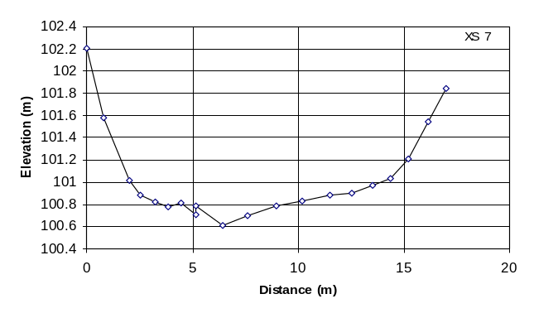

suggested, additional, interpolated sections. The differences in the profiles between these two cases are small.
Actual water surface profiles for each study reach at each flowrate are also surveyed. This is accomplished by surveying the water surface elevation at each cross-section. The profiles are shown in Fig. 5 and 6. Some random error in this measurement is inevitable especially on the Florida River due to the nature of steep, mountain rivers. The water surface elevation at any given section varies across the section due to local turbulence caused by large boulders, etc. The relatively calm water near the bank is used as the measurement location.
Flowrates for the Florida Canal are measured using a Price AA current meter and the standard procedure for use of this instrument. Two sets of measurements are made at cross-section seven and averaged for both the low and high flow cases. The lower flow was gaged at 2.65 m³/s (93 ft³/s) and the high flow at 4.24 m³/s (150 ft³/s). Florida River discharge is obtained from the operator of Lemon Dam. The flows for this study are 6.94 m³/s (245 ft³/s) and 16.28 m³/s (575 ft³/s).

MODEL CALIBRATION AND VALIDATION

The HEC-RAS model is calibrated against the Mannings roughness coefficient (n-value) using the measured water surface elevation data from the low flow case. An n-value is first estimated based on the author's previous modeling experience and in consultation with textbook guidelines. Using this as a starting point the n-value is progressively changed until an optimization parameter, P, is minimized. P is calculated using,

P=(Σ_{i=1,t}(E_{i}-E_{ci})²)^{½}

Where E is the measured water surface elevation, E_{c} is the computed water surface elevation at each cross-section i and t is the total number of sections. The resulting n-value is the calibrated n-value.
In addition to the optimization parameter an average difference, D, in the water surface is computed using,

D = (Σ_{i=1,t}(E_{i}-E_{ci})²/n)^{½}

This metric represents the average vertical distance, over the study reach, that the computed elevation is above or below the measured elevation and provides an intuitive measure of the accuracy.
Model validation provides an assessment of the model's ability to accurately reproduce known results. This is performed by running the model at the high flowrate with the calibrated n-values. The computed water surface profile is compared to the measured profile and P and D are determined. This process is repeated for both study reaches.

RESULTS

Calibration on the Florida Canal began with an experienced based estimate of n equal to 0.021. This is used with the data associated with a flowrate of 2.65
m³/s (93 ft³/s). The same n-value is used for all cross-sections in the study reach. The resulting optimization parameter, P is 0.352 m and the average difference, D
is 0.091m (0.30 ft). After several iterations P is minimized at 0.065 m with a calibrated n-value of 0.030. The average difference, D, dropped to 0.017 m (0.06 ft). This means that prior to calibration the
average measured water surface elevation exceeded the computed elevation by 9.1 cm while after calibration the difference is 1.7 cm. Calibration reduced the error by a factor of 5.35. As a fraction of the average hydraulic depth for the reach, 0.63m (2.07 ft),
this translates to a drop in error from 14.3% to 2.7%. Hydraulic depth is defined as the flow area in the channel divided by the top width.
Validation of HEC-RAS using the Florida Canal data at the larger flowrate, 4.24 m³/s (150 ft³/s), and the calibrated n-value of 0.030 resulted in a P of 0.042 m and a D of 0.011 m (0.04 ft). This average difference, D, translates to a modeling error of 1.2% of the average hydraulic depth (0.93 m, 3.05 ft).
For comparison, the estimated n-value (0.021) on the Florida Canal is used with the high flow data and the value of D is 0.054 m (0.18ft) or an error of 5.8%. When the profile computed for the high flow is calibrated with the measured profile the calibrated n-value remains the same as for the low flow case, 0.030.
Figure 5 shows the water surface profiles for the Florida Canal for both flowrates. The calibration run used the low flow data and the validation used the high flow. As seen, both the calibration and validation did a good job matching the measured profile. These results are quantified in Table 1. Note that the HEC-RAS run using the best user estimate of n is shown on Figure 5 and in Table 1. For clarity it is not shown on Figure 6.
FIG. 5. Water surface profiles for the Florida Canal.
Similar computations are performed using the Florida River data. The experienced based estimate of n is 0.050 resulting in a P of 0.524 m and a D of 0.198 m (0.65 ft) at the low flow of 6.94 m³/s (245 ft³/s). The
average hydraulic depth is .46 m (1.50 ft) giving a
43.3% error. The n-value is calibrated to 0.090 and the corresponding values of P and D are 0.216 m and 0.082 m (0.27 ft) respectively. Calibration reduced the error to 17.9% of the hydraulic depth. The profiles are shown in Fig. 6. For clarity, only the measured and HEC-RAS calibrated and validated surfaces are shown.
Validation runs at the higher flowrate for the Florida River using the calibrated n-value (0.090) resulted in a P of 0.336 m and a D of 0.137 m (0.45 ft)
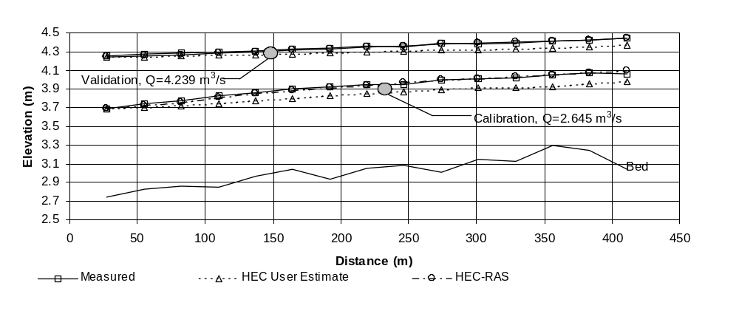or a modeling error of 20.8% based on an hydraulic

depth of 0.66 m (2.16 ft). Again for comparison, when the experienced based n is used the error is 22.4% (D of 0.148 m, 0.363 ft). And, when the high flow data is calibrated the n-value is 0.064 and the error is 11.5%
(D of 0.076m, 0.25 ft). Note that due to a suspected error in the measured water surface elevation at

FIG. 6. Water surface profiles for the Florida River.

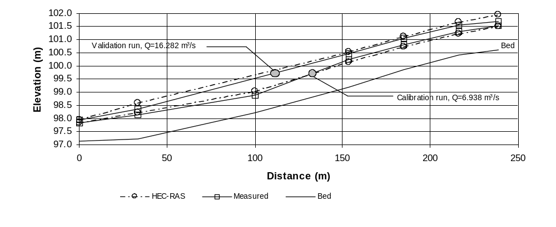
section 3, this point is not shown on the profile nor was it used in the computation of the modeling error. Calibration and validation results are summarized in Table 1.

TABLE 1. Calibration and validation results
Flowrate  (m³/s) | Exper.-Estimate of n-value |  |  | Calibrated n-value |  |  |  | Model Validation
Flowrate  (m³/s) | n | D (cm) | Error¹ | n | D (cm) | Error |  | n | D (cm) | Error
Florida Canal
2.65 | 0.021 | 9.1 | 14.3% | 0.030 | 1.7 |  | 2.7% | -- | -- | --
4.24 | 0.021 | 5.4 | 5.8% | 0.030 | 1.1 |  | 1.2% | 0.030 | 1.1 | 1.2%
Florida River
6.94 | 0.050 | 19.8 | 43.3% | 0.090 | 8.2 |  | 17.9% | -- | -- | --
16.28 | 0.050 | 14.8 | 22.4% | 0.064 | 7.6 |  | 11.5% | 0.090 | 13.7 | 20.8%
¹ Error is computed as the average difference D, as a percent of the hydraulic depth.

CONCLUSIONS

The purpose of this study is to assess HEC-RAS's ability to compute water surface profiles by comparing measured data with model results. As shown in Table 1 and Figures 5 and 6, the model did a very good job with the Florida Canal study reach. The validation run resulted in an average computed water surface profile that was within 1.2% of the measured profile. In contrast the Florida River validation results were much poorer with an average difference of 20.8%.
This large discrepancy in model validation error between the two study reaches is primarily attributed to the steep river gradient on the Florida River. With a slope of 0.0145 it is classified as a very

high gradient river whereas the Florida Canal, with a slope of 0.00078 is on the other extreme. As previously
mentioned, the computational procedure used in backwater analysis is more stable when the changes in energy between sections is small, as on the Florida Canal. The model does issue a warning when the energy changes are larger and suggests inserting additional cross-sections. In the case of the Florida River this was done affecting only minimal changes in the profile.
In addition to the model error, the measured survey accuracy decrease with a steeper river. High velocities, turbulence and the nonuniform nature of a rocky river bed all contribute to a larger random error and a greater likelyhood of mistakes in the measured survey data. This fact may also account for a portion of the error reported on the Florida River.
In conclusion, HEC-RAS did a good job modeling the low gradient channel (1.2% error) and a poorer job with the high gradient channel (20.8% error). Additional reaches covering the range of gradients between these two extremes will be studied in the future providing validation over a continuum of channel gradients.

ACKNOWLEDGMENTS

This study was funded by the National Science Foundation through the Louis Stokes Colorado Alliance for Minority Participation (LS-COAMP) program. LS-COAMP provides assistance and incentives to underrepresented minority students in science, math, engineering and technology. Special thanks to John Ey, operator of Lemon Reservoir, for his cooperation.

APPENDIX. REFERENCES

US Army Corps of Engineers (September 1982). HEC-2 Water surface profiles - Users Manual. Hydrologic Engineering Center.
US Army Corps of Engineers (September 1998). HEC-RAS River analysis system - Users Manual. Hydrologic Engineering Center.
Chow, V.T. (1959). Open-Channel Hydraulics, McGraw-Hill, New York, 109-123.

